Reference number of working document: **ISO/TC 23/SC 19 N 000**

Date: yyyy-mm-dd

Reference number of document: ISO/WD 7673-3

Committee identification: ISO/TC 23/SC 19/WG 1

Secretariat: XXXX

Agricultural Field Operations Data — Part 3: Irrigation Operations

*Élément introductif — Élément principal — Partie n: Titre de la partie*

Warning

This document is not an ISO International Standard. It is distributed for review and comment. It is subject to change without notice and may not be referred to as an International Standard.

Recipients of this draft are invited to submit, with their comments, notification of any relevant patent rights of which they are aware and to provide supporting documentation.

Document type: International standard

Document subtype: if applicable

Document stage: (20) Preparation

Document language: E

**Copyright notice**

This ISO document is a working draft or committee draft and is copyright-protected by ISO. While the reproduction of working drafts or committee drafts in any form for use by participants in the ISO standards development process is permitted without prior permission from ISO, neither this document nor any extract from it may be reproduced, stored or transmitted in any form for any other purpose without prior written permission from ISO.

Requests for permission to reproduce this document for the purpose of selling it should be addressed as shown below or to ISO’s member body in the country of the requester:

*[Indicate :*

*the full address*

*telephone number*

*fax number*

*telex number*

*and electronic mail address*

*as appropriate, of the Copyright Manager of the ISO member body responsible for the secretariat of the TC or SC within the framework of which the draft has been prepared]*

Reproduction for sales purposes may be subject to royalty payments or a licensing agreement.

Violators may be prosecuted.

Contents Page

Foreword vi

Introduction vii

1 Scope 9

2 Conformance 9

3 Normative references 10

4 Terms and definitions 10

4.1 Block 10

4.2 data exchange 10

4.3 data provider 10

4.4 grower 10

4.5 Irrigation collection 11

4.6 Irrigation item 11

4.7 recommendation 11

4.8 irrigation setup 11

4.9 irrigator 11

4.10 message 11

4.11 section 11

4.12 section flow 11

4.13 set 11

4.14 work order 11

4.15 work record 11

4.16 micro-sprinkler 12

4.15 section setup 12

5 Symbols (and abbreviated terms) 12

5.1 Note on multiplicity of properties 12

6 The Management Process 12

6.1 The In-Season Management Process 12

6.1.1 Grower Process: Work Record request/received 15

6.1.2 Irrigator Process: Work Order Received 15

6.1.3 Data Provider Process: Receive Event Data 15

6.1.4 Grower Process: Work Records Needed 16

7 Central Concepts 16

7.1 Describing Irrigation Systems and their Component Parts 17

7.1.1 Drip Irrigation Systems and their Component Parts 17

7.1.2 Wheel Lines, Hand Lines and their Component Parts 19

7.1.3 Travelers and their Component Parts 22

7.1.4 Solid Set 25

7.1.5 Pivot Irrigation Systems and their Component Parts 27

7.1.6 Linear Move systems 31

7.1.7 Surface Irrigation 34

7.1.8 Paddy Irrigation 34

7.2 Description of Irrigation Record 36

7.2.1 Irrigation Items and Collections 36

7.2.2 Section Flow 36

7.2.3 Chemigation and Fertigation 37

7.2.4 Hierarchical Structure 37

8 Core Documents for Irrigation Operations 39

8.1 Core Documents 39

8.2 Operations 39

8.2.1 IrrRefData 39

8.2.2 IrrSetupData 39

8.2.4 IrrDocs 40

8.3 Document Structure 40

9 Reference Data 40

9.1 Manufacturer 41

9.2 SystemModel 42

9.3 Product 42

9.4 ProductComponent 44

10 Setup Data 45

10.1 IrrSetupData 47

10.5 Cropzone 47

10.8 IrrSystem 47

10.9 IrrSetup 48

10.10 EndgunSetup 52

10.11 TabularValues 52

10.12 TableEntry 52

10.13 SystemSectionSetup 52

10.14 WaterSource 53

10.14 Set 54

11 Irrigation Data 54

11.1 Three Document Types 55

11.1.1 Shared Properties 57

11.1.2 IrrRecomendation 58

11.1.3 IrrWorkOrder 58

11.1.4 IrrWorkRecord 58

11.1.5 StatusUpdate 58

11.1.6 Note 59

11.2 Irrigation Records 59

11.2.1 IrrColl 59

11.2.2 IrrItem 60

11.2.3 SectionFlow 60

11.3 Chemigation and Fertigation 61

11.3.1 ProductSummary 63

11.3.1 ProductUse 63

12 Implementation Guidelines 64

12.1 System Setup 64

12.2 Document Structure 64

12.3 Irrigation Records 65

12.4 Consideration for Structure and Interpretation 66

12.4.1 Variable Rate Irrigation in Pivots 66

12.4.2 Guidelines for Drip Irrigation 70

Annex A (informative) UML Examples 74

A.1 Example 1 74

A.2 Example 2 1

A.3 Example 3 1

Annex C (normative) XML Examples 3

C.1 Example 1 3

C.2 Example 2 8

C.3 Example 3 13

C.4 Example 4 17

C.5 Example 5 18

Bibliography 26

Foreword

ISO (the International Organization for Standardization) is a worldwide federation of national standards bodies (ISO member bodies). The work of preparing International Standards is normally carried out through ISO technical committees. Each member body interested in a subject for which a technical committee has been established has the right to be represented on that committee. International organizations, governmental and non-governmental, in liaison with ISO, also take part in the work. ISO collaborates closely with the International Electrotechnical Commission (IEC) on all matters of electrotechnical standardization.

International Standards are drafted in accordance with the rules given in the ISO/IEC Directives, Part 2.

The main task of technical committees is to prepare International Standards. Draft International Standards adopted by the technical committees are circulated to the member bodies for voting. Publication as an International Standard requires approval by at least 75 % of the member bodies casting a vote.

Attention is drawn to the possibility that some of the elements of this document may be the subject of patent rights. ISO shall not be held responsible for identifying any or all such patent rights.

ISO 7673‑3 was prepared by Technical Committee ISO/TC 23, *Tractors and machinery for agriculture and forestry*, Subcommittee SC 19 *Agricultural electronics*.

Introduction

Part 3 of the Standard pertains to irrigation operations, including all of the activities associated with the application of water with an irrigation system. It focuses on management-level communications and record-keeping. The operations dataset is based around a set of Core Documents: a Recommendation, which describes a suggested course of action; a Work Order, which describes a desired course of action; and a Work Record, which describes what actually happened. This work is based on, and extends, the ISO11783-10 standard for communications between agricultural machinery and Farm Management Information Systems (FMIS) (ISO, 2015).

Software developers and others using this part of the Standard should read, and be familiar with the Core Concepts presented in ISO 7673-1, including the following:

* Business Process Models that are used to describe the flow of data within an integrated irrigation system
* The Actors and their role(s) in the process
* Core Documents and their relationships
* The use of Unique IDs and Compound Identifiers for objects in the Standard which are used by reference in another object
* How the Standard captures the concept of Time in irrigation events
* Specifying Reference, Setup and Configuration data

The sections titled Reference Data, Setup Data, and Irrigation Data describe the classes that compose messages in the Standard:

* UML class diagrams show all the properties
* List with precise description of each class’s properties
* Implementation guidelines

Annex A Contains a series of examples which represent common use cases covered by the standard.

Annex C Contains a series of XML examples representing common use cases covered by the standard.

NOTE: Readers may note the use of the acronym PAIL in this and other parts of the ISO 7673 standard. PAIL stands for Precision Ag Irrigation Language and was the name used for this set of standards prior to its introduction to ISO. Wherever the PAIL acronym is used, the intent is that PAIL refers to all parts of ISO 7673, collectively.

# 1 Scope

The purpose of this part of the Standard is to present an object model to represent the specification and reporting of irrigation water and product applications in an irrigation system. The scope includes planning and preparation phases (represented by documents called Plan, Recommendation and Work Order) as well as the recording of as-applied water and products (known as a Work Record). The scope of this document does not, however, include representing the Observations and Measurements that drive tactical decision-making in irrigation (and the creation of Recommendations and Work Orders); that material, corresponding to an irrigation-specific implementation of the ISO 19156 standard, is covered in Part 2 of this standard. This standard should enable a developer to unambiguously represent the data being communicated in various parts of the farmer's business process associated with irrigation field operations in terms of a set of classes based on the ISO 11783 standard, with the understanding that not all farming businesses will necessarily require or support all the documents described above.

The Standard is meant to support the *exchange* of data. The classes, data formats, and structures described herein are not meant to specify internal structure or the object model of an Farm Management Information System (FMIS) or similar system, nor necessarily a serialization format for the data. While it is easy to draw parallels between an object model and a database schema, the object model defined here is not specifically meant to be construed as a database schema or as the internal structure of an FMIS.

The standard does not specify any type of “summary” report. This is intentional. The information contained in a collection of Standard compliant documents will be sufficient to create a summary of irrigation applications. Actual summarization of irrigation requires aggregation, and the method or scope of aggregation is often derived from specific reporting requirements. The Standard is neutral regarding reporting requirements because these requirements are typically derived from a regional, basin, or administrative unit scale and are, therefore, out of scope.

It is important to note that Standard-compliant documents are intended for documenting operation or use of equipment, not the design of equipment. Many characteristics of an irrigation system are relevant for documenting the system’s design but not necessarily for documenting its use. For example, the pipe diameter of a pivot lateral is typically included in its specification. Documenting how much water the pivot applied does not require knowledge of the pipe diameter. Documentation of engineering design is out of scope for the Standard.

# 2 Conformance

ISO 7673 defines an abstract object model. Applications intending to use the ISO 7673 object model will need an implementation of the object model that is appropriate for the particular application development platform. Future parts of the standard (or versions thereof) will include reference serialization implementations.

A particular implementation of the object model, whether it is for serialization or application development, would need to demonstrate some conformance to the business rules and constraints defined in 7673.

Conformance testing is essential for the expectation that two separate implementations can interoperate successfully. Given the large size and scope of ISO 7673, specification of conformance requirements and associated tests, will be covered in a separate part of the 7673 series.

# 3 Normative references

The following referenced documents are indispensable for the application of this document. For dated references, only the edition cited applies. For updated references, the latest edition of the referenced document (including any amendments) applies.

ISO 7673-1 Agricultural Field Operations Data — Part 1: Core Concepts

ISO/FDIS 6709 Standard representation of geographic point location by coordinates

ISO 8601 Data objects and interchange formats — Information interchange — Representation of dates and times

ISO/IEC 9834-8 Information technology — Procedures for the operation of object identifier registration authorities — Part 8: Generation of universally unique identifiers (UUIDs) and their use in object identifiers

ISO 11783-10 Tractors and machinery for agriculture and forestry — Serial control and communications data network — Part 10: Task controller and management information system data interchange

ISO/IEC 13249-3:2011 Information technology — Database languages — SQL multimedia and application packages — Part 3: Spatial (WKT)

ISO 19109 Geographic information — Rules for application schema

ISO 19112:2003 Geographic information — Spatial referencing by geographic identifiers

ISO 19156:2011 Geographic information — Observations and measurements

ISO/IEC 19510:2013 Information technology — Object Management Group Business Process Model and Notation

ISO/IEC 19757-3:2006 Information technology — Document Schema Definition Language (DSDL) — Part 3: Rule-based validation — Schematron

ISO 22006:2009 Quality management systems — Guidelines for the Application of ISO 9001:2008 to crop production

WMO No. 8. Guide to Meteorological Instruments and Methods of Observation, 7th Edition. 2008. Geneva

# 4 Terms and definitions

For the purposes of this document, the following terms and definitions apply.

## 4.1 alternate furrow irrigation

A surface irrigation practice where furrows are used as channels to distribute water across a field and half (or approximately half) of the furrows are wetted separately, in an alternating fashion.

## 4.2 block

A subdivision of an irrigation system that enables application of water to a portion of the total area irrigated by the system and can be controlled independently of other blocks.

## 4.3 chemigation

an injection of agrochemicals, such as pesticides, herbicides or other growth-enhancement products, to the irrigation system, together with irrigated water.

[SOURCE: ISO/IWA 20:2017]

NOTE: Plant growth regulators are included in the category of products that can be applied through chemigation.

## 4.4 Corner arm

An articulated span of a pivot, typically the last span, designed to rotate relative to the adjacent span and enables irrigation of a portion of the corners of a rectangular area.

## 4.5 data exchange

a transfer of information between two or more entities where the information is typically in the form of electronic documents.

## 4.6 Data logger

See telemetry system (4.21 telemetry system)

## 4.7 data provider

a person or entity responsible for collecting, storing, and providing information used in **data exchange**.

## 4.8 endgun

set of one or more sprayers or sprinklers installed on the distal end(s) of a centre-pivot or moving lateral irrigation machine to increase the irrigated area, and usually operating for only a portion of the time to conform to field boundaries.

SOURCE: ISO 11545:2009(en), 2.6

## 4.9 evapotranspiration

the total evaporation of an area covered with vegetation. It is comprised of water that is intercepted by the vegetation followed by evaporation, the evaporation from the dry surface of plant leaves (transpiration), and the evaporation from the soil.

[SOURCE: ISO 6107-8:1993]

## 4.10 fertigation

the application of fertilizers with irrigation water (see chemigation).

## 4.11 field operation

a task or activity, whether planned or actual (i.e., that already happened), that is connected with the production of a crop. Planting, spraying, spreading, tillage, irrigation and harvest are all examples of field operations.

[SOURCE: ISO 7673-1]

## 4.12 grower

a person or entity responsible for managing agricultural production.

## 4.13 Irrigation collection

one or more **irrigation items** which together document water application on a particular field.

## 4.14 Irrigation item

information needed to document when, where, and how much water was or should be applied on a particular field.

## 4.15 irrigation efficiency

the amount of productivity (yield) in relation to the amount of water applied. Irrigation efficiency units are normally presented as the weight of yield per volume of water applied.

[SOURCE: ISO/IWA 20:2017]

## 4.16 irrigation setup

the arrangement and configuration of irrigation equipment at a particular time.

## 4.17 irrigation system

the physical components and configuration of pipes, components, and devices installed in the field for the purpose of irrigating a specific area used to apply water by irrigation.

[SOURCE: ISO 16075-2:2015]

## 4.18 irrigator

a person or entity responsible for managing the application of water for agricultural production.

## 4.19 message

a package of information (typically a document in electronic format) exchanged at a particular time for a particular purpose wherein the information pertains to the execution of a particular agricultural operation.

## 4.20 micro-sprinkler

sprinkler that distributes water in a dynamic or static way, either in circular area or part circular area, with a flow rate not exceeding 200 l/h

[SOURCE: ISO 24120-3]

## 4.21 pivot span

A contiguous portion of a pivot irrigation system.

## 4.22 recommendation

a document containing one or more irrigation collections which specify when, where, and how much water should be applied.

NOTE: Recommendations are assumed to be created by a person with expertise, that is *recommending* a course of action. Their meaning is distinct from that of work orders (4.14 work order), which are created by a person with authority, and represent the decision to irrigate as specified.

## 4.23 section

a contiguous portion of an irrigation system, irrigated using the same method (e.g. sprinklers, tape, furrow, etc.), and with the same nominal application rate.

## 4.24 section flow

an amount of water emitted from a section at a particular time and at a particular location.

## 4.25 set

A collection of one or more blocks (4.2 block) within the same irrigation system that are irrigated simultaneously and receive approximately the same depth of application. The blocks associated with a set may change during an irrigation season.

## 4.15 surface irrigation

In the context of this standard, irrigation occurring where the majority of the system is unpressurized, and water is distributed across a field via ditches, siphon tubes, or other devices operating without artificial pressurization.

## 4.19 section setup

The setup and configuration data necessary to specify essential features of a spatially distinct portion of an irrigation system.

## 4.20 system controller

the device that controls the irrigation system’s basic functions, including speed, direction of travel, water output, the operation of endguns (4.5), as well as additional pumps. It may include the combination of the system’s control panel and an associated telemetry system (4.21 telemetry system).

## 4.21 telemetry system

Electronic systems for transmission of field-collected data, and receipt of command data.

## 4.22 variable rate irrigation (VRI)

a method of managing the amount of water applied per unit area in a spatially explicit manner. In the context of pivot and linear systems, VRI regulates the system speed and provides the ability to turn sprinkler valves on and off. There is no conventional definition for VRI in other types of irrigation systems (e.g., drip, wheel lines, travellers).

## 4.23 variable speed irrigation (VSI)

 a method of managing water application by varying the speed of the centre pivot as it moves around the field.

## 4.24 work order

a set of instructions, given by someone with authority specifying a course of action. An irrigation work order describes the amount of water to apply to a given piece of land over a specific time period.

NOTE Work orders are assumed to be created by a person with authority, that is communicating the decision to irrigate. This is distinct from recommendations (4.7 recommendation), which are assumed to be created by a person with expertise, that is recommending a course of action.

## 4.25 work record

a document that describes what actually happened while performing the field operation. It may differ from the work order because the operator performing the field operation may have had to make adjustments to particular conditions (e.g., suspended the operation because the ground was too wet and returned the next day).

# 5 Symbols (and abbreviated terms)

## 5.1 Note on multiplicity of properties

This standard defines an abstract object model. The standard utilizes UML diagrams to *specify* the classes and their properties. The body text of the document *describes* the properties. For the reader’s convenience, we have included the multiplicity specification in the body text of each classes’ description. The following table shows the UML multiplicity specification and its meaning, as used in the body text of this standard.

Table 1 Multiplicity codes

|  |  |
| --- | --- |
| **Text** | **Meaning** |
| [0..1] | The property is optional and may appear only once |
| [1] | The property is required and shall appear only once |
| [0..n] | The property is optional and may appear any number of times |
| [1..n] | The property is required and may appear any number of times |

# 6 The Management Process

The Standard is built around an assumption that irrigation is managed and that the management can be defined by a process. This assumption is derived from the business process that is typical of irrigation management service providers and irrigation managers at more extensive operations. All the classes and objects defined in the standard are based on business practices. Agronomic processes are not ignored but instead are embedded in the business processes. The BPMN diagram defines all of the actors, processes, and messages (4.10 message) that are relevant to the irrigation management process.

NOTE: The specific processes formally documented by a given farming business will vary based on size, jurisdiction, regulatory compliance requirements, underlying limiting factors to production, and so forth. The BPMN model shown should thus not be interpreted as implying that farming businesses should support all of the documents in order to conform to this Standard. Additionally, not all farming businesses will have separate actors in the roles shown. In some cases, for example, the grower (4.4 grower), the irrigator (4.9 irrigator), and the advisor who provided the recommendation (4.7 recommendation) may all be the same person.

## 6.1 The In-Season Management Process

Figure 1 shows a Business Process Modeling Notation diagram of the irrigation management process. This diagram is also shown in Part 1 of this standard which contains a discussion on the content and meaning of this diagram. Part 1 also includes a primer on BPMN diagramming. A more detailed discussion is presented here.

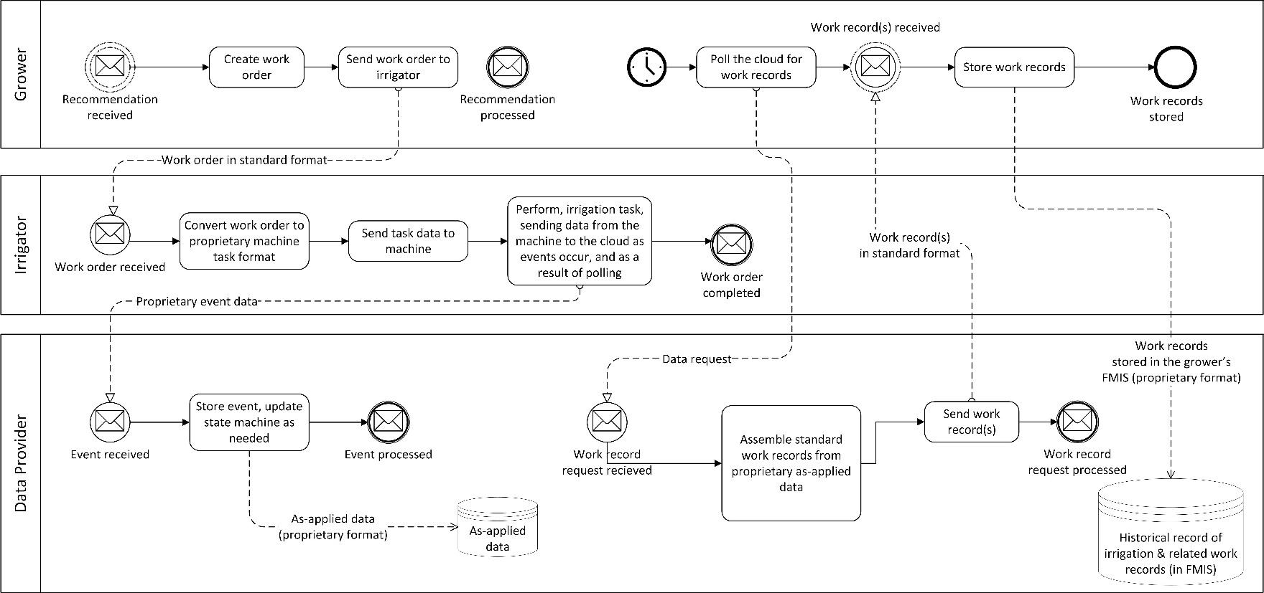

Figure 1 The BPMN diagram for in-season management operations

In the figure, the dashed lines represent messages that actors exchange during the process of implementing irrigation during the growing season. Not all the messages are in the Standard format. Non-standard messages are excluded from the standard because they include proprietary information. Non-standard messages are indicated as such in the diagram. The standard does not stipulate how to implement the processes; it only presumes that these processes occur and that the messages are passed. Some aspects of the processes may be indirectly limited by constraints of the context of the messages. While it is technically possible for the message exchange to happen manually (i.e., by paper or verbal exchanges), the standard assumes that the message exchange is facilitated by an FMIS or another software system. Finally, the diagram does not precisely specify the standard, only the context in which the actors exchange messages.

### 6.1.1 Grower Process: Work Record request/received

* The BPMN begins with receipt of a recommendation. The standard assumes that someone with expertise created the recommendation and did so using field measurements that indicate a need for irrigation. Part 2 describes the process by which recommendations are created.
* The Grower creates a Work Order (4.WorkOrder) based on the Recommendation. The Work Order may differ from the Recommendation based on the Grower’s knowledge or preferences.
* The Grower then transmits that Work Order to the Irrigator, the person in charge of performing the operation.

For small or mid-sized farms, the Grower and Irrigator is often the same person. In that scenario, the message exchange is primarily symbolic. The Work Order represents the decision by the Grower.

### 6.1.2 Irrigator Process: Work Order Received

* The process begins when an Irrigator receives a Work Order.
* The Irrigator then uses the work order to set up the irrigation task. The exact nature of this step will depend on the hardware involved: it may range from sending the standard-format Work Order in electronic form to a telematics system, to using the information on a printout of the work order to guide the manual programming of an irrigation system panel. The specifics of what happens at this step are not in scope of this standard.
* The Irrigator starts the machine and performs the task.

### 6.1.3 Data Provider Process: Receive Event Data

* While the machine operates, it will generate a series of events (e.g., machine is on and applying water, the machine turns off, there is low pressure or other error conditions, etc.)
* The event data is assumed to be logged by a Data Provider (4.3 data provider), who will translate the proprietary sequence of events into standard-format Work Records (4.15 work record).
* The process begins when an event is received by the Data Provider.
* The Data Provider stores the event data on its own, proprietary state machine database. The specifics of the data involved are outside the scope of this standard.
* The process ends after the storage operation is complete.

### 6.1.4 Grower Process: Work Records Needed

* The process begins when the Grower decides that he/she needs Work Records
* The Grower sends a request to the Data Provider
* The Data Provider assembles the Work Records collected during execution of the Work Order and sends them to the Grower. The messages may also include Work Orders with status updates for work that is still ongoing.
* After receipt of the Work Records, the Grower may choose to store these records in a proprietary database. The Data Provider who stores these records is not necessarily the same provider that generated the records.

# 7 Central Concepts

This section describes fundamental concepts that are used throughout the standard. The concepts presented in this section manifest in the standard as class definitions. The following sections contain the details of each class, its attributes, relationships, and constraints. This section introduces each class as a concept and describes its purpose.

The scope of this Standard includes eight separate irrigation technologies (center pivot, linear, traveler, drip, surface, solid set, hand lines, wheel lines). The particular implementation of the classes for each technology will be somewhat different, since some irrigation systems (e.g., center pivot, linear, traveler) have automated movement and thus the irrigated area changes over time, whereas others don’t, etc. Table 2 below shows the key system characteristics that were used to categorize the systems.

* **Technology**: the name of the system type
* **Sections**: does the system use static (constant over time) or dynamic (changing over time) definitions of sections (4.11 section).
  + **Static:** the spatial footprint of Sections is constant over time (i.e., defined at the section setup level (4.19 section setup))
  + **Dynamic:** the spatial footprint of Section definitions change over time (e.g., succession of polygons, defined in the IrrItem.SectionFlow instances)
  + **Both:** the spatial footprint may be static or dynamic
* **Uses Sets**: are Sections grouped into a collection of areas which are irrigated simultaneously
* **Setup volatility**: does the setup data vary often during an irrigation season
* **Endgun setup**: does the system need setup information for an endgun (4.4 endgun)

Table 2 Irrigation system features relevant for categorization of Irrigation System type

|  |  |  |  |  |
| --- | --- | --- | --- | --- |
| **Technology** | **Sections** | **Uses Sets** | **Setup volatility** | **Endgun setup** |
| Center pivot | Both* | No | Low | Yes |
| Linear | Both ** | No | Low | Yes |
| Traveler/Big Gun | Both ** | Yes | High | Yes |
| Drip | Static | Yes | Medium | No |
| Surface | Static | Yes | Medium | No |
| Paddy | Static | Yes | Low | No |
| Solid set | Static | Yes | Low | No |
| Hand lines | Dynamic | Yes | Medium | No |
| Wheel lines | Dynamic | Yes | Medium | No |

**\*** Sections along the primary system are described in radial form. Sections on a *bender* are described in radial form around a local center of rotation. Sections corresponding to a swing-arm corner are described as dynamic polygons**.**

** Linear and Traveler/Big Gun systems cannot be described in the radial shorthand used for pivots. Therefore, their coverage is a dynamic polygon. Note there are two different ways of setting this up: multiple static sections (that have a fixed footprint and only get water allocated to them when the system passes over them) and dynamic sections (that have a dynamic polygon coverage that can represent the water applied between two different moments in time**).**

## 7.1 Describing Irrigation Systems and their Component Parts

In the context of ISO 7673, irrigation systems are comprised of a collection of one or more components for delivering water to a given area. These components can be stationary, moving in a plane, or rotating around a point. The ISO 7673-3 data model contains abstract specifications of these components as they relate to documenting when and how much water is, was, or should be applied to a particular area. The fundamental abstraction is the SectionFlow class described in 7.2.2 Section Flow and the IrrItem described in 11.2.2 IrrItem. Each type of irrigation system has different physical constrains that will determine how to define the SectionFlow and IrrItem objects in irrigation documents. The following sections define the specific concepts used to relate the particular system components to the abstract concepts defined in 7673-3.

ISO 7673-3 defines two concepts that will help facilitate documenting water use with irrigation systems:

**Block**: A subdivision of an irrigation system that a) covers a portion of the total area irrigated, and b) can be controlled independently of other blocks. (4.1 Block)

**Set**: A collection of one or more blocks within the same irrigation system that are irrigated together. The blocks associated with a set may change during an irrigation season. (4.13 set)

A Set is an emergent property of the system’s management. A Block is a property of the system’s design. The application rate, within a given Block, is determined by the design of the irrigation system. The depth of application is determined by the management of the Set. The definition of these two terms depends on the system type.

Spatial extent can be specified with varying degrees of abstraction, ranging from explicit time-specific data, to abstract specification via relationships with other classes. Details how to specify the spatial extent in setup and configuration data, is defined in 10.8 SystemSectionSetup. Implementors may equate Blocks with CropZones (ISO 7673-1, Clause 9.2.10), because this simplifies documenting crop management (e.g., when the Blocks contain different crops), but this is not required.

### 7.1.1 Drip Irrigation Systems and their Component Parts

Within the context of Drip Irrigation systems, Block and Set have the following interpretation:

**Block**: A subdivision of a drip irrigation system that enables irrigation of a portion of the total area irrigated by the system and can be controlled independently of other blocks.

**Set**: A collection of one or more blocks within the same irrigation system that are irrigated together. The Blocks associated with a Set may change during an irrigation season.

Figure 2 illustrates Blocks in an example irrigation system. This example system has a rectangular area subdivided into six parts, where each part has its own valve controlling flow to that part. Each one of these parts, controlled by a single valve, is a Block in the context of 7673. Each Block shall have one SectionSetup instance in the IrrSetup instance. Each of these SectionSetup instances correspond 1-to-1 to the Sets in the physical irrigation system. Figure 3 shows a schematic view of a WorkRecord corresponding to a single irrigation event where the entire field (all the Blocks) are irrigated simultaneously.

The following constraints apply to drip irrigation systems:

* Each Block shall have exactly one SectionSetup
* SectionSetup shall use the SpatialFootprint property (not the InnerDistance or OuterDistance properties)
* SectionFlow instances corresponding to a single Set shall be grouped in a single IrrItem instance.

A typical scenario with drip systems in water scarce areas involves having a declining flow rate during the irrigation season. 12.4.2 Guidelines for Drip Irrigation contains a detailed example of how to produce irrigation records that accommodate this scenario. The examples also demonstrate best practice for documenting Sets in ISO 7673-3 irrigation documents.



Figure 2 Schematic diagram of a Drip irrigation system having six Blocks



Figure 3 Concurrent Sets, all Blocks irrigated simultaneously. The rectangles labelled SF 1, SF 2, etc, are the SectionFlow instances corresponding to the Blocks.

### 7.1.2 Wheel Lines, Hand Lines and their Component Parts

Wheel Line and Hand Lines are two types of sprinkler irrigation systems (Irrigation, 2011). Figure 4 illustrates the Wheel Line system components that are relevant to 7673-3. For the purposes of this standard, Wheel Line and Hand Lines are equivalent. Irrigation with Wheel Lines typically involves one or more portable lines with multiple sprinklers attached. The lines are moved periodically and typically in a repeating pattern. The line is attached to a hydrant (connection point) and the hydrant is stationary. For some Hand Lines, the hydrants are temporary but their location does not change during the irrigation season.

Each position of the Wheel Line is called a Set. The Set used for Wheel Lines is analogous to Set used by Drip systems described in the previous section. However, Drip systems can have different numbers of Blocks in each Set, Wheel and Hand lines typically have the same number of lines in each Set. In the context of Wheel and Hand lines, Blocks correspond to the area irrigated by a single line when attached to a single hydrant. For example, the system shown in Figure 4 has three Sets and six Blocks.

The following constraints define how to define Wheel Line and Hand Line system’s setup information and the irrigation records corresponding to those systems:

* Wheel Lines and Hand Lines shall have one SectionSetup instance for each independently moveable line. For example, the Wheel Line shown in Figure 4 would have two SectionSetup instances.
* The SectionSetup shall not use the InnerDistance or OuterDistance properties.
* The SectionType property of SectionSetup instances for Wheel Lines shall use the “WHEEL_LINE” enumerated value.
* The SectionType property of SectionSetup instance for Hand Lines shall use the “HAND_LINE” enumerated value.
* An IrrItem instance shall contain all of the SectionFlow instances that were irrigated at the same time. Minor variances in start/stop time between lines (i.e., if the lines are moved one at a time by a single person) may be ignored provided the total application depth or volume remains constant at the field level.
* The SectionSetup may use the SpatialFootprint property, however the SpatialFootprint shall cover the entire area irrigated by each Set of that line. For example, in Figure 4, the SpatialFootprint for “Line #2” would be the union of the areas labelled “Previous Position”, “Current Position”, and “Next Position”.
* When SectionFlow instances use the PolygonCoverage property, the spatial extent shall correspond to the area covered by the line for that particular Set.

Experienced engineers will note that Wheel Line (and Hand Line) systems are designed such that the sprinkler’s throw overlaps with adjacent sprinklers. This overlap ensures uniformity across the whole field. This overlap also prevents defining an unambiguous separation of the irrigated area corresponding to an individual set (i.e., the wetted area from one Set will overlap with other Sets). Within the context of this standard, the PolygonCoverage of all SectionFlow instances which reference the same SectionSetup instance shall correspond to the total area wetted by the line defined in the SectionSetup. This constraint ensures that the union of all the PolygonCoverages (for a particular line) is the total area irrigated by the individual line. The intent of this constraint is to ensure that the application rate and total application depth calculations are consistent at the Set, line, and whole field level.

Figure 4 and Figure 5 illustrate each of these constraints. The system shown in Figure 4 has two lines (“Line #1”, and “Line #2”), each having three Sets. A single irrigation event would require moving each line three times. The two lines are always operated simultaneously. Figure 5 shows the WorkRecord’s structure for a single wetting of the entire field. The first Set is represented by IrrItem 1, the 2nd by IrrItem 2, etc. The hatching patterns shown in Figure 4 correspond to the hatching in the WorkRecord figure. Since there are three Sets, the IrrColl contains three IrrItem instances. Since both lines are operated simultaneously, each IrrItem contains two SectionFlow instances (labelled “SF 1”, “SF 2”, etc); one for each Line.

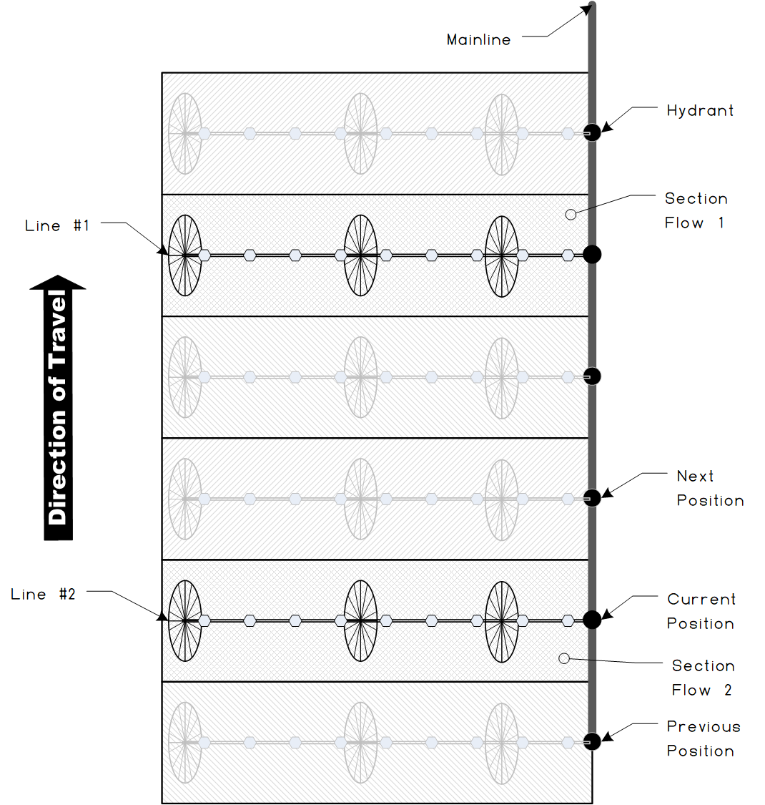

Figure 4: Schematic view of a Wheel Line system having two lines and three sets.



Figure 5: A WorkRecord corresponding to the Wheel Line shown in the previous figure. The vertical positioning of the SectionFlow boxes is meant to emphasize the temporal ordering of the Sets.

### 7.1.3 Travelers and their Component Parts

ISO 8244-1 describes Traveller irrigation machines. For the purposes of 7673-3, Travellers includes those systems defined in 8244-1, and systems with the following attributes:

* The emission device(s) is/are mobile during the irrigation event
* The emission device(s) follow a prescribed or planned path during the irrigation
* The emission device(s) move continuously (or periodically with short intervals) during water application

Recent technological advances (low cost RTK GPS) have enabled semi-autonomous hard-hose traveller irrigation systems. While Traveller systems are generally not automated, newer semi-autonomous systems have performance characteristics that will benefit from standardized data exchange (4.2 data exchange).

Figure 6 shows the schematic elements of a Traveller system relevant to 7673-3. This figure shows a hard-hose Traveller with attached sprinkler making three passes across a non-rectangular field. Figure 7 shows the WorkRecord structure corresponding to the irrigation shown in Figure 6. The following constraints apply to Traveller systems:

* Each continuous pass shall be represented by a single IrrItem containing a single SectionFlow instance. If the system stops during the pass (intentionally or unintentionally), the pass shall be represented as two separate IrrItem instances.
* The temporal extent of the individual passes shall be documented using the TimeScope property of the SectionFlow’s parent IrrItem (see 11.2.2 IrrItem for details of the IrrItem class). For example, in Figure 6, the temporal extent of “Pass #1” should be documented by the TimeScope property of “IrrItem 1”. If the IrrCollection instance contains a TimeScope property, the TimeScope shall document the overall duration of the irrigation; including both the time spent applying water and the time spent moving the system.
* The spatial extent of the wetted area of each pass shall be documented in one of two ways:
  1. When the same (or nearly the same) machine path is used, the SectionSetup’s SpatialFootprint property shall be used to document the spatial extent of an individual pass. Thus, the IrrSetup will have a separate SectionSetup instance for each pass.
  2. When the area covered by a pass is a) unique each time the system is used, or b) is documented by GPS data collected during the pass, the SectionFlow’s PolygonCoverage property shall contain the spatial extent of the individual pass.

Given the manual nature of Traveller machines, wetted areas often overlap in less-than-optimal ways. This issue is illustrated in Figure 6 by the overlapping hatched areas. It is often impractical to measure the spatial extent *in situ*. As a best practice, the PolygonCoverage (or SpatialFootprint) property may contain an estimated spatial extent of the area covered by the sprinkler.

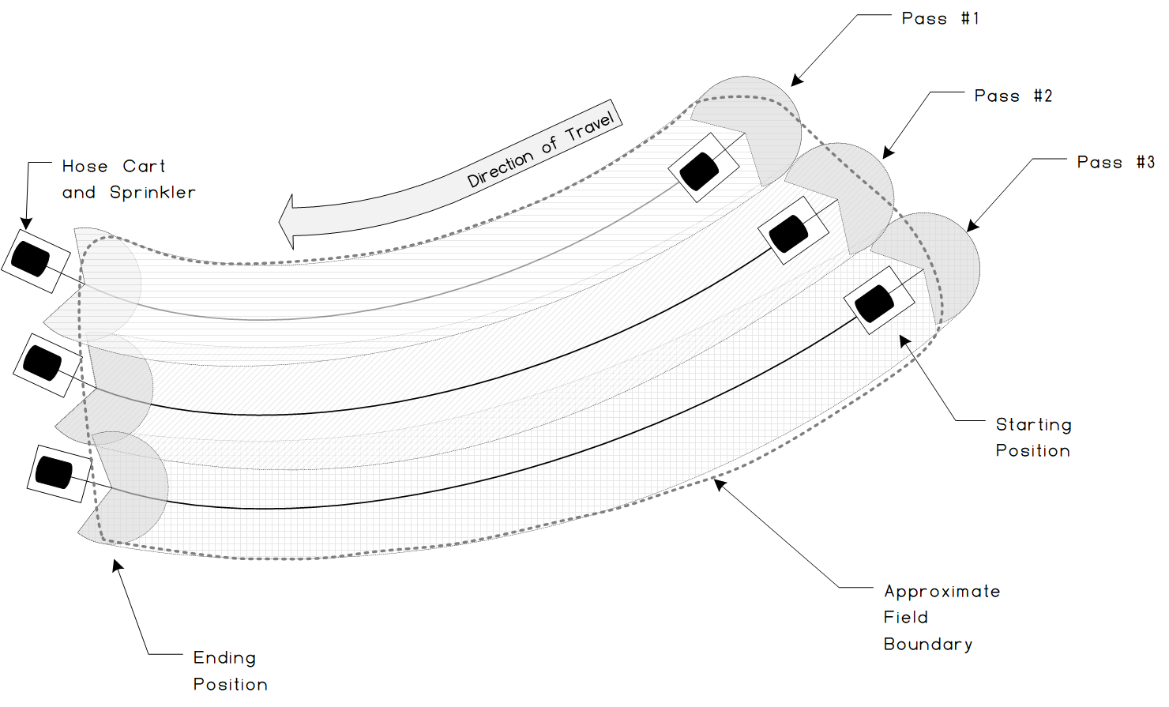

Figure 6 Traveller schematic diagram

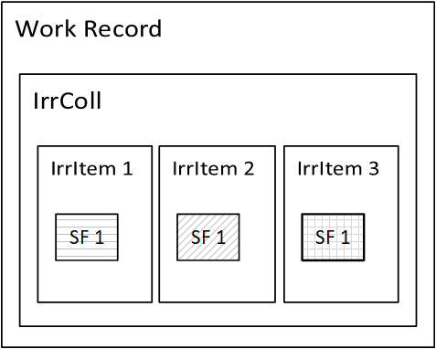

Figure 7 WorkRecord structure for a Traveller machine

### 7.1.4 Solid Set

Solid Set systems have been defined in various standards such as EN 13742-1. For the purposes of this standard, a solid set system has the following features:

* The system components (particularly the sprinklers) do not move during or in between irrigations. The system components may move in between irrigation seasons.
* The emission devices are typically sprinklers which distribute water as droplets over distances significantly larger than micro-sprinkler (4.17 micro-sprinkler) systems (as defined in ISO24120-3).

These two features differentiate Solid Set systems from Hand Lines (which do move between irrigations), and from drip systems which do not move during or in between irrigations. Solid Set systems may be designed such that portions or subsets of the field can be irrigated; much the same way drip irrigation systems do.

Figure 8 shows a schematic view of a Solid Set system having two sets. The hatched areas delineate the managed area relevant to documenting irrigation. Typically, the field boundary is the managed area. However, given the semi-indeterminate nature of the wetted area (i.e., lack of full sprinkler overlap at the field boundaries), Solid Set systems may use the IrrSetup’s SpatialFootprint property to define the field boundary, and the SectionSetup’s SpatialFootprint property to define the spatial extent of the wetted area. When both IrrSetup.SpatialFoorptint and SectionSetup.SpatialFootprint are used, the IrrItem.SectionFlow’s Vol and Depth properties shall refer to the area defined by SectionSetup.SpatialFootprint.

Figure 9 shows a WorkRecord document structure for a single irrigation by the system shown in Figure 8. The hatching in the section flow boxes (labelled “SF 1”, and “SF 2”) corresponds to the hatched areas in Figure 8. Solid Set systems shall use the same definition of Set and Block as used by Drip Systems (see 7.1.1 Drip Irrigation Systems and their Component Parts).

The following constraints shall be applied to Solid Set systems:

* The IrrSetupData.IrrSystem.SystemType property shall use the SOLID_SETenumerated value
* The spatial extent of individual sets shall be documented using the SectionSetup.SpatialFootprint property.
* The temporal extent of individual sets shall be documented by the IrrItem’s TimeScope property
* When multiple sets are irrigated simultaneously, the SectionFlow instances shall be grouped in the same IrrItem instance.

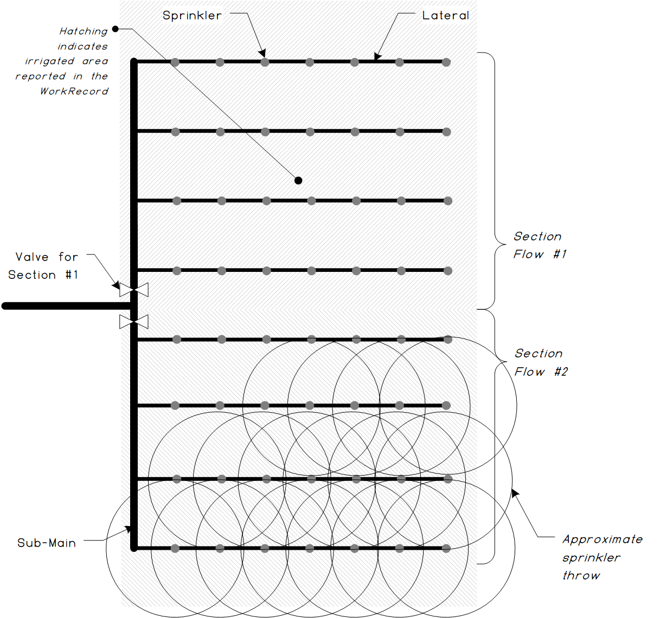

Figure 8 Schematic view of a Solid Set irrigation system having two Sets.



Figure 9 Sample document structure for a Solid Set system

### 7.1.5 Pivot Irrigation Systems and their Component Parts

With a center pivot irrigation system, water is applied by sprinklers that cover some length of the total system. Depending on the abilities of the irrigation system the sprinklers may be controlled individually or as a group of sprinklers. This group of sprinklers or contiguous wetted portion is called a Section (4.11 section). If the group of sprinklers covers the full length of the irrigation system, there is one section and its inner distance is the distance from the pivot center to the first sprinkler or innermost wetted area. Similarly, the outer distance is the distance from the pivot center to the last sprinkler or outermost wetted area. The geometric interpretation of Section is illustrated in Figure 10. When there are multiple groups of sprinklers, each section is defined as the distance of the first sprinkler or wetted area of the section (measured from the pivot's center) to the distance of the last sprinkler or wetted area of the section. Sections are a basic unit of water delivery in this standard. Pivots, and Linear Move, do not use the Set and Block concepts.

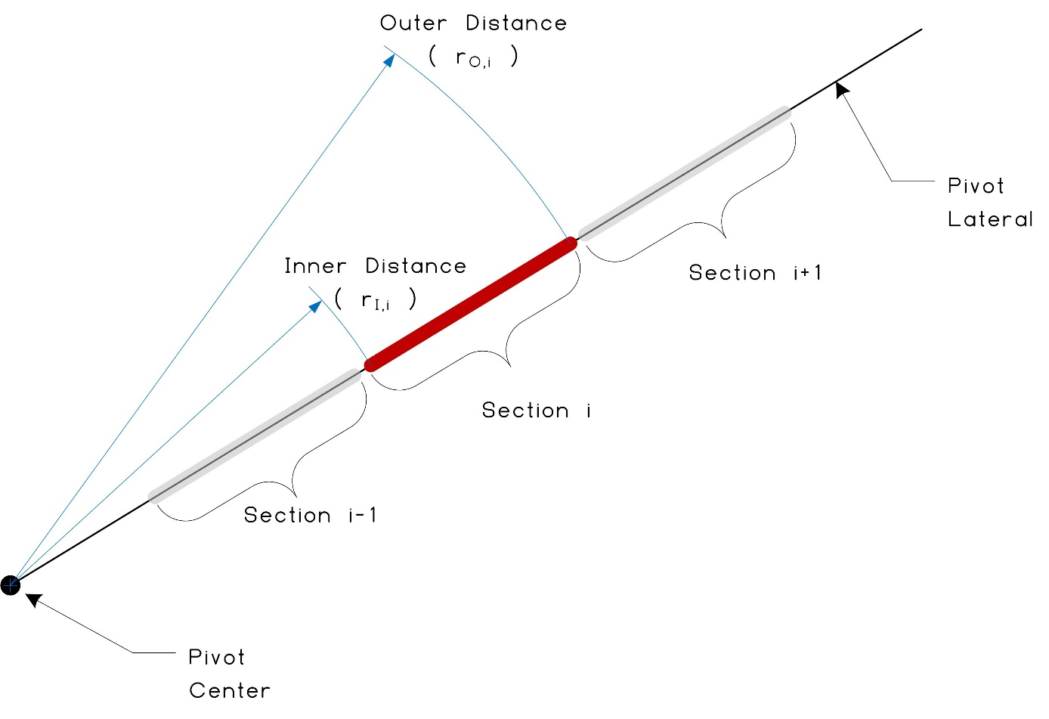

Figure 10 Schematic illustration of a Section class

The Section concept enables description of the physical and conceptual partitioning of an irrigation system. The physical partitioning applies to the obvious relation of a single section describing a single span of a pivot. The Section class can be used to describe more than a single span. It is entirely valid to have a single Section describe an entire pivot or an individual sprinkler. This flexibility is how Sections, combined with the IrrItem, can document nearly any type of irrigation application. It is important to note, however, that Section definitions are intended to support documenting water applications that differ along the length of the system. Adjacent section definitions that are identical in all respects except position do not enable any additional expository benefit and will increase reporting burden. If a pivot is defined with two sections that both apply the same depth of water each time they are used then the resulting Work Orders, and Work Records will contain unnecessary duplication.

The Section abstraction is not meant as a direct analog of pivot architecture. Instead, the abstraction is convenient for pivots and adequate for any other system type. The Section definitions enable separation of the physical description of the system from the description of the system’s use. The intent here is to support pivot systems in a convenient manner but also be flexible enough for most other system types. The Section abstraction will still be relevant for more disparate system geometries because the definition includes an optional geometric specification for the irrigated area.

For non-radial areas, the Section class also includes a SpatialFootprint object that can be used to describe any physical partitioning of the irrigated area. This is achieved using the SpatialScope class defined in ISO 7673-1.

It is important to note that the radial specification does not, by itself, specify a particular location or area. Figure 10 shows how the definition of a section in terms of distances from a center of rotation translates into an irrigated area when the system rotates. Figure 12 illustrates how the IrrItem, SectionFlow, and the Section together specify an amount of water applied to a particular area.

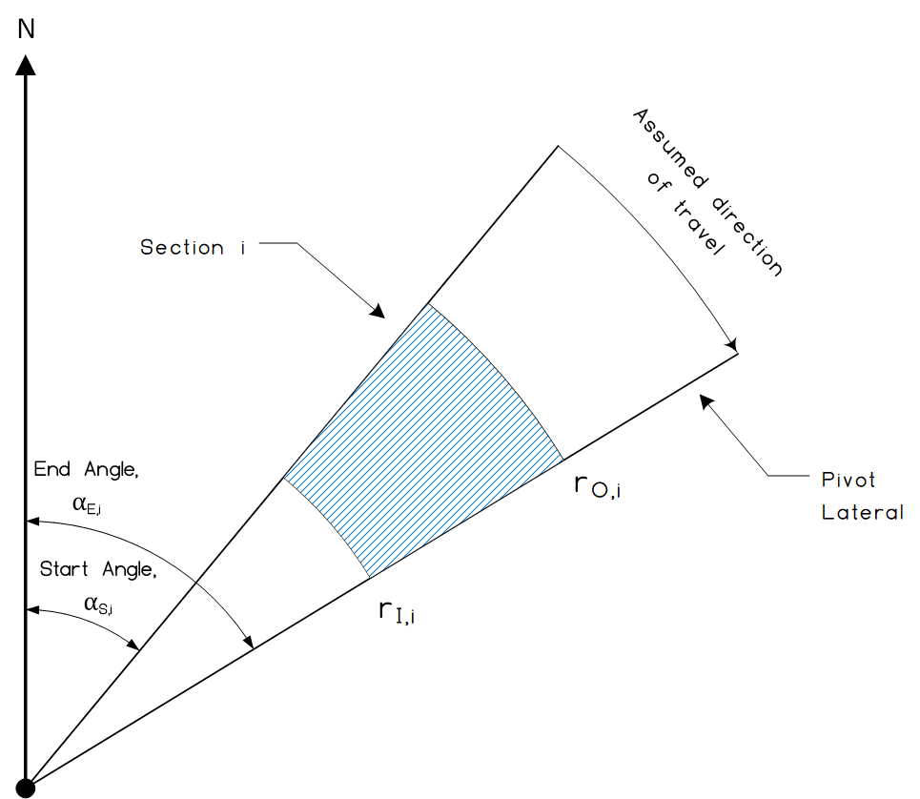

Figure 11 Schematic view of the area subtended by a Section moving from Start Angle to End Angle

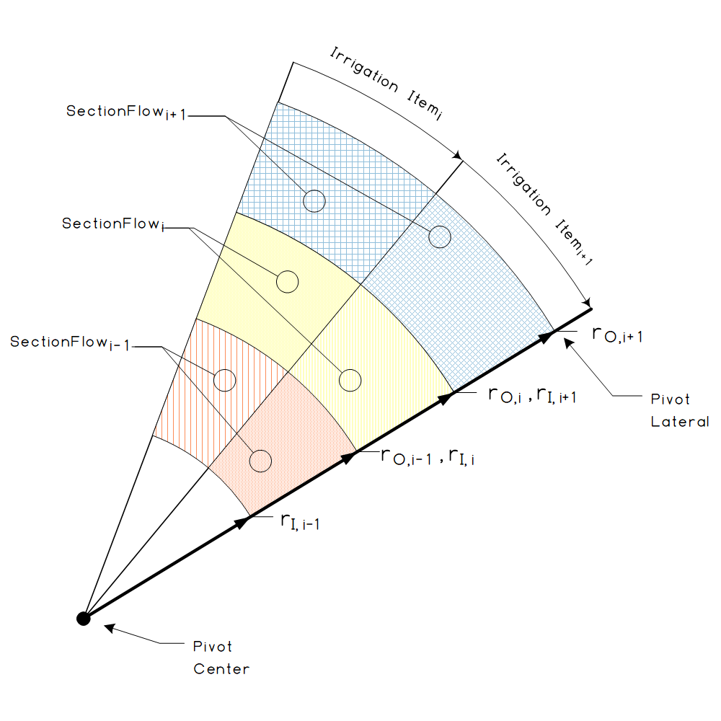

Figure 12 Six SectionFlow areas associated with three adjacent Section definitions and two adjacent IrrItems.

When applying water with a center pivot irrigation system knowing how much water was applied and where it was applied is essential. With a single section, the area can be calculated by taking the area of the entire circle multiplied by the percentage that was covered as described by the start and end angles. To find the area covered by a specific section use the equation is described below.

$A_{i,j}=\left(\frac{α_{i,j}-α_{i,j}}{2π}\right)\left(π{r_{O,i}}^{2}-π{r_{I,i}}^{2}\right)=\left(\frac{α_{e,j}-α_{e,j}}{2}\right)\left({r_{O,i}}^{2}-{r_{I,i}}^{2}\right)$ (1)

where

*Ai,j:* The area irrigated by section *i* during time interval *j*

*α:* An angle of rotation, measured clockwise from a reference (e.g., north)

*r*: A radius (i.e., system length), measured with respect to the centre of rotation.

Clauses 12.2 Document Structure and 12.3 Irrigation Records contain examples of the document structure for Pivot systems.

Endguns (4.4) extend the outer range of a pivot system. These devices are often but not always pressurized by a supplemental booster pump. In some cases, the endgun is only pressurized when the pivot is near the corner of a square or rectangular field, and the added range enables irrigation over an otherwise unirrigated area. While it is possible to install pressure regulation downstream of the booster pump, this practice is not universally applied. On fields where groundwater levels vary over a season, the pressure and flowrate of the pivot also vary. This seasonal change in pressure and flow also create a seasonal change in throw distance and flowrate of the endgun, resulting in a seasonally variable irrigated area. This variation of irrigated area is often small enough that operators ignore it. However, as water resources become more scarce, particularly groundwater, it becomes necessary to more accurately quantify irrigation applications. To that end, ISO 7673-3 enables specification of endgun use in three ways.

When endguns are present on a pivot, one of the following three scenarios shall be used:

1. **Complete specification of application depth and spatial extent**. The computational burden is placed on the data producer. In this scenario, the data producer must specify the spatial extent in each WorkRecord.
2. **Partial specification of wetted area**. In this scenario, the data producer uses an assumed throw length obtained from the setup, and reports depth/volume of application in the WorkRecords. Data producers may use multiple IrrSetup instances, with different TimeScopes and varying SectionSetup instances, to increase the accuracy of the spatial extent. When the endgun is only used in the corners, the data producer shall use a polygon to specify the wetted area. When the endgun is used throughout the field, the data producer shall use the SectionSetup.innerDistance and SectionSetup.outerDistance to specify the wetted area.
3. **Implicit specification of wetted area and application depth**. The computational burden for estimating these quantities is placed on the data consumer. The sender shall include SectionFlow instances that contain only id values. In this scenario, the setup records must contain an instance of the EndgunSetup class, which the data receiver shall use, together with reported pressure data, to compute the estimated wetted area and the depth of application.

Table 3 summarizes the characteristics of these three scenarios.

* The column titled “**Who determines throw and depth?**” specifies whether the data producer or the data receiver computes the depth of application and the wetted area.
* The column titled “**Pressure data required?**” indicates if pressure information must be included in the WorkRecord.
* The column titled “**Spatial extent**” indicates whether the wetted area is specified for each irrigation event, or assumed constant
* The column titled “**EndgunSetup required?**” indicates if the setup document must contain the EndgunSetup object instance and whether that instance must be sent to the data consumer.
* The column titled “**SectionSetup contains …**” indicates what information is required in the SectionSetup instance.
* The column titled “**SectionFlow contains …**” indicates what information is required in the SectionFlow instances appearing in WorkRecords.

Details of the EndgunSetup data are specified in Clauses 10.5 EndgunSetup, 10.6 TabularValues, and 10.7 TableEntry.

Table 3: Three scenarios for use of endguns on pivot systems.

|  |  |  |  |  |  |  |
| --- | --- | --- | --- | --- | --- | --- |
| **#** | **Who determines throw and depth?** | **Pressure data required?** | **Spatial extent** | **EndgunSetup required?** | **SectionSetup contains…** | **SectionFlow contains …** |
| 1 | sender | No | specific polygon per irrigation | Yes, but not required by data consumer | Only id | Volume/depth, polygon spatial extent |
| 2 | sender | No | Either: 1) Inferred angle of rotation and inner/outer radii, or 2) specified via polygon | No | Either: 1) Inner and outer radius, possibly based on seasonal changes, or 2) a polygon specifying wetted area when endgun is used in corners. | Volume/depth, no spatial extent |
| 3 | receiver | Yes, for WorkRecords. For Recommendations and WorkOrders, IrrSetup must contain nominalPressure. | Inferred from angle of rotation and throw distance (as computed from pressure) | Yes, required by data consumer | Only id | SectionFlow instance exists but contains only id. |

### 7.1.6 Linear Move systems

Linear Move (also known as Lateral Move) irrigation systems use equipment similar to Pivot systems but the Linear Move system moves in a linear rather than circular pattern. Newer Linear Move systems are also steerable and can follow a predefined path. Linear Move systems that always move in a straight line (i.e., operating on a rectangular field), may use some of the same simplifying features defined for pivots; with some limitations to account for rectangular geometry. Linear Move systems which move in a non-rectangular pattern are also accommodated by 7673-3, however, the resulting data structure is more complex.

Figure 13 shows a schematic view of a steerable Linear Move system operating in a non-rectangular field. Figure 14 shows the corresponding WorkRecord document structure for a single covering of the entire field.

The following constrains apply to Linear Move systems

* Sections have the same interpretation that Pivot systems use
* Section numbering/ordering begins with the Section closest to the hose reel cart or drafting inlet
* IrrItems shall have non-overlapping temporal scope (i.e., non-overlapping IrrItem instances in the same IrrCollection)
* IrrItem numbering/ordering begins with the earliest item
* SectionFlow instances relate to and reference SectionSetup instances in the same way that Pivots do
* SectionFlow instances which are not rectangular shall use the SectionFlow’s PolygonCoverage property to document the area covered by the irrigation system

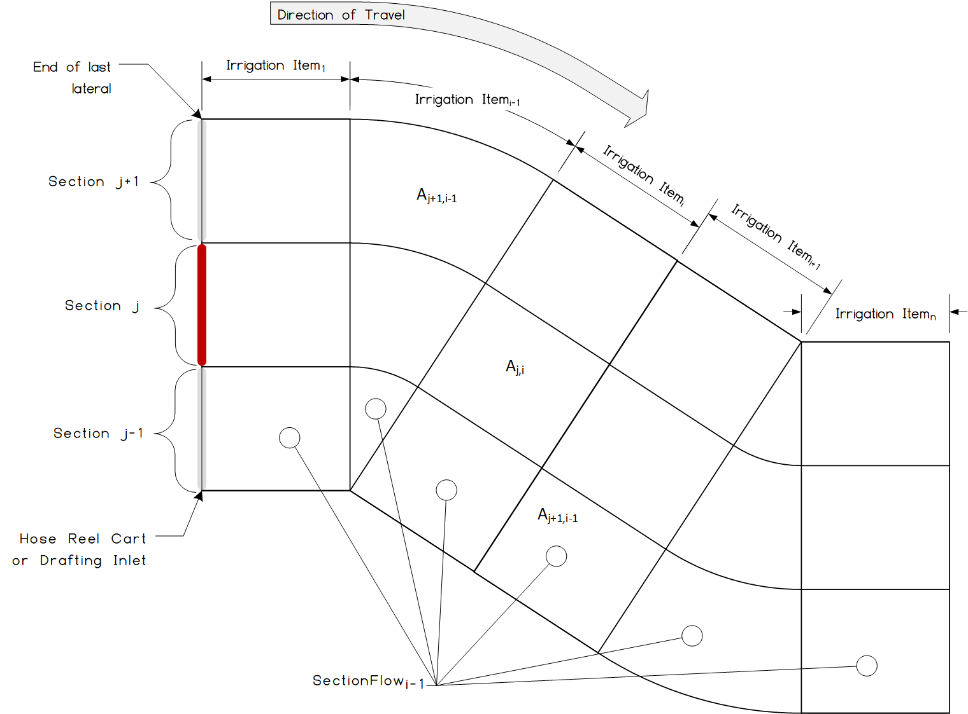

Figure 13: Schematic view of a Linear Move irrigation system following a curved path



Figure 14: WorkRecord structure corresponding to the Linear Move schematic view shown in the previous figure

### 7.1.7 Surface Irrigation

Surface irrigation is modeled similarly to drip systems in that it involves sections with shapes that are invariant over the course of an application of water, using a polygon representation for the geographic extent of the sections (rather than a radial shorthand usable in pivots).

In general (with the exception of paddy irrigation, which is covered in the following clause) the desired and actual applications of water are, as in the case of drip systems, specified in terms of a desired volume or depth of water; i.e., a representation centered on mass balance.

The following interpretation of Block and Set apply to surface irrigation:

**Block**: A subdivision of the total area of a field, irrigated by the system, and which can be controlled independently of other blocks. Control in this context refers to any mechanism that allows the irrigator to alter the flow of water, such as gates, valves, check structures, temporary dams, temporary ditches, and siphon tubes. Block boundaries shall use the SectionSetup.spatialFootprint property to specify spatial extent.

**Set**: A collection of one or more blocks within the same irrigation system that are irrigated together. The Blocks associated with a Set may change during an irrigation season.

When alternate furrow irrigation is used in the same Block, the same Block instance should be used for each irrigation event. If the data producer must document alternate furrow irrigation, two instances of Block, each having identical physical characteristics, shall be used. These two identical instances shall not appear in the same Set instance.

When tailwater recovery (also known as pumpback) is used, the data provider may specify the tailwater as a second WaterSource instance. If the tailwater is specified separately, the TAILWATER enumeration shall be used in the WaterSource instance. If the field has tailwater recovery and the tailwater is not specified separately, data consumers may assume that no off-field runoff occurred.

### 7.1.8 Paddy Irrigation

Paddy irrigation presents a special case of surface irrigation. While a paddy system can still be divided into one or more sections, the amount of water to apply is specified not necessarily in terms of volume, but in terms of a depth goal. In other words, water is added or removed until the specified goal is reached. This goal can be specified using a model analogous to that of the observations & measurements used in ISO 7673-2; in other words, a key-value pair where the key represents the meaning of the observation (e.g., depth of the water column), and the value is the numerical depth along with a code denoting the unit of measure.

The SectionFlow class has a property, waterLevel, which enables specification of the depth in the paddy. In a Recommendation or WorkOrder, the waterLevel value represents the recommended or prescribed water level in the paddy. In a WorkRecord, the waterLevel value represents the average waterLevel at the end of TimeScope of the sectionFlow’s parent IrrItem. Variable water level shall be documented with multiple IrrItem instances, each having non-overlapping timeScope, and having instances of sectionFlow with waterLevel values. In the context of paddy irrigation, the SectionFlow.vol property specifies the net volume of water delivered to the Block.

The following interpretation of Block and Set apply to paddy irrigation:

**Block**: A subdivision of the total area of a field, irrigated by the system, and which can be controlled independently of other blocks. Block boundaries shall use the SectionSetup.spatialFootprint property to specify spatial extent.

**Set**: A collection of one or more blocks within the same irrigation system that are irrigated together. The Blocks associated with a Set may change during an irrigation season.

Figure 15 and Figure 16 illustrate an example paddy field having six blocks. Figure 16 shows the conceptual document structure for a WorkRecord where all six blocks were irrigated and the waterLevel was constant during each IrrItem’s timeScope.



Figure 15 Example schematic diagram of a paddy irrigation system. Note that while generic valves are shown on the inlet and outlets (using ISO 15081 symbology), a head gate would be equally appropriate. The subdivisions of the field can apply in cases of open channel flow or pressurized systems.

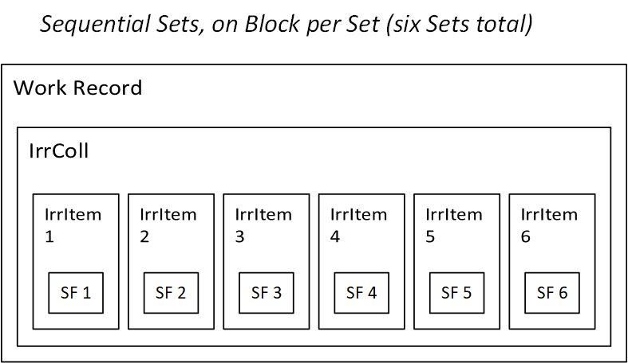

Figure 16 Document structure for the paddy system shown in the previous figure. The Work Record shows six sequentially irrigated Sets each having one Block per set.

Paddy irrigation requirements are often goal-based where the goal is a desired water level in the paddy and the goal has a time frame desired for achieving the targeted water level. For example, here is a potential work order and work record that represent the goal-based approach that is typical of paddy irrigation.

TODO: complete paddy example

* 0.3 Ha paddy area
* 10 cm desired water level (in work order or recommendation )
* Starting water level is 5 cm
* 3000 m2 X 5 cm = 150 m3 volume delivered (in work record)
* Include an explanation of efficiency as used in this context (not necessarily the same as nominal application efficiency as used in SystemSectionSetup)
* Work Order (or Recommendation) contains:
  + A single IrrItem having
  + TimeScope = 24 hours
  + SectionFlow.waterLevel = 10 cm 🡨 this is the goal
* Work Record contains:
  + IrrCollection containing three IrrItems (one for each 8 hour period) each having a waterLevel value representing the measured/observed water level at the end of the TimeScope
  + IrrItem #1 (containing one SectionFlow instance)
    - TimeScope = first 8 hours
    - SectionFlow.waterLevel = 7 cm
    - SectionFlow.volume = XX m3 (this volume could be slightly larger than the geometric volume, to accommodate efficiency)
  + IrrItem #2
    - TimeScope = second 8 hours
    - SectionFlow.waterLevel = 8.5 cm
    - SectionFlow.volume = XX m3 (this volume could be slightly larger than the geometric volume, to accommodate efficiency)
  + IrrItem #3
    - TimeScope = third 8 hours
    - SectionFlow.waterLevel = 10 cm
    - SectionFlow.volume = XX m3 (this volume could be slightly larger than the geometric volume, to accommodate efficiency)

TODO: paddy example of Alternate Wetting and Drying. See: <https://www.fao.org/family-farming/detail/en/c/1618095/>, see also <https://ghgmitigation.irri.org/mitigation-technologies/alternate-wetting-and-drying>

* Dry, in this context, means the soil is actually dry, not a zero water level

## 7.2 Description of Irrigation Record

The Section specification, by itself, is not sufficient to document irrigation operations. Standard compliant documents rely on the IrrColl, IrrItem, and SectionFlow classes to complete the documentation requirements. These three classes refer to the Section definitions and enable specification of an amount of water applied at a specific area, at a specific time by a specific subset of the irrigation system. These four facets (how much, when, where, by what) enable precise documentation or specification of water use. These facets are necessary for spatially explicit irrigation systems (i.e., Variable Rate Irrigation) and for accounting of chemigation and fertigation applications.

### 7.2.1 Irrigation Items and Collections

The IrrItem (4.6 Irrigation item) represents the time-varying physical state of an irrigation system. Properties specified by IrrItem apply to the whole system, and those properties are assumed to be constant over the time interval specified by the IrrItem. A complete irrigation record may contain a list of separate IrrItem objects. Each IrrItem may contain any number of SectionFlow objects described in the following section. Irrigation documents can further organize the IrrItems by grouping them into collections called IrrColl (4.5 Irrigation collection). These collections can also specify some of the time-varying physical properties associated with the irrigation system.

### 7.2.2 Section Flow

Records of irrigation applications are composed of a collection of objects that document the amounts of water (and other products) of an IrrItem, expressed by section. These items are called SectionFlow objects and are equivalent to a single application of water over a specific area during a specific window of time. Each SectionFlow object contains a reference to a Section instance. As an example, Figure 12 shows how each SectionFlow, along with the context from its parent IrrItem, can specify a specific area in a center pivot system. By including references to Sections, the SectionFlow enables compact specification of water application because all of the information that can be “factored out” is contained in the Section definition.

A SectionFlow describes how water and/or product was applied for a section described in the IrrSetup. The water applied is documented as the volume applied and/or in the irrigation depth that was applied over the described area. Either one is required; the other may be calculated by Volume = Depth  Area. Any other substance that is applied with the water is described in the ProductUse class.

### 7.2.3 Chemigation and Fertigation

Chemigation and Fertigation are handled with a trio of classes whose structure parallels the IrrItem and SectionFlow classes. ProductUse, ProductSummary, and Product classes each document a facet of the overall application of crop nutrition and protection products. These classes are not meant to control or direct operation of chemigation systems. Rather, these are only for documenting the use of a product or specifying the use of a product.

### 7.2.4 Hierarchical Structure

In the Standard irrigation documents, the SectionFlow, IrrItem, and associated objects appear in a hierarchical structure, as shown in Figure 17. The Reference Document, Irrigation Document, and Setup Document are shown as blocks containing sub-blocks corresponding to the various objects that make up the document. Arrows indicate which objects make reference to objects in parts of other documents. For example, the Section Flow object in the Irrigation Document makes reference to the Section object in the Setup Document. The hierarchy creates parent-child relations such that a child object always appears in the encapsulating context of the parent. Throughout the Standard irrigation records, there is an implicit assumption that the properties of the parent apply equally to all of its children. This enables efficient specification of operating parameters. For example, the IrrColl can specify the irrigation system’s pressure. This pressure applies to all of the collection’s child IrrItem objects and to all of the child SectionFlow objects. If one of the IrrItems included its own pressure value, that value applies only to that IrrItem and the IrrItem’s child SectionFlow objects. The IrrItem’s siblings would not need to specify pressure since they inherit this value from their parent IrrColl.

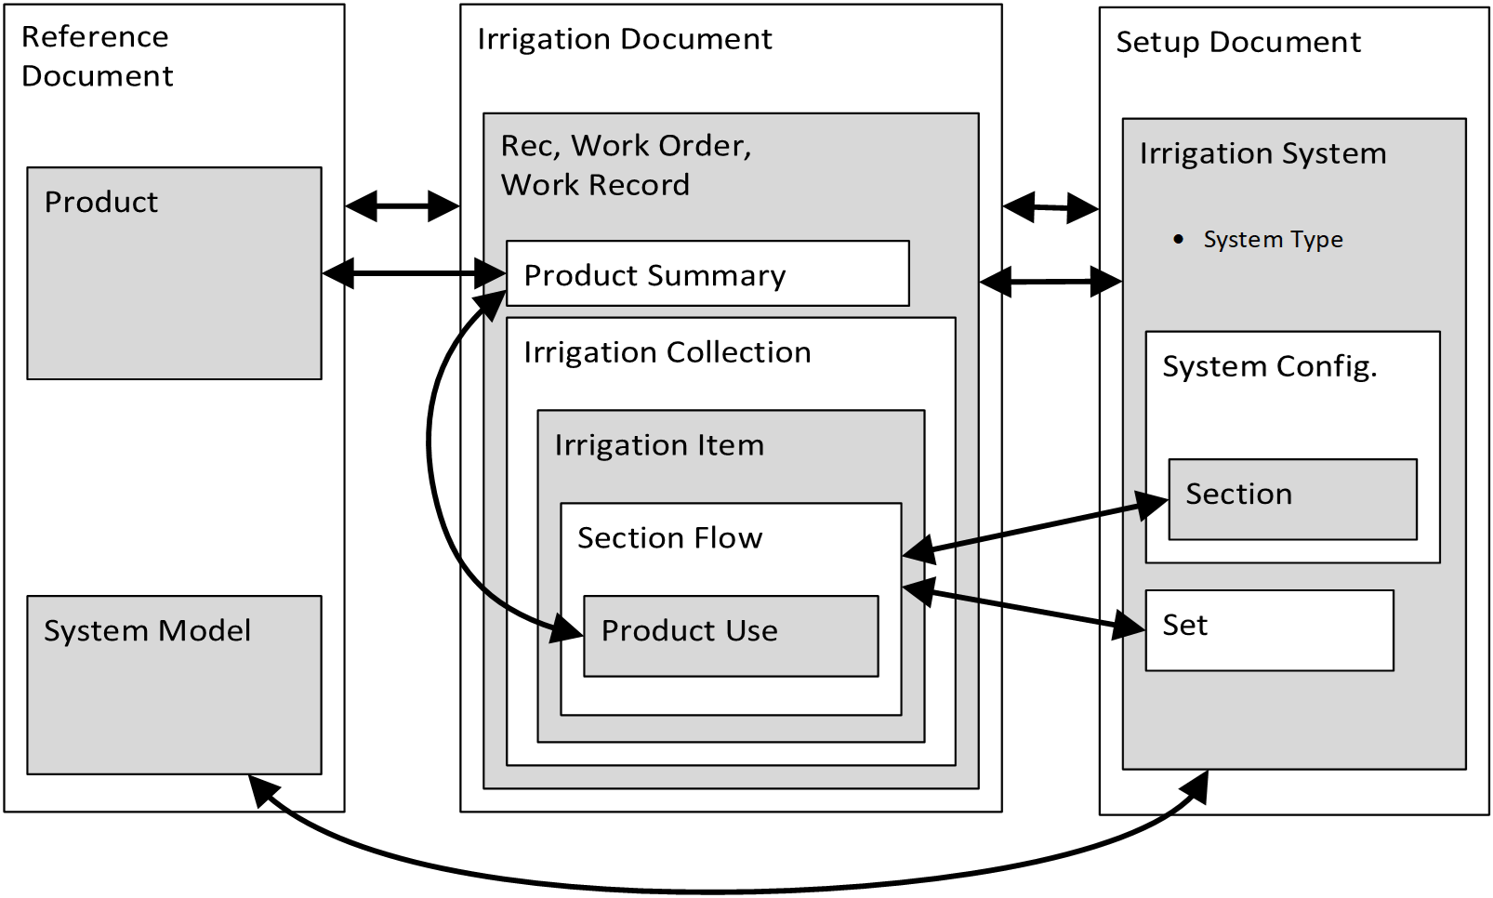

Figure 17 Relationships among document elements. The arrows indicate links between the document elements. Note how the Irrigation System class has an attribute called SystemType

A single document will typically contain at least one IrrColl, which contains at least one IrrItem, which contains at least one SectionFlow object. In the simplest case, a pivot would have only one Section definition. If the pivot makes one complete revolution and all the operating parameters remained constant (i.e., no speed changes or flow variations), then the irrigation document would contain a single IrrColl, containing a single IrrItem which itself would contain a single SectionFlow object. Annex A contains several examples that illustrate the different permutations and combinations possible with Section, Irrigation Collection, Irrigation Item, and Section Flow.

The same set of abstractions (Irrigation Collections, Irrigation Items, and Section Flow) are used in all documentation of irrigation applications regardless of whether the documents describe irrigations that should happen (Recommendations), irrigation that will happen (Work Orders), or irrigation that did happen (Work Records). There are arguably many other ways to represent irrigation records. The Standard uses this particular set of classes to meet three goals. The first is to maintain the efficiency of expression. The hierarchical structure between Irrigation Collections and Irrigation Items, along with the separation of Section definitions from documenting irrigation with Section Flow, both help reduced redundancy in irrigation documents. This efficiency means irrigation documents will be smaller and communication burdens minimized.

Second, the hierarchical structure along with separation of work orders, work records, and recommendations help to document the management process. As will be described in later sections, construction of irrigation documents is meant to reflect the management process. This enables consumers of these documents to differentiate between different management actions even if they result in the same quantity of water applied. The flexibility derived from separating documentation of management from documentation of water enables documentation of a variety of management processes.

Third, the classes and their relationships enable extensibility for future versions of the standard. As stated previously, this scheme is convenient for pivots and linear systems. The hierarchy enables inferring specific areas without explicitly delineating their geometric boundaries. However, in each of the classes where spatial information is relevant, the classes have optional properties for explicit specification of geospatial data. The hierarchical structure can be mapped to virtually any irrigation system and, by using spatially explicitly properties, Standard compliant documents can work with any particular geometry. The hierarchical structure assumes that the flow network is tree shaped (branches and nodes). The Standard will not work where the hydraulic system within the field boundary is a recurrent network. Recurrent networks are rare in agricultural irrigation systems, so this limitation was deemed acceptable..

# 8 Core Documents for Irrigation Operations

The Operations schema defines three core document types: Reference, Setup, and Irrigation records. These documents follow the core document structure defined in Part 1 of this standard. Some classes defined in Part 1 are only used in Part 3 (this part). This separation is intended to support subsequent versions of the Standard. Those classes defined in Part 1 were deemed general enough that they were likely to see use in other application areas that are not currently part of the Standard’s scope (e.g., pumping plants or chemigation systems).

Please note that the UML diagrams provided in each of the following sections contain details of class names, property names, types, and multiplicity. Unless otherwise noted, all class properties are optional.

## 8.1 Core Documents

In much of this standard, exchange of data is described as an exchange of messages or files. These two concepts are used interchangeably throughout the standard. The files themselves contain instances of the classes defined herein. The format of the contents of a message or file depends on the sterilization method. The standard generally assumes that the serialization will be either XML or JSON. However, no part of the standard explicitly requires either of these methods. Annex C contains example XML documents that use an XML Schema (an XSD file) that will be included in a separate standard.

## 8.2 Operations

This is the top-level container for all of the instances of reference, setup, or data records within a particular file. The Operations class has only one property: UoMAuthority. Specification of units of measure is detailed in Part 1. The UoMAuthority applies to all of the child objects of the Operations instance. This constraint requires that the same units of measure authority be used across the entire file or message. This constraint does produce some inconvenience when assembling documents from multiple sources. For example, when assembling a collection of Work Records and Recommendations derived from different sources, the sources might use different units of measure. In this case, the application assembling the combined document must convert all of the UoM specifications to a single authority. This constraint is intended to reduce the burden on consumers of files by allowing them to assume that the entire document uses the same unit of measure authority.

### 8.2.1 IrrRefData

This class contains information common to all instances of Manufacturers' equipment models and products. This represents data shareable (i.e., non-proprietary) across the whole industry.

### 8.2.2 IrrSetupData

Grower-specific information used to provide context for data exchange. For example, it is possible for a grower to set up data exchange with a partner such as a crop advisor by sending IrrSetupData.

### 8.2.4 IrrDocs

This class encapsulates a set of field operations-related documents: recommendations, work orders, and work records, as shown in Figure 18.

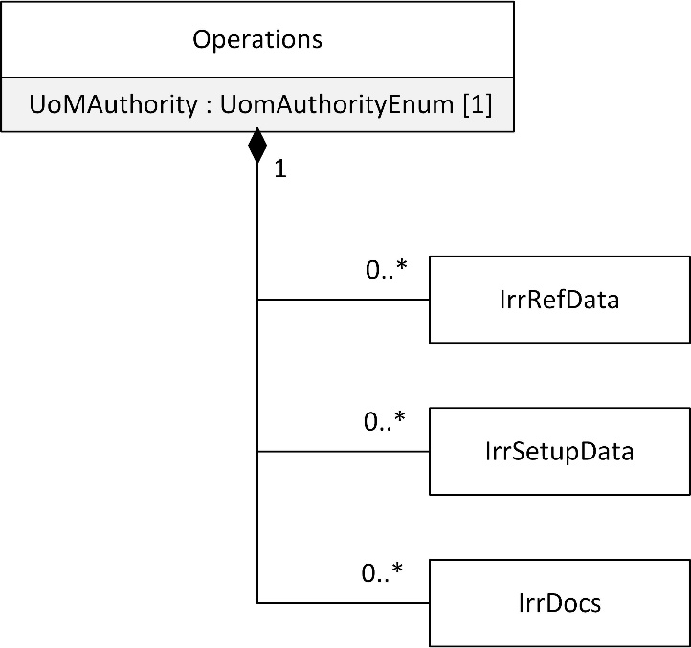

Figure 18 Operations document general class diagram

## 8.3 Document Structure

It is generally expected that a single file will contain instances of IrrRefData, IrrSetupData, and IrrDocs. As described in Part 1 of this standard, maintaining the integrity of irrigation documents requires durable association between the operations data and the setup data associated with those operations. There are some use cases where inclusion of Setup is inefficient, and the child classes of IrrDocs include a mechanism to address that inefficiency. Additionally, there are use cases where an abstract specification of a Recommendation is useful and, in that case, an Irrigation Setup (4.8 irrigation setup) information would not be required. Details can be found in Section 9 and in the implementation guide.

The document structure follows the same general structure and constraints as defined in 7673-1. A particular Operations document may contain any number or combination of IrrRefData, IrrSetupData, or IrrDocs objects. The following sections contain the detailed specification for each of these classes.

# 9 Reference Data

Reference data contains information common to all instances of Manufacturers' equipment models and products. This represents data shareable across the whole industry and is contained in the class IrrRefData. The UML diagram in Figure 19 shows the classes used in an IrrRefData document. Please note that many of the class properties have the same name as the class name of their type. The following sections provide details on each of the classes and their properties.

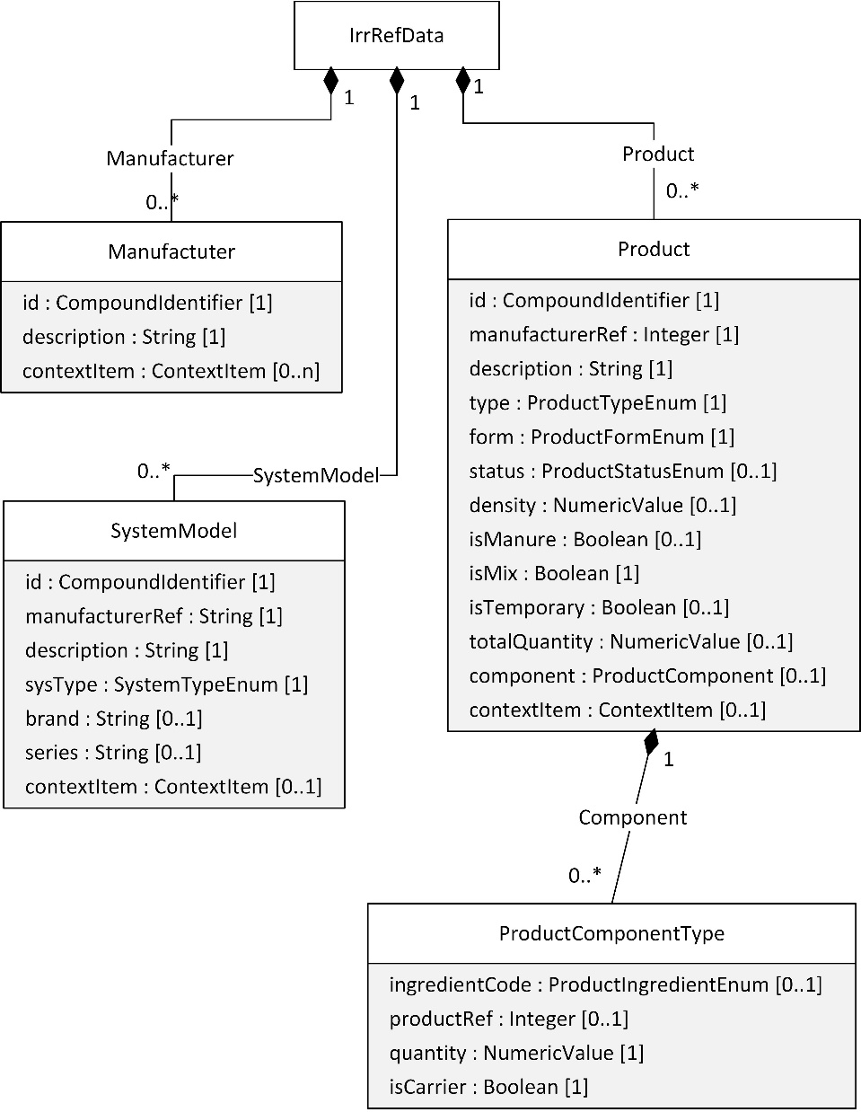

Figure 19 Operations reference classes

## 9.1 Manufacturer

The Manufacturer class contains reference data identifying a manufacturer of products or equipment.

**id** [1]**:** CompoundIdentifier for the manufacturer. The manufacturer's GLN can be represented as a ContextItem.

**description** [1]**:** Human-readable manufacturer name.

**contextItem** [0..1]**:** List of context items. These allow associating geopolitical-context-specific information to otherwise universal data types.

## 9.2 SystemModel

The SystemModel contains reference data describing a particular manufacturer-specific model of equipment.

**id** [1]**:** Compound identifier that establishes a "shorthand" value used to refer to this SystemModel in the scope of the document, along with a collection of unique ids that represent the system model in FMIS and other systems. The Id value must at least be unique within the scope of the document where it appears but the scope of the value’s uniqueness may extend beyond the scope of the document.

**manufacturerRef** [1]**:** Shorthand string id corresponding to the reference identifier of the system model's manufacturer's CompoundIdentifier Id.

**description** [1]**:** Human-readable name for the system model number; e.g., "E5000."

**sysType** [1]**:** Enumerated description of the type of irrigation system (pivot, linear, etc.). This property’s value is defined by the SystemTypeEnum. Takes on the following values:

Table 4 Enumerated values of the SysType property.

|  |  |
| --- | --- |
| Enumerated Value | Meaning & Interpretation |
| PIVOT | Irrigation system that rotates around a fixed center point |
| LINEAR | Irrigation system in which the span(s) traverse in a straight line |
| FIXED_ZONE | Irrigation system that does not move. This would apply to solid set, drip, sub-surface drip, and micro sprinkler systems. |
| TRAVELING_GUN | Irrigation system consisting of one nozzle/gun that moves through during use. |
| SET_MOVE | Irrigation systems that involve discrete movements but do not move during operation. This applies to wheel lines, hand lines, similar types of systems. |

**brand** [0..1]**:** Human-readable brand name (e.g., "Valley", "Zimmatic").

**series** [0..1]**:** Human-readable series name (e.g., "8000 Series").

**contextItem** [0..n]**:** List of context items. These allow associating geopolitical-context-specific information to otherwise universal data types.

## 9.3 Product

The Product class contains reference data describing a particular manufacturer-specific product to be applied through an irrigation system (e.g., a chemical or fertilizer). This class is defined in Part 1. The details of Product’s properties are repeated here for the reader’s convenience.

**id** [1]**:** Compound identifier for the product. Links to specific information about the product can be included via a URI within the CompoundIdentifier.

**manufacturerRef** [0..1]**:** Shorthand string id corresponding to the reference identifier of the product manufacturer's CompoundIdentifier Id.

**description** [1]**:** Human-readable name for the product.

**type** [1]**:** An enumerated value describing whether the product is a chemical, a fertilizer, etc. The "Mix" option refers to hybrid products where fertilizers and chemicals are mixed together. Otherwise, a mixture of multiple crop protection products would still be a crop protection product; a mixture of multiple fertilizer products would still be a fertilizer product; a mixture of a generic product with any other type of product would still be a generic product.

Table 5 Enumerated values of the Type property

|  |  |
| --- | --- |
| **Enumerated Value** | **Meaning & Interpretation** |
| GENERIC | A product that does not fit into any of the other three categories |
| CHEMICAL | A crop protection product |
| FERTILIZER | A crop nutrition product |
| MIX | A combination of two or more of the other three categories |

**Form** [1]**:** Indicates if the product a solid or a liquid

Table 6 Enumerated values of the Form property

|  |  |
| --- | --- |
| **Enumerated Value** | **Meaning & Interpretation** |
| SOILD | A product that is solid prior to injection into the water stream |
| LIQUID | A product that is liquid prior to injection into the water stream |

**status** [1]**:** Enumerated value that describes the status / availability of a product. Allows the management of drop-downs and other UI elements: e.g., an Inactive product would not be shown as available for use but is kept in order to not orphan existing records of that product's usage.

Table 7 Enumerated values of the Status property

|  |  |
| --- | --- |
| **Enumerated Value** | **Meaning & Interpretation** |
| ACTIVE | Currently being manufactured and in use |
| INACTIVE | No longer in use but still retained for recording purposes |
| RETIRED | No longer in use |
| NO_LONGER_SOLD | No longer sold but may still be in use |

**density** [0..1]**:** The density of the product. Uses the NumericValue type which includes a unit of measure.

**isManure** [0..1]**:** Set to True if this is a fertilizer product and it is manure.

**isTankMix:** Set to True if this product is defined as a mix of products, as opposed to a single product.

**isTemporary** [0..1]**:** Set to True if this is an ad-hoc product created by the grower.

**totalQuantity** [0..1]**:** Optional, allows for a mix to be specified in terms of mass or volume contributions. If the total product is specified this way (for example, 300 gallons of mix) and there are two components A and B that participated in the quantity of 30 pounds of A (a solid), and 60 quarts of B (a liquid), the amount of A and B that are applied as the mix, C, is applied by volume per time, or volume per area, or volume per volume of pivot water, can be easily back-calculated.

**component** [0..n]**:** List of zero or more ProductComponent objects that define the makeup of the product. Would usually not be present in a chemical product unless it were a mix. Would also not be present in a fertilizer unless the user was keeping track of the analysis / composition.

**contextItem** [0..n]**:** List of context items. These allow associating geopolitical-context-specific information to otherwise universal data types.

## 9.4 ProductComponent

The Component class defines the makeup of a Product. This class is typically only used for fertilizers.

**ingredientCode** [0..1]: Enumerated code that specifies that the component is; e.g., "N" for nitrogen. Should not be used together with ProductID (they are mutually exclusive).

Table 8 Enumerated values of the IngredientCode property

|  |  |
| --- | --- |
| Enumerated Value | Meaning & Interpretation |
| N | Nitrogen |
| P | Phosphorus |
| P205 | Phosphorus pentoxide |
| K | Potassium |
| K2O | Potassium dioxide |
| CA | Calcium |
| MG | Magnesium |
| S | Sulfur |
| B | Boron |
| CL | Chlorine |
| FE | Iron |
| MN | Manganese |
| MO | Molybdenum |
| ZN | Zinc |
| FULVIC_ACID | A highly soluble organic phenol found in humus that chelates elemental mineral nutrients. |
| HUMIC_ACID | A brown, melanin tinted mixture of polymers, found in lignite, peat, and soils, where it acts as a cation exchange agent |
| WATER | Dihydrogen monoxide |

productRef[0..1]**:** Used only when a product is defined in terms of other existing products. It should not be used together with IngredientCode.

quantity[1]**:** How does this component participate in the product? Includes a value and its unit of measure (UoM); the UoM is expected to be either a concentration (e.g., UN Rec 20 common code "59" for parts per million) or a quantity added to a tank (e.g., "GLL " for US Gallon, "KGM" for kilogram, etc.).

isCarrier[0..1]**:** Is this component the carrier for a mix? Typically, ingredientCode would be "WATER" if this value is set to True unless the carrier is a liquid fertilizer.

**contextItem** [0..n]**:** List of context items. These allow associating geopolitical-context-specific information to otherwise universal data types.

# 10 Setup Data

Figure 20 shows a UML diagram of the classes used to define setup and configuration, with a focus on water. (Classes relating to crop nutrition or protection are shown in Figure 19.) Please note that many of the class properties have the same name as the class name of their type.



Figure 20 Operations Setup classes

## 10.1 IrrSetupData

Grower-specific information used to provide context for data exchange. It is possible for a grower to set up data exchange with a partner such as a crop advisory sending IrrSetupData. The Grower, Farm, Field, Cropzone, FieldBoundary, Person, and PersonRole classes are all defined in detail in Part 1.

**grower** [0..n]**:** A list of zero or more Grower objects.

**farm** [0..n]**:** A list of zero or more Farm objects.

**field** [0..n]**:** A list of zero or more Field objects.

**cropzone** [0..n]**:** A list of zero or more Cropzone objects.

**fieldBoundary** [0..n]**:** A list of zero or more FieldBoundary objects.

**person** [0..n]**:** A list of zero or more Person objects

**personRole** [0..n]**:** A list of zero or more PersonRole objects.

**irrSetup** [0..n]**:** A list of zero or more IrrSetup objects.

**irrSystem** [0..n]**:** A list of zero or more IrrSystem objects.

## 10.2 Cropzone

Definition of a Cropzone that defines a subpart of a Field. Detailed description of Cropzone is found in Part 1. The properties are repeated here for the reader’s convenience.

**id** [1]**:** Compound identifier that establishes a "shorthand" id used to refer to this field in the scope of a document, along with a collection of unique ids that represent the Cropzone in FMIS and other systems.

**description** [1]**:** Human-readable name of the Cropzone.

**fieldRef** [0..1]**:** Optional shorthand id corresponding to the reference identifier of the parent field's CompoundIdentifier Id.

**timeScopes** [0..n]**:** Optional set of timestamps (encapsulated along with their meanings) that can be used to qualify the Cropzone.

**arableArea** [0..1]**:** Surface area of the Cropzone. Uses the NumericValue type which includes the units of measure.

**boundingRegion** [0..1]**:** The Cropzone boundary expressed as a WKT MultiPolygon.

**gNSSSource** [0..1]: Code from GNSSSourceEnum.

**contextItem** [0..n]**:** List of context items. These allow associating geopolitical-context-specific information to otherwise universal data types.

## 10.3 IrrSystem

Definition of specific irrigation systems, independent of setup.

**id** [1]**:** Compound identifier for each particular instance of an irrigation system.

**description** [1]**:** Brief, human-readable description of the Irrigation System. It is required since it is simple to auto-generate a description if needed.

**systemModelRef** [1]**:** Reference to a System Model defined in IrrRefData.

**systemType** [1]**:** Identifies what kind of system is being reported. This property’s type is SystemTypeEnum which is the same as the SysType property of the SystemModel class used in the Reference Data.

**contextItem** [0..n]**:** List of context items. These allow associating geopolitical-context-specific information to otherwise universal data types.

## 10.4 IrrSetup

Definition of the setup of a particular irrigation system (during an optionally specified time period). This type can also be used independently of a system, for hardware-independent recommendations and work orders. This is optional in order to accommodate an Operations file containing only abstract, hardware-independent recommendations and/or work orders.

**id** [1]**:** Compound identifier for each particular instance of an IrrSetup (defined in ISO 7673-1, Clause 8.1.1).

**systemRef** [0..1]**:** Reference to the irrigation system describe in IrrSystem

**systemLocation** [0..1]**:** Provides a geographical reference position for the system. Elevation is optional. This object is optional to accommodate abstract, hardware-independent recommendations and work orders. The purpose of the SystemLocation property is to define a geographic reference point. For systems where a “point” would be ambiguous, the point (if used) may be defined as a matter of convenience. The meaning of this point will vary depending on the type of system:

* Pivot: Center
* Linear: End of wheel track closest to the Northwest.
* Drip: the geographic position where the mainline first crosses field boundaries.
* For other systems one following points shall be used:
  + where the mainline crosses the field boundary,
  + the main valve or gate on the mainline,
  + the main pump or filter station for the field.

**growerRef** [0..n]**:** Reference to the grower(s) the irrigation system is associated with.

**farmRef** [0..n]**:** Reference to the farm(s) the irrigation system is associated with.

**fieldRef** [0..n]**:** Reference to the field(s) irrigated by the system.

**cropzoneRef** [0..n]**:** Reference to the Cropzone(s) irrigated by the system.

**sectionSetup** [1..n]**:** Describes how the irrigation system (or area to be irrigated, in the case of abstract, hardware-independent recommendations and work orders) is divided into sections. It is acceptable for a system to have only one section.

**spatialFootprint** [0..1]**:** When radial specification is present, it defines the angular range of the pivot (i.e. a partial circle). When a polygon is used, it is meant to represent the irrigated area of the whole system. Note that, unlike other places where SpatialScope appears, in IrrSetup the SpatialScope instance may contain instances of both RadialScope and MultiPolygonScope.

**FlowDataPedigree** [0..1]**:** Provides information about how the flow data is being generated.

Table 9 Enumerated values of the FlowDataPedigree property

|  |  |
| --- | --- |
| Enumerated Value | Meaning & Interpretation |
| FLOW_METER | Flow data is collected from a flow meter |
| HOUR_METER | Flow data is estimated from an hour meter |
| UNKNOWN | Flow's source is unknown |

**locationDataPedigree** [0..1]**:** Provides information about how the system location data is being generated.

Table 10 Enumerated values of the LocationDataPedigree property

|  |  |
| --- | --- |
| Enumerated Value | Meaning & Interpretation |
| SINGLE_GPS_WAAS | Location data provided by a GPS with a WAAS fix |
| SINGLE_GPS_BASIC_FIX | Location data provided by a GPS with a Basic fix |
| DIFFERENTIAL_GPS | Location data provided by a Differential GPS (DGPS) system |
| MECHANICAL | Location data is provided by an encoder, resolver, or other mechanical means |
| DESKTOP_GENERATED_DATA | Location data provided by desktop computer software |
| MANUAL_INPUT | Location data manually entered by a person |
| DRAWN | Location data provided from a drawing |
| OTHER | Location's pedigree is from another source |
| UNKNOWN | Location's pedigree is unknown |

**timeDataPedigree** [0..1]**:** Provides information about how the system event data is being generated. This can be useful in interpreting the perceived behavior of the system (e.g., a pivot appearing to speed up or slow down as a result of events being delayed but tagged with server time.)

Table 11 Enumerated values of the TimeDataPedigree property

|  |  |
| --- | --- |
| Enumerated Value | Meaning & Interpretation |
| GPS_ON_EVENT | Timestamp is taken from the GPS when the event occurred |
| DEVICE_CLOCK_ON_EVENT | Timestamp is taken from the device's internal clock when event occurred |
| SERVER_CLOCK_ON_EVENT | Timestamp is taken from the server when it receives the transmission from the device |
| DEVICE_CLOCK_ON_TRANSMISSION | Timestamp is taken from the device's internal clock when transmission occurs |
| UNKNOWN | Timestamp's source is unknown |

**timeScope** [0..1]**:** TimeScope allows data consumers to interpret the meaning of the Setup record. If the system can only keep track of one (the latest) setup, then there should be no EndDateTime specified; the same should happen if this is the current setup of a system. If this is a past setup and the start and end date/times are known, then they should be documented here. If the system does not know when this setup became valid, then this object should be skipped.

**systemLength** [0..1]**:** The overall length of the system. Useful for identifying systems and allocating water in FMIS.

**lengthUoM** [0..1]**:** units of measure for the SystemLength.

**areaTotalUoM**  [0..1]**:** Unit of measure of the total irrigated area covered by a recommendation, work order or work record.

**endgunSetup** [0..1]**:** Basic information of how the endgun is set up. It may contain a nominal value of the water applied or a table expressing where the water is applied by the endgun.

**nominalPressure** [0..1]**:** Minimum pressure value that constitutes the system as applying water.

**nominalEfficiency** [0..1]**:** Application efficiency as it applies to the whole system when no other section specific efficiency values are present and when no WorkRecord specific values are given.

**pressureUoM** [0..1]**:** Units of measure used for pressure values.

**pressureLocation** [0..1]**:** Physical location in the system where the pressure is being measured.

Table 12 Enumerated values of the PressureLocation property

|  |  |
| --- | --- |
| Enumerated Value | Meaning & Interpretation |
| AT_PUMP | Pressure value taken from near the pump immediately upstream of the system |
| AT_BASE_OF_SYSTEM | Pressure value taken from the base of the system. On a center pivot, this would be at the center point. |
| AT_END_OF_SYSTEM | Pressure value taken from the end of the system. On a center pivot, this would be at the last span. |
| UNKNOWN | Pressure location is unknown |

**nominalFlow** [0..1]**:** The nominal volume per unit time being delivered by the irrigation system.

**flowUoM** [0..1]**:** Unit of measure used to express all flows in the system (e.g., NominalFlow).

**depthUoM** [0..1]**:** Unit of measure used to express irrigation depth (e.g., within SectionFlow objects).

**waterTotalUoM** [0..1]**:** Unit of measure of the total amount of water applied.

**productRateUoM** [0..1]**:** Unit of measure used to express product (e.g., chemical or fertilizer) rate within SectionFlow objects.

**productTotalUoM** [0..1]**:** Unit of measure used to express total product (e.g., chemical or fertilizer) used within SectionFlow objects.

**note** [0..n]**:** An optional note, including free text, optional time, location, and person/role. The Note objects are meant to convey human-readable information relevant to the setup.

**description** [0..1]**:** Human readable description of the setup. Useful when multiple setups exist for the same system.

**waterSourceRef** [0..1]**:** A reference to the WaterSource instance representing the default water source for this IrrSetup instance.

**nominalFullCircleTime** [0..1]**:** The time that it takes a center pivot to make a full circle at maximum speed. Applies to Pivots only.

**bearingOffset** [0..1]**:** Offset to convert (additively) from bearing reported by machine to actual compass bearing. IMPORTANT: this offset, if nonzero, will also act on plans, recommendations, and not just work orders (this applies to *all* records). Applies to Pivots only.

## 10.5 EndgunSetup

Basic information of how the endgun is set up. The data expressed in EndgunSetup is the basic information needed to calculate application depth and wetted area when system pressure varies during operation. These calculations may be produced by applying appropriate hydraulic principles. This information is not intended for nor is it sufficient for calculation of spray losses. EndgunSetup may contain a nominal value of the water applied or a table expressing where the water is applied by the endgun.

**manufacturerRef** [0..1]**:** Shorthand id corresponding to the reference identifier of the endgun manufacturer's CompoundIdentifier Id.

**model** [0..1]**:** Human-readable model name.

**nominalValues** [0..1]**:** Nominal Values is where we would typically enter a nominal throw estimate and a nominal endgun flow estimate.

**tabluarValues** [0..1]**:** A list of Pressure, Throw, and Flow values that can be used to estimate wetted area or flow rate at various pressures. This is meant as a supplement to the NominalValues.

## 10.6 TabularValues

This optional table allows documenting the tabulated relationship between pressure and throw/flow in an endgun. The TabularValues class is composed of zero or more TableEntry objects.

## 10.7 TableEntry

Collection of entries describing how the endgun applies water.

**pressure** [1]**:** The independent variable. Expected to be expressed in the units of pressure specified in the system setup.

**flowValue** [1]**:** A dependent variable, used for water amount calculations. Assumed to be a value of volume per unit time, expressed in the flow unit of measure specified in the system setup.

**throwValue** [1]**:** A dependent variable, used to calculate applied area and effective rate. Assumed to be a value of distance, expressed in the corresponding unit of measure specified in the system setup.

## 10.8 SystemSectionSetup

Describes how the irrigation system is divided into sections. In the case of abstract, hardware-independent recommendations and work orders, SystemSectionSetup describes the area to be irrigated. It is acceptable for a system to have only 1 section. A detailed description of the Section concept is provided in 7.1 Describing Irrigation Systems and their Component Parts.

It is possible to specify an irrigated area in very abstract terms, without the need for a spatial footprint, as long as the irrigated area is a CropZone or field boundary specified in the IrrSetup. The spatial footprint shall either be expressed explicitly through SystemSectionSetup’s spatialFootprint or innerDistance/outerDistance, or implicitly by referencing the parent IrrSetup’s spatialFootprint, or the CropZone’s spatialFootprint, or the Field’s spatialFootprint. Instances shall not have no spatial definition, that is, there must be some specification, implicit or explicit, that defines the spatial extent of the wetted area. When the spatial extent is overspecified (i.e., when multiple spatialFootprint properties exist), the SystemSectionSetup takes precedence, followed by the IrrSetup, followed by the CropZone, followed by the Field. When a Recommendation, IrrWorkOrder, or IrrWorkRecord contain SectionFlow instances having polygonCoverage properties, the polygonCoverage takes precedence.

**sectionId** [1]**:** In pivots and linear systems sections are generally assumed to be contiguous (excepting some endgun scenarios); in pivot systems section 1 is assumed to be closest to the center. In linear systems (see 7.1.6 Linear Move systems), is the section with a wheel track intersecting the SystemLocation. In drip tape systems section numbers can be arbitrary. Traveling gun and stationary gun systems are assumed to have only one section.

**sectionType** [0..1]**:** SectionType is a complement to SystemType, in that it provides data consumers with information to support interpreting the data. SectionType is not relevant in systems that have only one type of section (e.g., Drip Tape, Traveling Gun, and Stationary Gun). These system types shall use the “FIXED” enumerated value. When sections are specified for the purpose of delineating a management zone (e.g., for Variable Rate Irrigation Systems), the SectionType identifies what type of part (or type of span) that the management zone is associated with. For management zones that span multiple section types, this property may be omitted. When the section is of a type that does not conform to any of the enumerated values, this value should be omitted.

Table 13 Enumerated values of the SectionType property

|  |  |
| --- | --- |
| Enumerated Value | Meaning & Interpretation |
| SPAN | A span on a pivot irrigation system. |
| END_BOOM | The portion of a pivot system that extends beyond the last tower. |
| END_GUN | The area covered by an endgun. |
| CORNER | A span that is articulated such that it can change its angle relative to the neighboring span. These are sometimes called Corner Arm or Swing Arm. |
| WRAP_BENDER | A secondary pivot point that is some distance from the primary pivot point. When the span reaches the secondary pivot point, the up-stream spans stop moving, and the downstream spans continue moving but now pivot around the secondary pivot point. The WrapBender is the span immediately downstream of the secondary pivot point. |
| FIXED | Any portion of the irrigation system that does not move during an irrigation event. |

**innerDistance** [0..1]**:** InnerDistance describes the distance from the proximal end of the section to the system reference point (e.g., pivot center). It is optional, and the meaning of its absence is context-dependent: a) In section 1, an absent InnerDistance is assumed to have a value of 0. In subsequent sections, an absent InnerDistance is assumed to take the value of the previous section's OuterDistance.

**outerDistance** [0..1]**:** In a single-section pivot system this value would equal the system length. Note that in a lateral system that has an endgun on the span of section 1, the corresponding endgun section would have an out-of-sequence number, a 0 InnerDistance, and a negative OuterDistance. This object is optional, to accommodate non-radial footprints.

**spatialFootprint** [0..1]**:** This property provides the ability to specify a static spatial footprint for a section. The interpretation of the spatial footprint will depend on the irrigation system type.

**nominalEfficiency** [0..1]**:** Default application efficiency for the section. When present, this value supersedes the system level application efficiency. When WorkRecord items specify efficiency, those values override this value.

**setReference** [0..1]**:** A reference to the Set which contains this Block. This is the default Set membership.

**cropZoneRef** [0..1]: A reference to a CropZone instance. When the CropZone instance has a value for boundingRegion, and the SystemSectionSetup does not have a value for spatialFootprint, the CropZone’s boundingRegion may be used as the spatial extent of the SystemSectionSetup.

## 10.9 WaterSource

The WaterSource class enables documenting water use from distinct sources. The WaterSource class is intended for basic tracking and accounting of water use from various sources. The WaterSource class is not intended as a complete accounting of water quality, regulations, or other aspects of conjunctive water use from multiple sources.

**id** [0..1]**:** The CompoundIdentifier that uniquely identifies this WaterSource instance.

**sourceType** [0..1]**:** The enumerated value that classifies the type of water source. Enumerated values are shown in table xx.

Table 14 Enumerated values of the SourceType property

|  |  |
| --- | --- |
| Enumerated Value | Meaning & Interpretation |
| UNKNOWN | Use this value when the source of the water is not known |
| OTHER | This value indicates that the source of the water is known and is not one of the existing categories. |
| GROUNDWATER | This value indicates that the water was pumped out of an underground aquifer |
| SURFACE | Water captured from a surface source such as a river, lake, or dam |
| MUNICIPAL | Water source managed (or provided) by a municipality (e.g, “graywater”, potable water). This does not include water (surface or groundwater) provided by an irrigation district or user community specifically formed to provide water to agricultural users. |
| TAILWATER | Water captured from surface runoff caused by irrigation or drainage. When this value is used, applications should assume that the volume of water is derived, indirectly, from another source arriving at or on the field. Assuming that TAILWATER is an entirely separate source will result in incorrect water balance calculations. |

**name** [0..1]**:** Human readable name of the WaterSource.

**description** [0..1]**:** Human readable description of the WaterSource.

**contextItem** [0..1]**:** List of context items. These allow associating geopolitical-context-specific information to otherwise universal data types.

## 10.10 Set

The Set class represents a collection of one or more blocks within the same irrigation system that are irrigated together. The blocks associated with a set may change during an irrigation season. Thus, a Set is an emergent property of the system’s management. Definition of Set instances is separated from the definition of the relationship between Set and Block. This separation enables changing membership during the irrigation season.

**name** [0..1]**:** Human readable name of the Set.

**description** [0..1]**:** Human readable description of the Set.

**contextItem** [0..1]**:** List of context items. These allow associating geopolitical-context-specific information to otherwise universal data types.

# 11 Irrigation Data

In the Standard, irrigation data encompasses records of what should be applied, called a Recommendation, what will be applied, called a Work Order, and what was applied, called a Work Record. The first part of this section describes these three documents and their intended use. These documents share many attributes in common. In the interest of brevity, the shared properties are described once. Following the common properties, each of the three document types is described in detail. The Irrigation Data section describes the classes that specify where, when, and how much water is/was/will be applied. The section ends with some implementation guidelines. Examples of the Irrigation Data can be found in Annex A.

## 11.1 Three Document Types

Irrigation Documents are described by the class IrrDocs. This class encapsulates a set of field operations-related documents: recommendations, work orders, and work records. Figure 21 shows a UML Class Diagram of the three document types and their associated classes. Please note that many of the class properties have the same name as the class name of their type. Capitalization is used to differentiate between classes and properties. The class descriptions do not use the “Type” appendix for the class names.

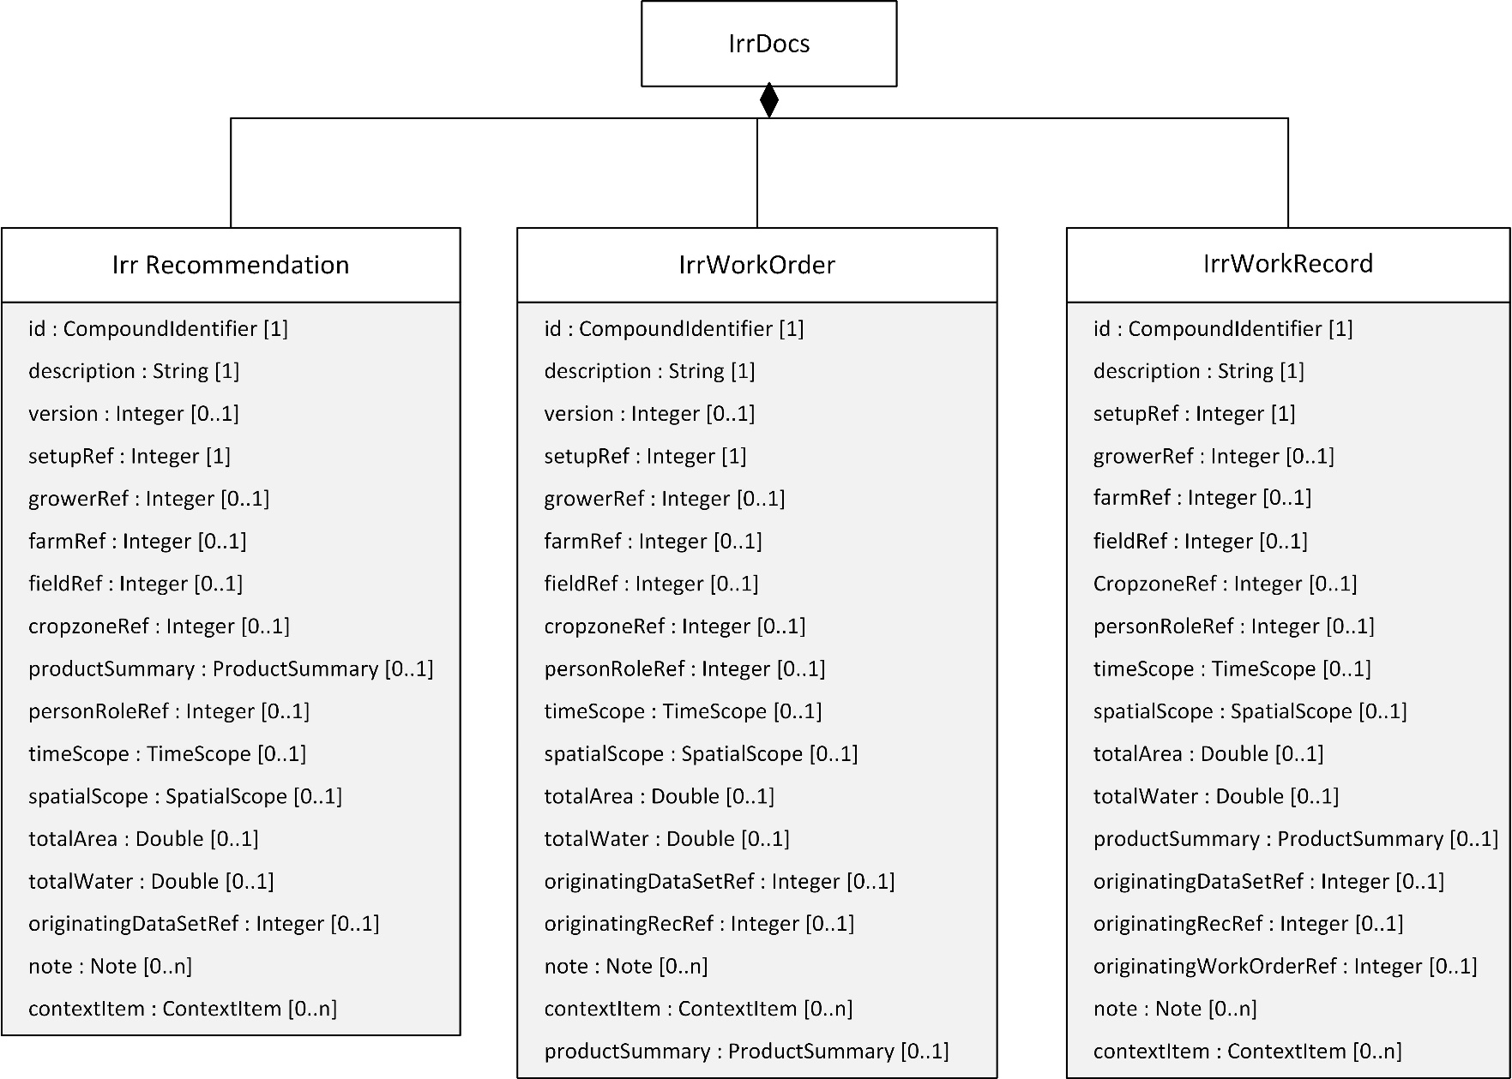

Figure 21 Class diagram of the irrigation data documents (see next figure for associated classes)



Figure 22 Class diagram of the irrigation data document’s associated classes

### 11.1.1 Shared Properties

Due to the nature of these documents, many properties are common across them. Unless specified otherwise, each of these properties appears in Recommendation, WorkOrder, and WorkRecord.

**id** [1]**:** Compound identifier described in ISO 7673-1. It is used to uniquely identify the documents and provide a short code that can be referenced by other documents in the collection.

**description** [1]**:** Brief, human-readable description of the document. It is required since it is simple to auto-generate a description if needed.

**note** [0...n]**:** An optional note described in ISO 7673-1. The note can include free text, optional time, location, and person/role.

**contextItem** [0...n]**:** Context Item described in ISO 7673-1. These allow associating geopolitical-context-specific information to otherwise universal data types.

**setupRef** [1]**:** This is the unique identifier of the IrrSetupData document that is used by the Irrigation Document and provides farm, field, person, or machine information.

**growerRef** [0..1]**:** Optional reference to the grower(s) the irrigation document is associated with.

**farmRef** [0..1]**:** Optional reference to the farm(s) the irrigation document is associated with.

**fieldRef** [0..1]**:** Optional reference to the field(s) the irrigation document is associated with.

**cropzoneRef** [0..1]**:** Optional reference to the Cropzone(s) the irrigation document is associated with.

**personRoleRef** [0..1]**:** Reference to a person/role combination relevant to this document.

**timeScope** [0..n]**:** This object describes the desired, planned, or actual start and end times depending on whether the document is a recommendation, work order, or work record, respectively.

**spatialScope** [0..1]**:** This object describes the spatial footprint of the records. For pivots specifically, we'd typically expect to see StartAngle and EndAngle. However, there may be pivots that do not have the means to tell their azimuth, so it is optional. In the case of a lateral, the spatial footprint of the observations would be expressed in polygon form.

**totalArea** [0..1]**:** Total irrigated area, or estimate thereof. The unit of measure is defined in the corresponding IrrSetupData document referenced by the SetupRef object. This area should not exceed that of the footprint of the system; i.e., if a recommendation describes two full revolutions of a 10-hectare center pivot, the TotalArea is 10 hectares, not 20.

**totalWater** [0..1]**:** Total amount of water to apply, or estimate thereof. The unit of measure is defined in the corresponding IrrSetupData document referenced by the SetupRef object. Also, this object enables abstract recommendations such as "Given X gallons of water, apply them to fields A, B, and C."

**originatingDataSetRef** [0..n]**:** Establishes an optional relationship with observations and measurements that informed the creation of the Recommendation.

**setupURL** [0..1]**:** A URL that links to a file containing the IrrSetupData instance that applies to the Recommendation, WorkOrder, or WorkRecord. This should only be used if the IrrSetupData cannot be included in the Operations file.

**version** [0..1]**:** Optional integer version number. Used to keep track of successive versions of the document during an exchange among different actors. This property is only used in the Recommendation and WorkOrder.

**productSummary** [0..n]**:** A list of ProductSummary objects.

### 11.1.2 IrrRecomendation

Recommendation (4.7 recommendation) document. Describes a course of action suggested by an actor with expertise. This may not always be acted upon; upon approval, it is acted on via a work order.

### 11.1.3 IrrWorkOrder

Irrigation work order document. Describes a course of action indicated by an actor with authority. In addition to the shared properties described previously, IrrWorkOrder has the following properties:

**originatingRecRef** [0..n]**:** Establishes an optional relationship with a recommendation that informed the creation of the Work order.

**statusUpdate** [0..n]**:** StatusUpdate objects are used when work records are provided prior to the completion of an irrigation event.

### 11.1.4 IrrWorkRecord

Irrigation work record document. Describes the water and products applied by an irrigation system; i.e., what actually happened in the field. In addition to the shared properties described previously, IrrWorkRecord has the following properties.

**originatingRecRef** [0..n]**:** Establishes an optional relationship with a recommendation that informed the creation of the Work order.

**originatingWorkOrderRef** [0..n]**:** Establishes an optional relationship with a work order that motivated the field operation being documented.

### 11.1.5 StatusUpdate

StatusUpdate objects are used when work records are provided prior to the completion of an irrigation event.

**status** [1]**:** Enumerated value of the work status

Table 15 Enumerated values of the StatusUpdate property

|  |  |
| --- | --- |
| Enumerated Value | Meaning & Interpretation |
| Canceled | Work Order Canceled |
| Scheduled | Work Order has not yet started |
| InProgress | Work Order has not yet completed |
| Paused | Work Order has started, but progress has stopped |
| PartiallyCompleted | Work Order has started but has not yet completed |
| Completed | Work Order has completed |

**comment** [0..1]**:** Optional human-readable comment regarding the status.

**timeStamp** [1]**:** Describes when the change of status occurred

### 11.1.6 Note

Provides a mechanism for tagging a document or setup object with one or more free-form annotations, including who made the annotation, where, and when. This class is defined in Part 1, and its properties are repeated here for the reader’s convenience.

**noteText** [1]**:** The free-form text of the note.

**timeStamp** [0..1]**:** Time when the note was created

**location** [0..1]**:** Location where the note was created. Uses the LocationType specified in Part 1.

**personRoleRef** [0..1]**:** The ID of the note’s creator

## 11.2 Irrigation Records

The IrrColl and IrrItem structures capture the spatial and temporal specification of individual water applications. These two classes are defined in the following sections.

### 11.2.1 IrrColl

A collection of one or more Irrigation Items. The IrrColl class maintains a hierarchical relationship with IrrItem. Both classes have several identically named property definitions. Properties specified by an instance of IrrColl apply to each of the IrrColl’s child IrrItem objects unless the IrrItem contains a different specification. When the child IrrItem objects have values for the members, the child’s values take precedence. It is allowed for only some of the child IrrItems to have properties specified. This optional specification enables greater efficiency of specification (i.e., smaller files) when some values vary occasionally. For example, if the irrigation system experienced a temporary pressure drop, then the IrrColl would contain the nominal operating pressure specified by the Pressure member, and one (or more) IrrItem objects would contain Pressure members with the lower pressure reading. The other IrrItem objects (the ones where pressure was nominal) would not need to have Pressure members present. IrrItem may redundantly specify IrrColl properties, but this is not recommended. If a particular property is not specified by either IrrColl or IrrItem, then that property’s value should not be inferred.

An IrrColl consists of the following properties

**id** [1]**:** Compound identifier described in ISO 7673-1. It is used to uniquely identify the documents and provide a short code that can be referenced by other documents in the collection.

**timeScope** [0..1]**:** Start date/time and End date/time for the irrigated collection. It's meaning will vary depending on whether it appears in a Work Record (observed times) or a Work Order (desired times). It is meant to act as an envelope for the TimeScopes of the IrrItems it contains.

**spatialScope** [0..1]**:** This property describes the spatial footprint that is covered by the irrigation collection. The RadialScope object expresses the start/end angle of a radial irrigated region. The InnerDistance and OuterDistance defined at the section levels and referenced via the section IDs, provide a very compact shorthand way of completing the representation of the spatial coverage of most pivot sections. Spatial coverage of pivot corner arms, pivot wraps/benders, laterals, and traveling guns shall be expressed as polygons at the section level. Spatial coverage of tape sections is defined in the section setup, so the section ID should suffice to describe coverage.

**flowTag** [0..n]**:** This is a simple mechanism for communicating information about the record: was the system chemigating? Was it fertigating? Note that, while chemigation and fertigation tags seem redundant in the context of product use reporting at the section level, the reality of irrigation monitoring systems at the time of this writing is that specific products can usually not be documented before the data is processed in an FMIS. These flags provide the FMIS operator with a warning that additional data entry is needed.

**pressure** [0..1]**:** Pressure value corresponding to the whole collection

**potCtr** [0..1]**:** Used to define a local center of rotation for the set of IrrItems contained in an IrrColl. This is useful for benders / wrap spans in a pivot.

**estimatedEfficiency** [0..1]**:** The estimated efficiency of this application. This value overrides the NominalEfficiency values given in the setup.

**contextItem** [0..n]**:** List of context items. These allow associating geopolitical-context-specific information to otherwise universal data types.

**waterSourceReference** [0..1]**:** A reference to the WaterSource instance that identifies where the water came from.

### 11.2.2 IrrItem

An IrrItem represents a single application of water. For a pivot, a single IrrItem corresponds to a single (possibly partial) rotation of the whole machine. For other system types, an IrrItem corresponds to a wetting of a specific area of the field. Each IrrItem contains a sequence of SectionFlow objects. Each SectionFlow object is associated with a single Section object specified in the Setup.

An IrrItem consists of the following properties:

**timeScope** [0..1]**:** Start date/time and End date/time for the irrigated region being described in this item.

**spatialScope** [0..1]**:** The spatial footprint described in this item.

**flowTag** [0..1]**:** See description of flow tag for the collection. This object is specific to the irrigation item.

**rotCtr** [0..1]**:** This property is specific to Pivots. The rotation center for this item. If left blank, the center defined in the setup should be used.

**pressure** [0..1]**:** The average pressure as recorded during the execution of Work Record within the scope of this particular IrrItem

**errorCode** [0..1]**:** This code, when present, indicates that an error occurred during the execution of the field operation described by the IrrItem. This error may be identified by the supplier of the data, or it may be identified during analysis by the consumer. This code applies to all of the SectionFlow objects in this IrrItem.

Table 16 Enumerated values of the ErrorCode property

|  |  |
| --- | --- |
| Enumerated Value | Meaning & Interpretation |
| Communication | Loss of communication or readings missing from this IrrItem |
| LowPressure | IrrItem contains pressure values that are below the nominal value defined in IrrSetup |
| Unspecified | Unspecified error occurred in this IrrItem |

**estimatedEfficiency** [0..1]: The estimated efficiency of this application for this particular section. This value overrides the EstimatedEfficiency specified for the IrrCollection and the values specified in the IrrSetup.

**contextItem** [0..n]**:** List of context items. These allow associating geopolitical-context-specific information to otherwise universal data types.

**waterSourceReference** [0..1]**:** A reference to the WaterSource instance that identifies where the water came from.

**sectionFlow** [1..n]**:** A collection of SectionFlow instances.

### 11.2.3 SectionFlow

The SectionFlow class is where the IrrItem and Section classes relate to each other. Each SectionFlow contains a reference to a specific Section definition and, by aggregation, a specific IrrItem. The combination of these two result in delineation of specific area of the field at a specific time. The SectionFlow also specifies an amount of water, specified either by depth or by volume. The SectionFlow objects, when combined with their related IrrItem and Section objects, completely specify an irrigation application.

The SectionFlow class serves another purpose in that it improves efficiency of specification. Data specified by Section changes infrequently. Time and depth of application are often different for each irrigation. The linear structure of pivots is such that many sprinklers will operate at the same time. By separating these facets, irrigation records will not need to repeatedly specify the same information within each document.

**sectionRef** [0..1]**:** Shorthand reference to the Id for the section, corresponding to the Ids declared for each section in SectionSetup of the IrrSetup.

**vol** [0..1]**:** Total volume (expressed in the VolumeUoM listed in the IrrSetup) of water applied to the section for this IrrItem. At least one of Vol and Depth must be present.

**depth** [0..1]**:** Irrigation depth applied to / desired on (volume / application area, expressed in the DepthUoM listed in the IrrSetup) the section for this IrrItem. At least one of Vol and Depth must be present.

**productUse** [0..n]**:** Describes the (observed or desired) use within this section of a given product specified by an ID which is matched by the ID of a ProductSetup record at the work record / work order level.

**polygonCoverage** [0..1]**:** This polygon documents the coverage area for a) irregular coverages on pivots such as corner arms and wraps/benders, b) laterals and c) Traveling guns. Although it can conceivably be used to document the coverage of pivot spans, using radial scope of the parent along with section number is much more compact. The PolygonCoverage class is described in ISO 7673-1.

**waterSourceReference** [0..1]**:** A reference to the WaterSource instance that identifies where the water came from.

**waterLevel** [0..1]**:** Relevant to surface irrigation, represents the desired (or achieved in the case of a Work Record) water level in the irrigated area, e.g., a paddy. Expressed in the DepthUoM listed in the IrrigSetupDoc. Vol and/or Depth can also be present, to represent the mass balance aspect; i.e., how much water must be added (positive) or removed (negative) to reach the desired goal.

## 11.3 Chemigation and Fertigation

The ProductSummary and ProductUse classes are used in conjunction to specify fertigation or chemigation. Figure 21shows a UML class diagram detailing the classes relevant to product application. Please note that many of the class properties have the same name as the class name of their type. In the UML diagrams, the type name is appended with the string “Type” so as to differentiate the property name from the type name. The class descriptions do not use the “Type” appendix for the class names.

When individual fertigation uses a tank mix of several products, then each individual product appears as a separate ProductSummary. A ProductUse object must appear for each ProductSummary when used in a SectionFlow. If no ProductUse appears, this indicates that no product was applied in the area associated with the SectionFlow.

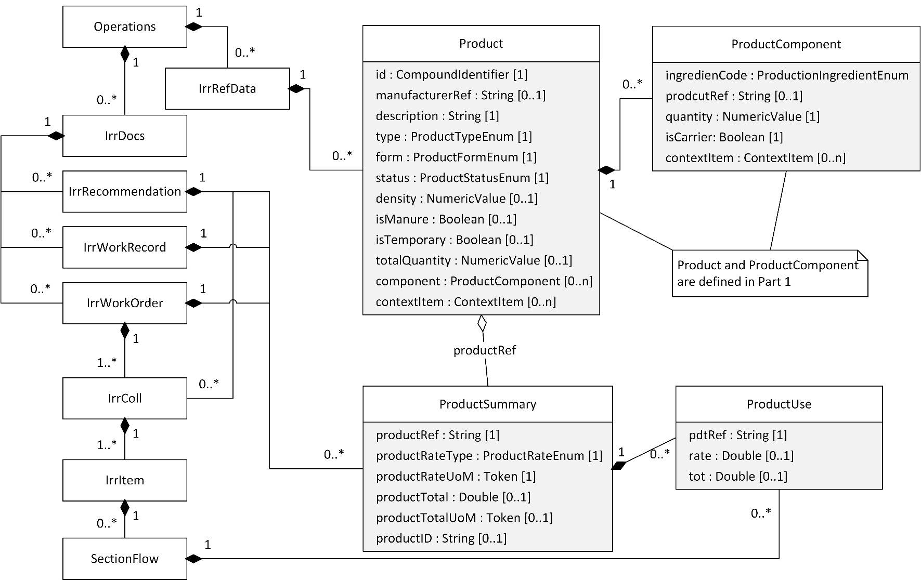

Figure 23 Classes for documenting product application

### 11.3.1 ProductSummary

Summary of the product and how it was or should be applied.

**productRef** [1]**:** This is a shorthand identifier for the product, that will be used in section flows. This value allows listing all the products that are used in the work record, and reference to them using the ID in the section flow records. The compound identifier it references can also include one or more unique IDs and a source (e.g., a GLN, GTIN, or a URI) for the product ID.

**productRateType** [1]**:** Explains how the product is applied and what to expect in terms of units of measure. The nomenclature corresponds to DDIs used by the ISO11783-10 standard, available at http://dictionary.isobus.net/isobus/ Note that if VolumePerTime and MassPerTime are used, these are expressed on a per SECTION basis in the SectionFlow objects, and would typically be equal to the system-wide injection rate only in a single-section system. Also, if there is a change in the water flow rate through the pivot (e.g., as an endgun is turned on/off) the effect of that change of water flow on product concentration (in the context of an assumed constant injection rate) must be taken into account.

Table 17 Enumerated values of the ProductRateType property

|  |  |
| --- | --- |
| Enumerated Value | Meaning & Interpretation |
| VolumePerArea | Volume of product applied to an area |
| MassPerArea | Mass of product applied to an area |
| VolumePerVolume | Volume of product applied given a volume of water |
| MassPerVolume | Mass product applied given a volume of water |
| VolumePerTime | Volume of product applied over a given amount of time |
| MassPerTime | Mass of product applied over a given amount of time |

**productRateUoM** [1]**:** code for the unit of measure used to apply the product, or an extension thereof. This unit should be convertible to the unit used in the corresponding ISO11783-10 DDI.

**productTotal** [0..1]**:** Total amount of the product applied over the scope of the document.

**productTotalUoM** [0..1]**:** code for the for the unit of measure used to describe the total product applied, or an extension thereof. This unit should be convertible to the unit used in the corresponding ISO11783-10 DDI.

**productID** [0..1]**:** Reference ID of the Product as define in the reference data.

### 11.3.1 ProductUse

This class enables expressing how much of a product (e.g., a fertilizer or crop protection product) was/should be used in a section flow. At least one of Rate or Tot should be populated.

**pdtRef** [1]**:** (required) Shorthand integer ID of a product. Should match the ID of a corresponding ProductSetup record under the parent Work Record / Work Order.

**rate** [0..1]**:** The meaning of this value should match the rate type specified in the ProductSetup record; i.e., if the ProductSetup record specifies, say, a volume per time rate, this Rate value should be in Liters per minute, or similar.

**tot** [0..1]**:** Total product used in this section during this observation. This total should correspond to the makeup (solid or liquid) described in the Product record.

# 12 Implementation Guidelines

The following section provides a set of general guidelines and examples intended to aid implementation of the Standard.

## 12.1 System Setup

* The collection of Sections must cover all portions of the System that emit water. Dry sections may be omitted.
* An individual collection of IrrItems (from a single Work Record) is not required to cover the entire wetted area of a particular field. When a partial covering occurs, SpatialScope objects (or equivalent radial notation for Pivots) must be present to show the wetted area. If no SpatialScope objects are present, consumers may assume that the entire area was irrigated. Areas not covered by SectionFlow objects are assumed to receive no water.
* All of the Work Records in a given time span must be adequate to account for all the water applied by the system in that time frame. A single document should not have gaps in reported water applications. If a gap in data exists, the document should be constructed with multiple Operation objects in the same file or as separate files.
* An instance of a SectionFlow object should not contain both radial and MultiPolygon specifications. The schema does not explicitly prohibit this, but having both would either be redundant or contradictory.
* The SectionFlow’s depth and area, or volume, combined with the TimeScope of IrrItem, should be equivalent to the total flow rate of the corresponding section. Consequently, the sum of all the SectionFlow objects should specify the total flow volume of the irrigation system over that time interval. When flow meter readings are not sufficiently close to the flow estimated from SectionFlow objects, this condition indicates a problem with one or more hardware or software components. The object model is not built to prevent or account for this kind of problem; business rules must be in place to do so.
* When a single IrrColl covers the entire irrigated area of the field (e.g., a complete circle inscribed in a square field), then all of the sections contributing water will be referenced at least once in the IrrColl.
* An individual SectionFlow may not overlap itself spatially. This constraint is particularly important for WorkRecords that contain multiple revolutions of a pivot.
* A pivot’s speed is assumed to be constant during the TimeScope of a single IrrItem. Variable-speed systems will have separate IrrItem instances for each speed change. This constraint applies to Linear systems also.
* The IrrItem’s TimeScope, and spatial scope, combined with the full-circle time at maximum speed specified in the setup, will be sufficient to estimate the pivot’s percent speed setting for pivot controllers that use this type of control.

## 12.2 Document Structure

A common practice with pivots involves running the system continuously for several revolutions. This practice presents some ambiguity regarding how to represent the revolutions as IrrWorkRecords. It is possible to represent these revolutions as multiple work orders with individual IrrColl items, or a single WorkOrder with multiple IrrColl objects for each rotation. The Standard is derived from management practices, specifically the business process associated with agricultural production. Whenever there is ambiguity about how to represent irrigation, the preferred approach is to structure the documents so that they represent how the management process was executed. The number and association of Recommendation, WorkOrder, and WorkRecord should reflect how the management process manifested into action. The following three scenarios illustrate how the management process defines document structure.

Example A: *The consultant recommends application of one inch starting on a specific day on a field that typically would receive multiple continuous revolutions. As the pivot nears its starting point, the manager, who is accustomed to multiple revolutions, has not* received any more recommendations from the consultant or work orders from the farm owner. The manager concludes: “They didn’t tell me to turn it off, so I’ll keep it running.”

In this scenario, only one Recommendation and one WorkOrder exists. No other management messages were exchanged. There should be one WorkRecord containing multiple IrrColl objects; one for each revolution.

Example B: *The consultant recommends application of 2 inches per week for the next four weeks. The manager set the pivot speed for a 3.5 days per rotation, applying 1 inch per pass. The manager leaves the pivot running continuously for 8 rotations (28 days total runtime).*

In this scenario, only one Recommendation and WorkOrder were exchanged. No other management actions occurred. The WorkRecord should contain one IrrColl with multiple IrrItem; at least one for each rotation.

Example C: *The consultant recommends a 1-inch application, starting as soon as possible on a field that typically runs continuously for multiple revolutions. As the pivot nears its starting point, the consultant recommends to keep the system running. The manager leaves the pivot running as recommended*

In this scenario, there are two Recommendations and two WorkOrders. There should also be two WorkRecords, one for each rotation of the pivot, each containing a single IrrColl.

It is not exactly possible (or intended) to deduce the exact management process based on a set of irrigation records. The relationship between the process and document structure is intended to guide construction of the documents, not necessarily to be an exact documentation of the process.

It is important to note that pivot and linear movements which do not include application of water, are not relevant to the Standard. It is possible to construct IrrItem & SectionFlow objects with zero depth of applications. However, this capability is not intended to represent moving the pivot for reasons unrelated to irrigation (e.g., to move equipment during harvest). This constraint applies to all moveable irrigation system types.

## 12.3 Irrigation Records

* Pressure is assumed constant within the time scope of an IrrItem. It is appropriate to use multiple IrrItems to report variations in pressure, flow rate, speed, or any other reportable variable.
* Two SectionFlow objects within the same IrrItem must not overlap in time and space. This would be an over-specification of water application with potentially contradictory water amounts.
* The reader may note that neither IrrItem nor SectionFlow contain a percent speed or percent depth property that would normally be associated with pivot controls. The IrrItem’s TimeScope should, given full-circle time at maximum speed in the system setup, be sufficient to estimate the percent speed of the pivot. Although percent speed is common among different pivot control systems, it is not used consistently across the industry and is tightly associated with the control system itself. For these reasons, percent speed was not included in the Standard. Given a fully specified IrrSetup, IrrColl, and IrrItem, it should be possible for an FMIS to deduce the speed setting for the given IrrItem.
* Tabular style reporting of pivot operation is a common practice among data providers. The Standard’s documents are not explicitly tabular in their structure, but an equivalent interpretation exists. Generally speaking, there are two types of tabular reporting 1) where each row is an event or current state of the system or 2) where each row is an angular range.
  + For type 1: the IrrItem objects correspond to pairs of rows and the pressure, depth, and volume correspond to what happened between the two reported events. For systems that use this type of reporting, the implementer has discretion on how to report a change in state. However, the volume, depth, and time span of a collection of IrrItems should equal the same volume, depth, and time span associated with the source data.
  + For type 2: the rows correspond directly with IrrItems
* For VSI systems that employ repeated passes over the same area (i.e., wiping back and forth), each pass must be represented as a separate IrrItem
* When constructing Irrigation Data for VRI or VSI, two options are possible: 1) use the SectionSetup and SpatialScope in combination (this requires SectionSetup for each sprinkler or group of sprinklers) or 2) use the PolygonCoverage for each management zone.
  + Option 1 can result in a large number of SectionSetup objects, but generally will result in smaller WorkOrders. This approach also means that the number of zones is partially fixed (always a multiple of the number of SectionSetups), but the geometry of the resulting coverages is conveyed accurately, without the need to specify a point density.This approach is preferred.
  + Option 2 provides the greatest flexibility in specifying management zones but can quickly produce large files depending on the spatial complexity of the management zones. Each zone will appear as an individual IrrItem with a SpatialScope object having Polygon coverages. The disadvantage with this approach occurs when large numbers of management zones appear in the prescription. There is an additional complication that when the management zones span multiple SectionSetup objects, the management zones must be split so that they do not cross SectionSetup partitions. Additionally, accurately representing curved pivot areas will require a high point density, and therefore the application of this option either results in large amounts of data (in the case of a high point density), or inaccurately specified spatial coverage (in the case of low point density). This approach is discouraged.
* For VRI systems that prefer to specify prescriptions using angles and distances (i.e., a polar grid), the most efficient solution is to provide a SectionSetup object for each sprinkler or group of sprinklers that are individually controllable. For example, a pivot with 10 groups would have 10 SectionSetup objects. Prescriptions would then use one IrrItem per angular range with n SectionFlow objects for each IrrItem. In this way, each SectionFlow corresponds to a single grid cell in the polar grid, and it only needs to contain the depth (or volume) and SectionRef.

## 12.4 Consideration for Structure and Interpretation

### 12.4.1 Variable Rate Irrigation in Pivots

Implementers have some discretion in how to organize the IrrColl, IrrItem, and SectionFlow objects in irrigation documents. The following example illustrates how different interpretations can lead to different but equally valid representations. Figure 23 shows a recommendation for a VRI system with three zones. The consultant who generated the prescription did so solely based on conditions observed in the field. The areas requiring irrigation were delineated using polygons. VRI zones are, generally speaking, homogeneous such that the zone receives the same application rate within the zone. The VRI system cannot match the polygon shapes exactly so the irrigation manager must interpret the recommendation based on the VRI system’s capabilities.

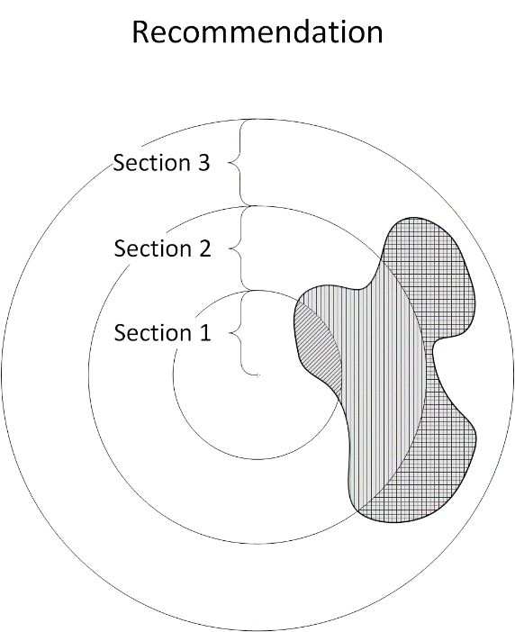

Figure 24 A VRI Recommendation

Figure 24 shows a Work Order that is intended to implement the recommendation shown in Figure 23. This prescription has four IrrItem objects with one SectionFlow object in each IrrItem.

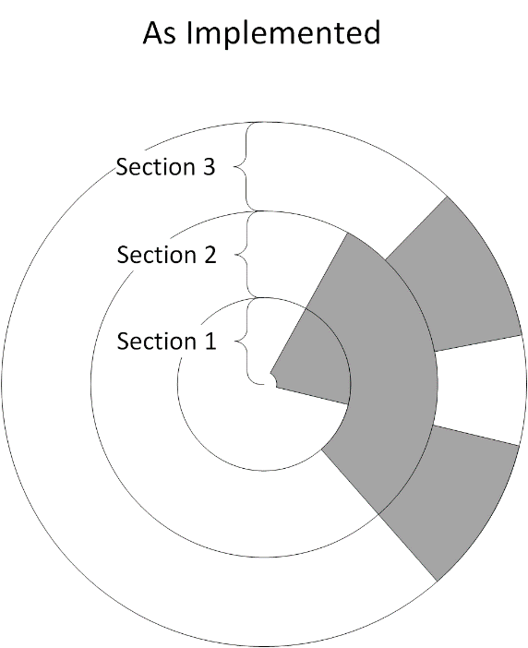

Figure 25 The WorkOrder created by the operator from the VRI prescription of the previous figure.

If this WorkOrder were sent to a pivot control system, there are multiple ways that the system could report the WorkRecord. Two potential examples are shown in Figure 25 and Figure 27.

Option 1 is shown in Figure 25 and Figure 26. The WorkRecord follows the same structure used in the WorkOrder, in which the state transitions of the different sections happen independently, and each SectionFlow can have its own start and end angles, because the IrrItems contains only one SectionFlow object each. This structure is convenient because of its similarity to the WorkOrder and because of its size. The structure is inconvenient because the IrrColl contains IrrItem objects that are irregularly spaced in time such that the WorkRecord does not easily document the variations in flow rate associated with VRI.

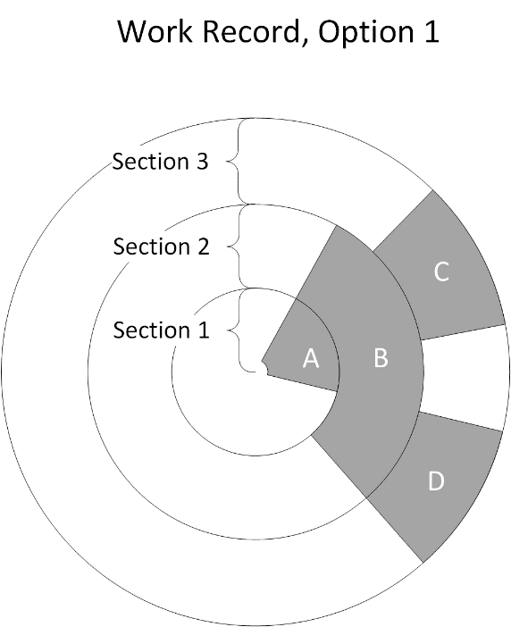

Figure 26 The VRI WorkRecord, option 1

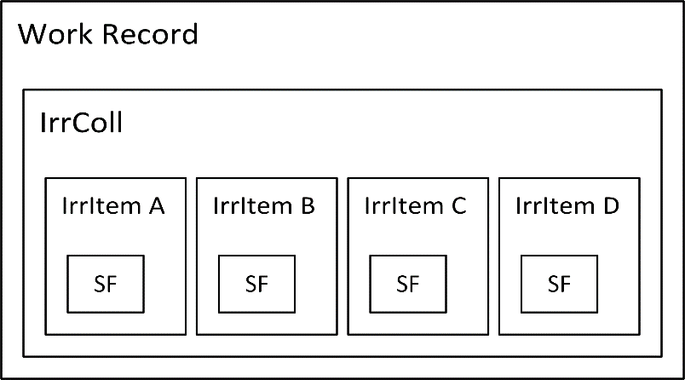

Figure 27 Structure of the WorkRecord for option 1

Option 2, shown in Figure 27 and Figure 28, uses a structure more congruent with how VRI systems typically report water application: there are four IrrItems, but the subdivisions are based on angular displacement rather than spatial contiguity. A consequence of this discretization is that differing numbers of SectionFlow objects appear in each IrrItem, but the start and end angles (and times) for all the SectionFlows irrigating a given azimuth angle are the same.

This form, while more verbose than Option 1, is preferred. It is convenient in that the operational parameters are constant within individual IrrItem objects (e.g., the flow rate is constant). It is inconvenient because the files are larger and the structure may not match the WorkOrder.

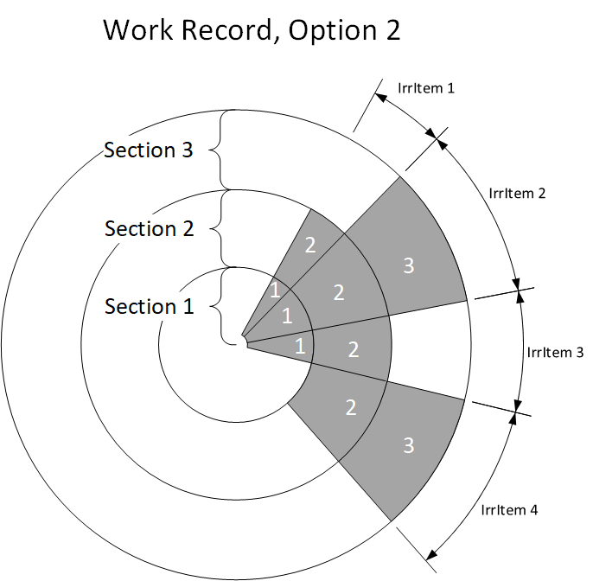

Figure 28 The VRI WorkRecord, option 2

Figure 28 shows the structure of the Irrigation Data for the WorkRecord shown in Figure 27. Note that some areas are not covered by SectionFlow objects. Areas not covered by a SectionFlow object are assumed to not have received any water.

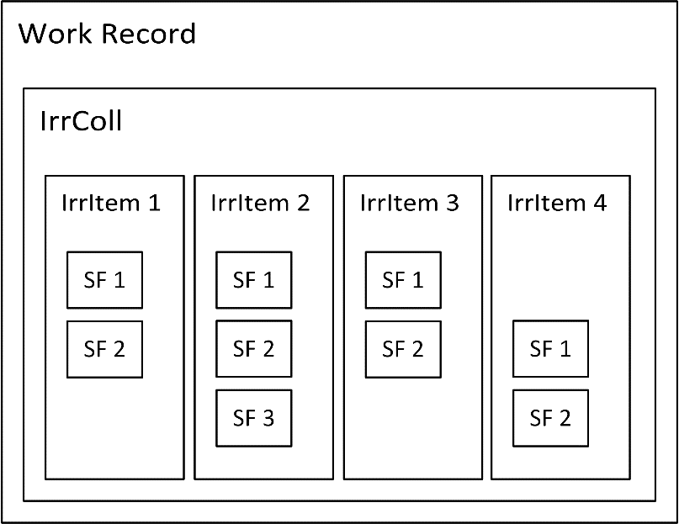

Figure 29 The VRI WorkRecord, in preferred form

The preceding example also illustrates the value of including Setup information along with the IrrDocs. In the example, the Recommendation was generated based solely on field observations and was expressed as an abstract (i.e., machine independent) prescription. A side effect of enabling machine independence is that consumers may not immediately recognize incompatibilities between Recommendations and system hardware. This Standard does indirectly and directly stipulate some congruence between the Setup and IrrDoc. Specifically, SectionFlow objects must contain a reference to a Section object. Guidelines for using SectionFlow objects stipulate that the spatial extent of individual SectionFlow objects may not span the spatial extent of multiple Section objects. Using these constraints, an FMIS can detect some, but not all, possible incompatibilities between Recommendations and machine capability.

### 12.4.2 Guidelines for Drip Irrigation

The following section illustrates the relationships between drip irrigation systems and the encoding of IrrColl & IrrItems in ISO 7673-3 WorkRecords. Drip systems are typically subdivided into Blocks using valves and other components such that the Blocks can be irrigated separately. As described in 7.1.1 Drip Irrigation Systems and their Component Parts, groups of Blocks are called Sets and the grouping can change from year to year or within a single season. The three examples described below are each based on the same drip system design shown in Figure 20, which represents the same system shown in Figure 2. This system is a single field with six Blocks.

Example 1: A typical constraint in Drip system operation occurs when the instantaneous flow rate is not sufficient to irrigate the entire field at the same time. Instead, portions of the field are irrigated separately so that the system flow is applied over a smaller area and the application rate is higher than it would be if the whole field were irrigated simultaneously. A typical strategy to address this constraint, and the reason for subdividing the field into Blocks, is to irrigate half of the field at a time. The WorkRecord, shown in Figure 21, illustrates how to document this strategy. The Field is divided into two Sets, denoted by the blue and green highlighting. The WorkRecord, which documents a single covering of the entire field, is composed of a single IrrColl instance containing two IrrItems. Each IrrItem is composed of the three SectionFlow instances. As the color indicates, the first Set contains Blocks 1, 2, & 3, and the second Set contains Blocks 4, 5, & 6.



Figure 30 Schematic view of a Drip irrigation system having six Blocks. The two Sets are indicated by the blue and green highlighting.



Figure 31 A WorkRecord having two Sets, with three Blocks per set.

Example 2: In many groundwater dependent regions, flowrates decline over the course of the season as groundwater levels decline. Crop water demands also tend to increase during the peak of the growing season. Drip systems with multiple blocks can accommodate these constraints by changing the Sets. Figure 22 shows the same field as Figure 20, but subdivided into three sets instead of two. By using fewer Blocks per Set, the instantaneous flowrate is lower (because a smaller area is being irrigated simultaneously). Figure shows the Work Record from a single covering of the field. The WorkRecord has a single IrrColl with 3 IrrItems, each corresponding to a single Set, and each IrrItem has 2 SectionFlow instances corresponding to the two Blocks that make up the Set.



Figure 32 A Drip system with six Blocks and three Sets. The Sets are shown with different colours.



Figure 33 A WorkRecord corresponding to the Sets shown in the previous figure. Each Set has two Blocks.

Example 3: Another common (and unfortunate) scenario with water limited systems occurs when the instantaneous flow of the whole system declines below the level needed to adequately irrigate the crop. In this situation, abandoning a portion of the field may be necessary and Figure & Figure illustrate this scenario. Half of the field is abandoned (white areas), and Blocks 1, 3, & 5 are still irrigated. The corresponding WorkRecord, shown in Figure , contains a single IrrColl with three IrrItems, corresponding to the three Sets, and each Set contains a single SectionFlow instance which represents the single Block in each set.



Figure 34 A Drip irrigation system with six Blocks, three of which are not irrigated.



Figure 35 A WorkRecord having three Sets, three Blocks not irrigated.

The previous three examples are meant to illustrate the following guidelines for drip systems:

* IrrItem corresponds to Sets
* SectionFlow corresponds to Blocks
* All of the SectionFlow instances within a single IrrItem are irrigated at the same time
* A single IrrColl roughly corresponds to a single covering of the field

These guidelines are slightly different from the Pivot based example in the previous section. The VRI example shown in 12.4.1 Variable Rate Irrigation in Pivots indicates that simultaneous SectionFlows (i.e., areas wetted at the same time) are not required to be grouped in the same IrrColl instance. The same is true for Drip systems. However, because SectionFlow instances do not include TimeScope properties, it is considered best practice to group SectionFlows with identical times into the same instance of IrrItem, and IrrItems contained by an IrrColl should not have overlapping TimeScope. This is considered a best practice. Overlapping TimeScope is permitted and is only recommended where a more compact WorkRecord is necessary.

Annex A  
(informative)  
  
UML Examples

## A.1 Example 1

The following example shows a complete set of Reference, Setup, and Irrigation Documents. The irrigation records include a WorkOrder and associated WorkRecord. The example shows a 7-span pivot with zone control VRI where each span is a single zone. Because of its size, the diagram is split into 4 parts. The first part, Figure A.1, shows only the top-level objects. The three following figures, Figure A.2, Figure A.3, and Figure A.4 show the Reference, Setup, and Irrigation Document objects respectively. Note that while the descriptions refer to the Reference, Setup, and Irrigation data as separate “documents’, they would typically all reside in the same file.

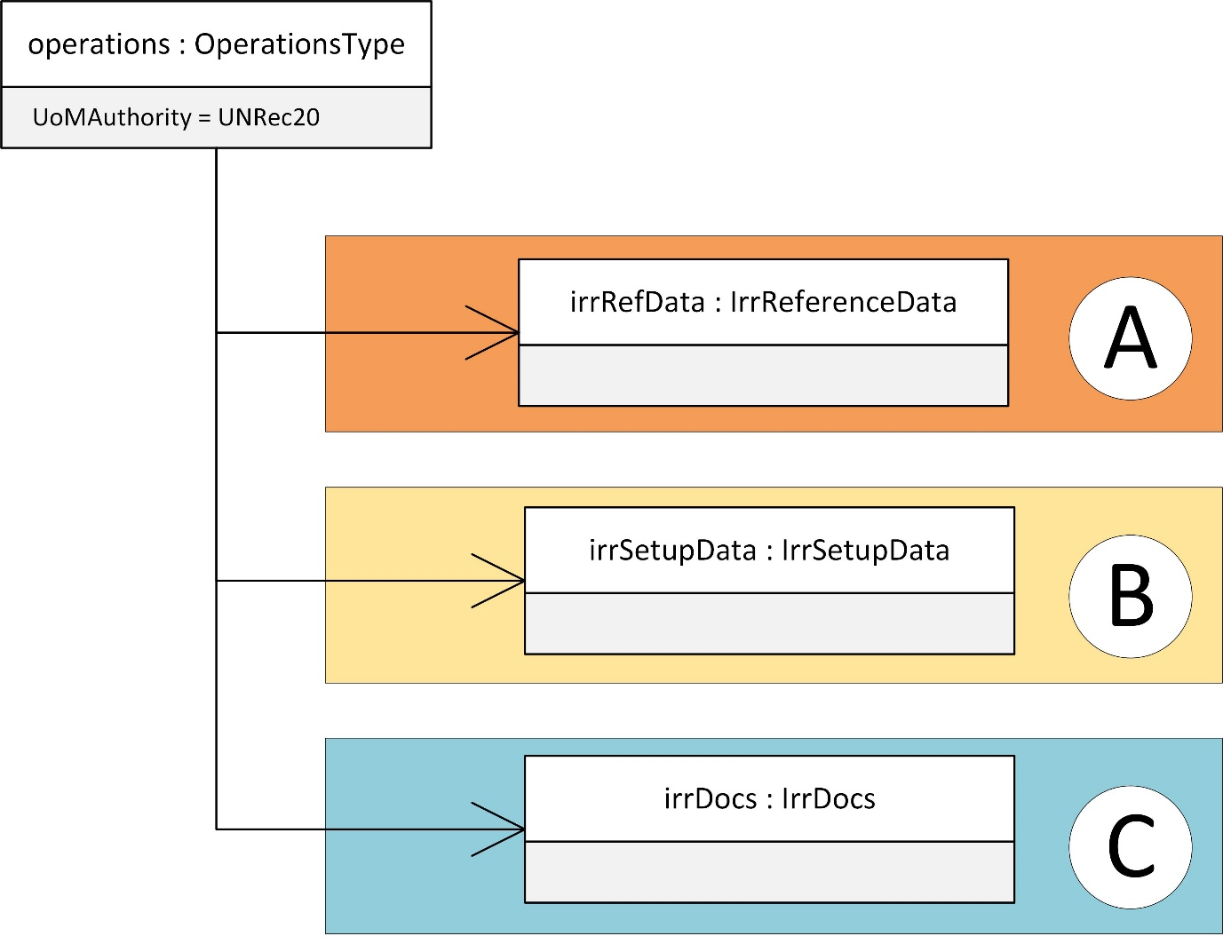

Figure 36 Example 1 overview

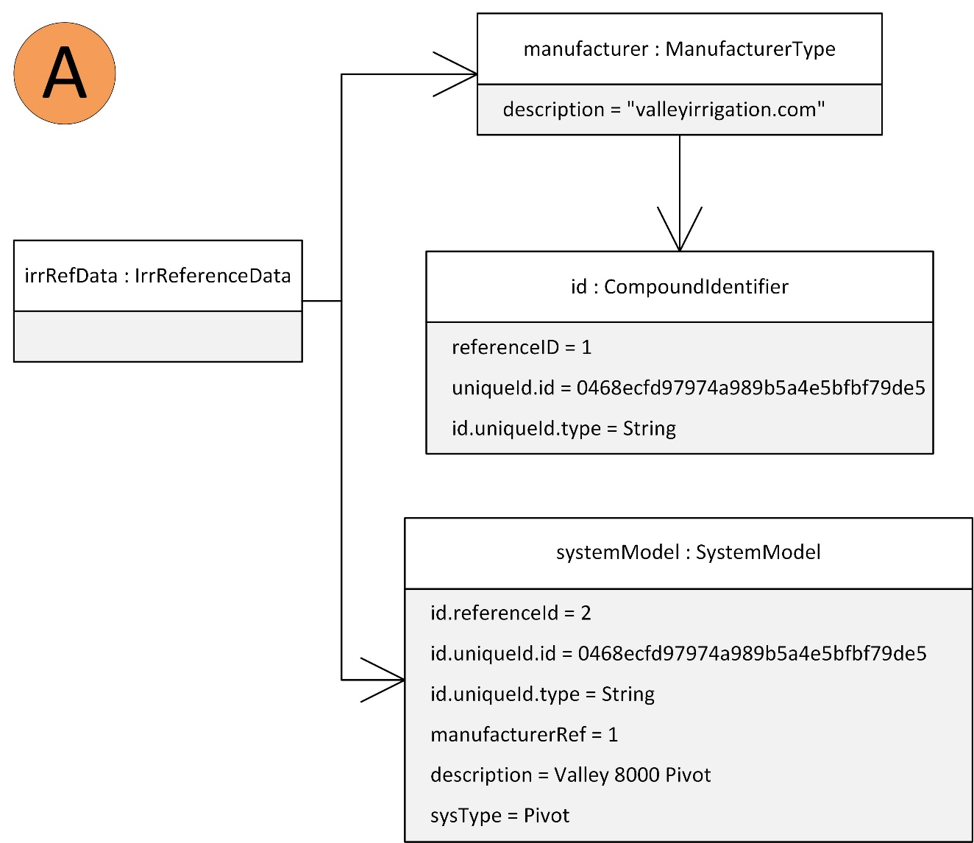

Figure 37 Example 1, Reference document

Figure A.3 shows all the setup information. The example defines a grower, farm, and field. The FieldBoundary uses the SpatialData object to define the field’s spatial extent. In the interest of brevity, the field is approximated as a rectangle. The IrrSetup defines the current system configuration. This particular pivot has a zone control VRI package installed. For convenience of the example, the system has seven groups of sprinklers corresponding to the seven spans of the pivot. Note that the InnerDistance of the first SectionSetup is 41.4; the distance of the innermost portion of the wetted area. The SectionSetup objects are also defined in sequence from innermost to outermost with no overlaps.

Figure A.4 shows a work order and work record. The WorkOrder is a VRI prescription scheduled to begin on June 6, 2017, with application depths varying between 0.7 to 1.0 inches. The WorkRecord has the same application depths (indicating that the irrigation depths occurred as prescribed) but the start time is delayed by two hours.

This example is repeated in XML form as Example 1 in Annex C.

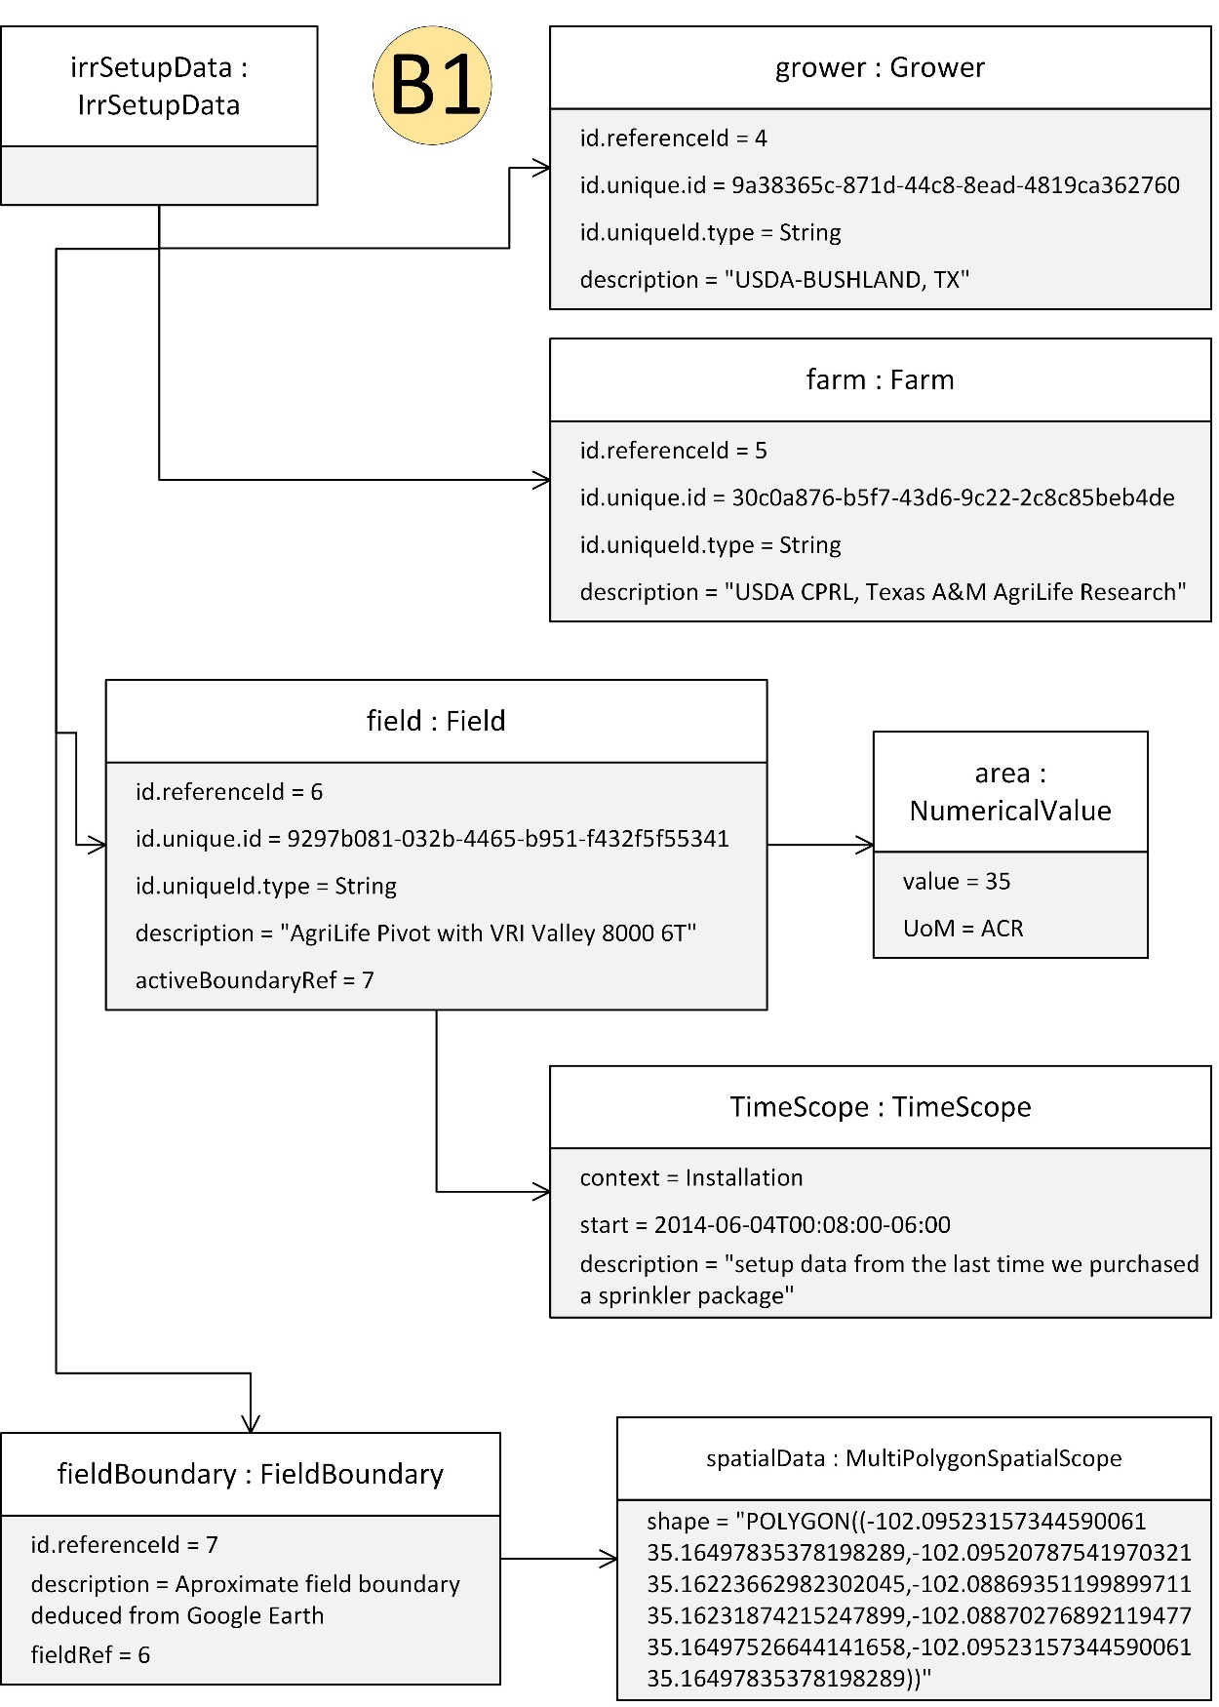

Figure 38 : Example 1 Setup document, part 1 of 2

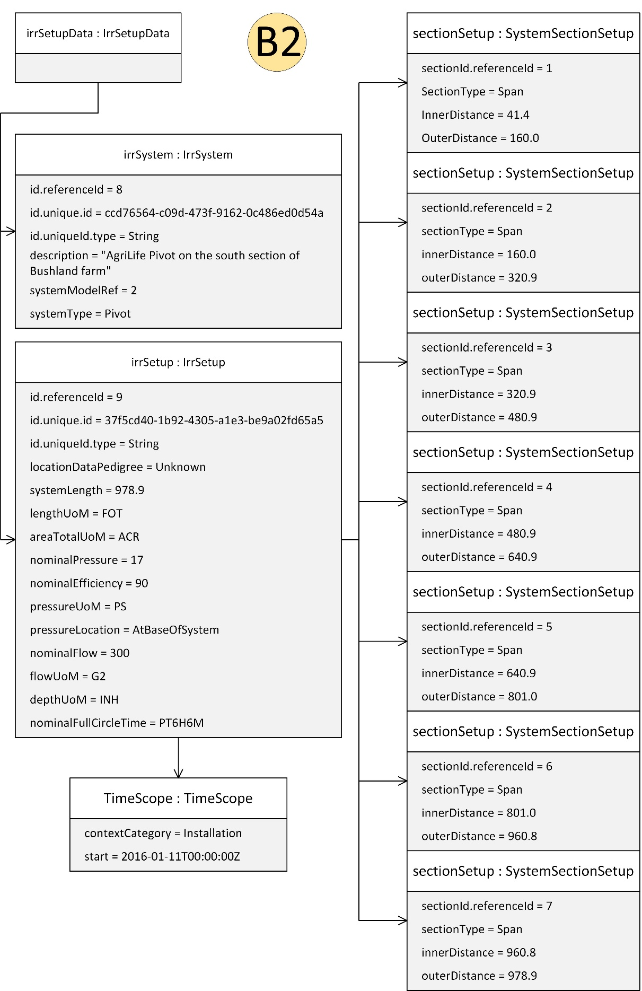

Figure 39: Example 1 Setup document, part 2 of 2

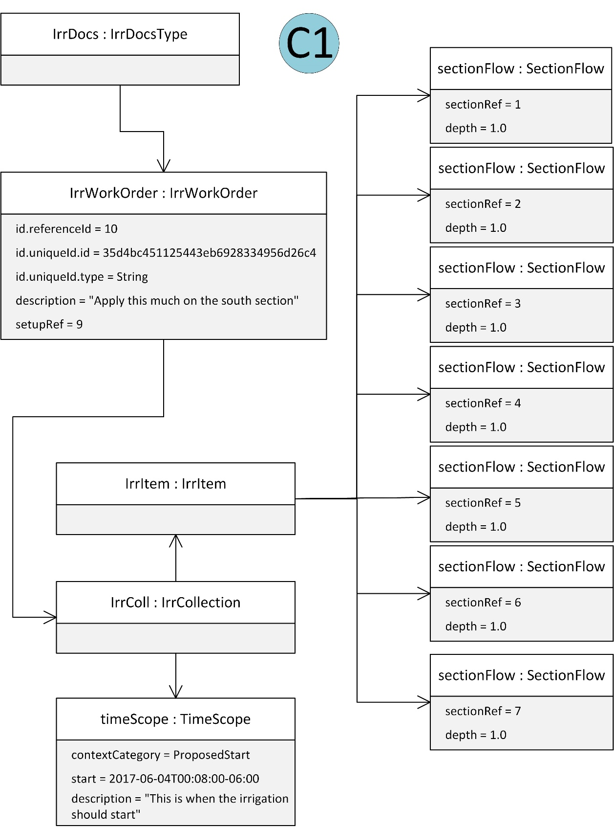

Figure 40: Example 1 Work Order and Work Record (1 of 2)

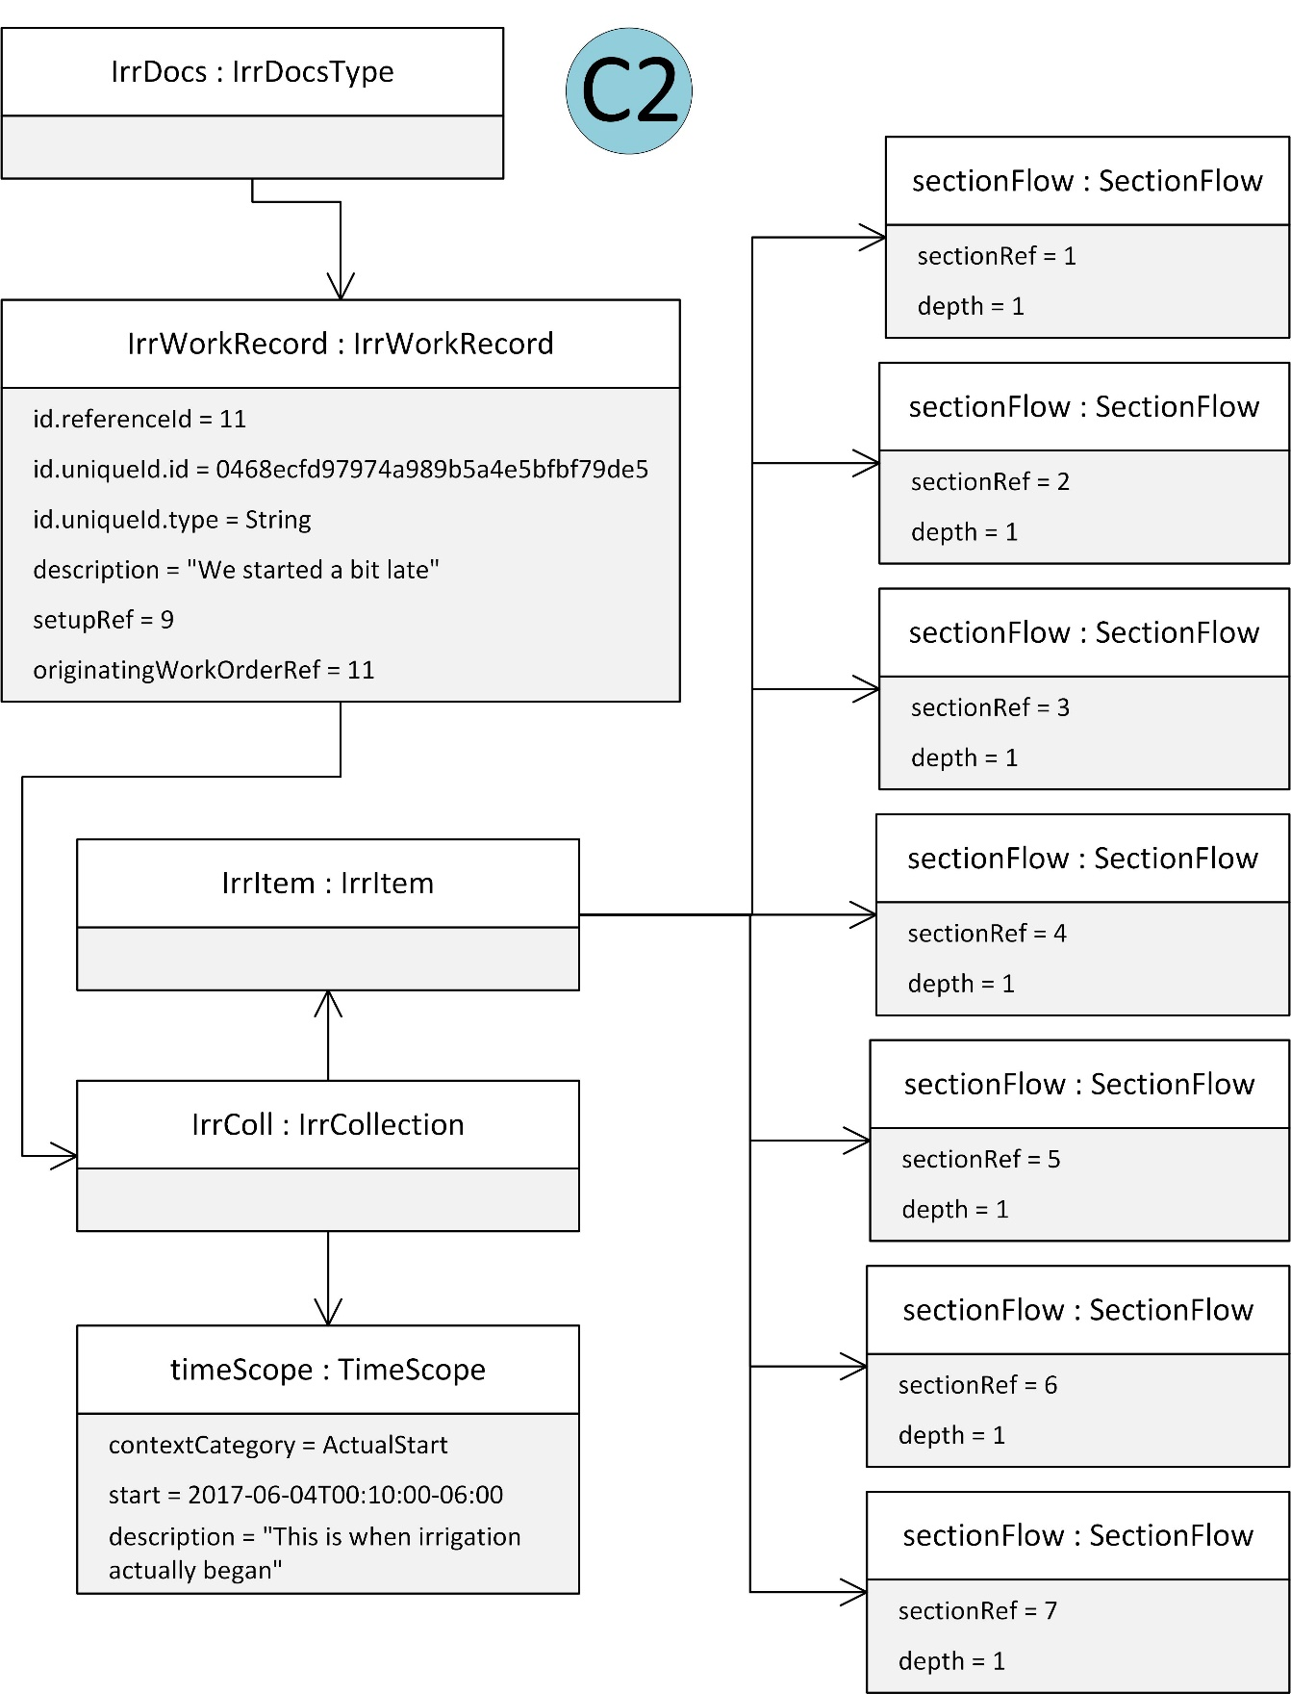

Figure 41: Example 1 Work Order and Work Record (2 of 2)

## A.2 Example 2

Example 2 shown in Figure A.5 illustrates a single file containing a Recommendation, Work Order, and Work Record. This example uses the same setup as Example 1 however, the IrrSetup object is referenced as an external file via the SetupURL property.

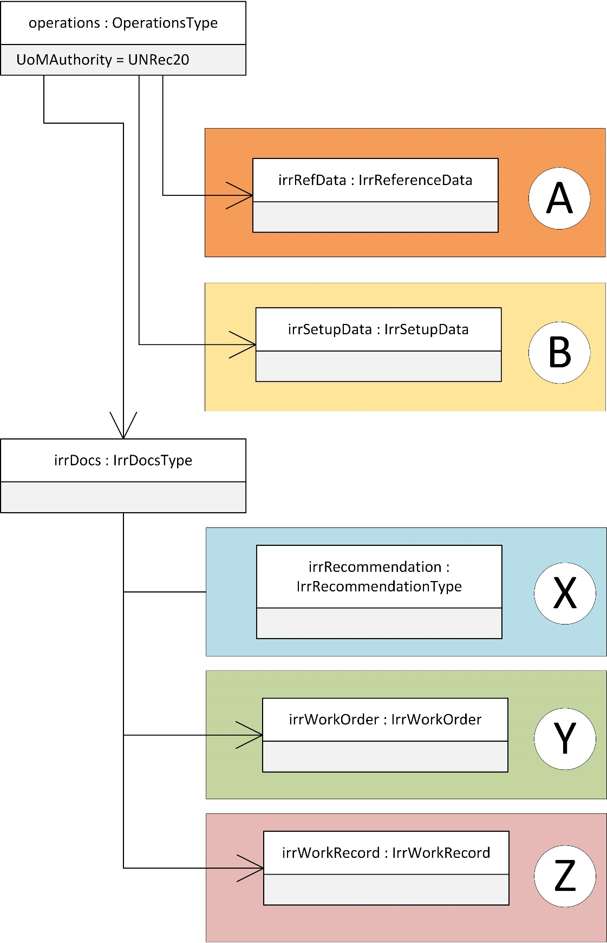

Figure 42: Example 2 (part 1 of 4)

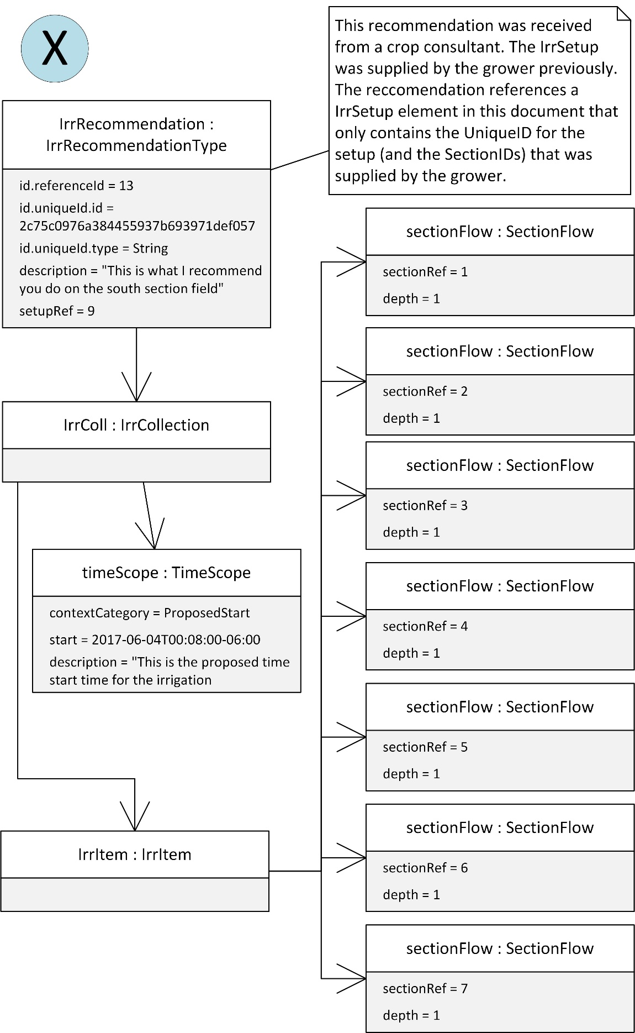

Figure 43: Example 2 (part 2 of 4)

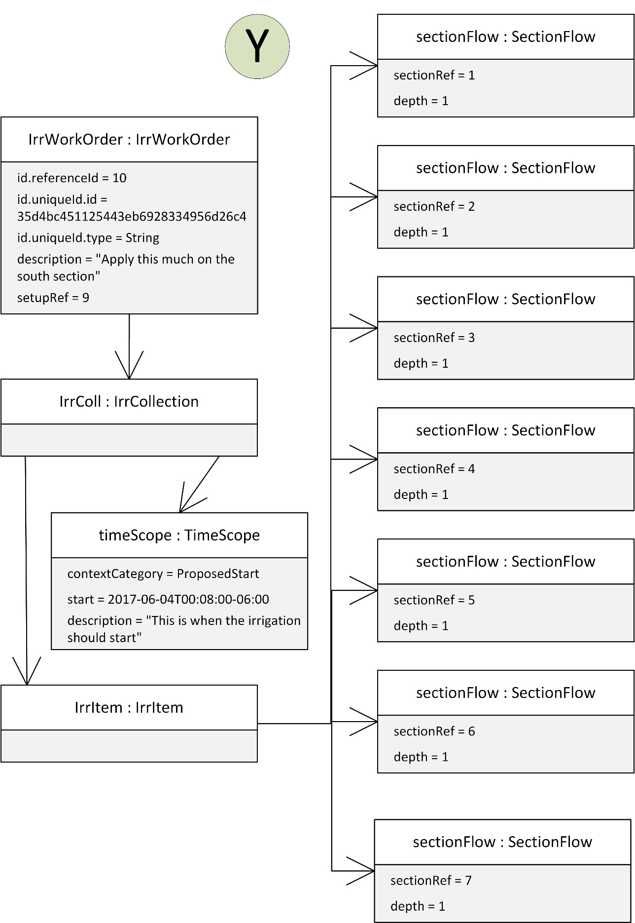

Figure 44: Example 2 (part 3 of 4)

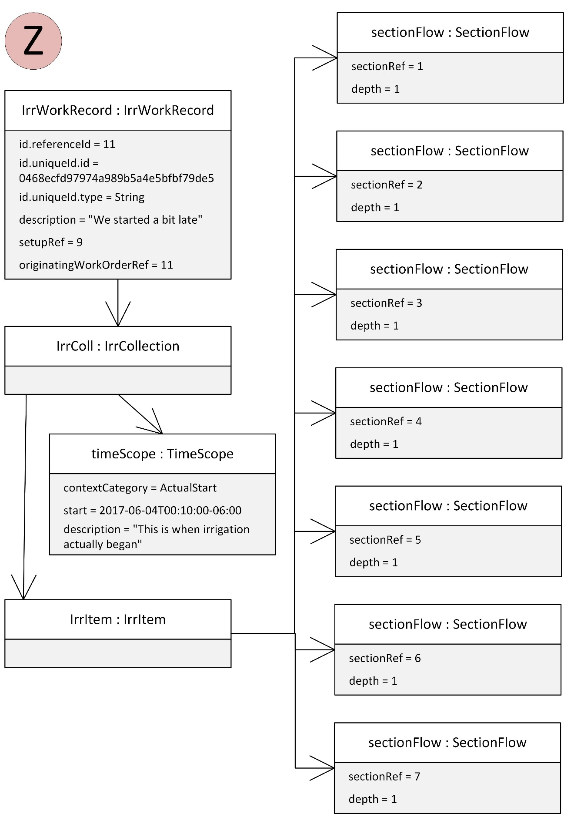

Figure 45: Example 2 (part 4 of 4)

## A.3 Example 3

The following example illustrates the use of a single Section object that covers the whole pivot. In the Work Record, the irrigation event started late, and the operator included a note explaining the difference. The example also uses the RadialScope object to show what area was irrigated. This example is replicated in Annex C as Example 3 however, instead of the RadialScope, the WorkRecord uses a MultiPolygonScope.

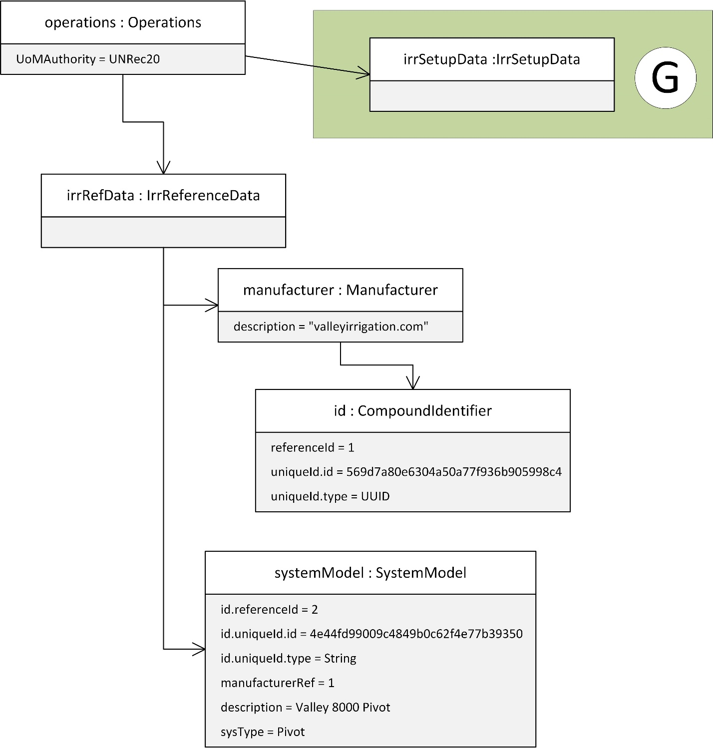

Figure 46: Example 3, setup and reference objects (part 1 of 2)

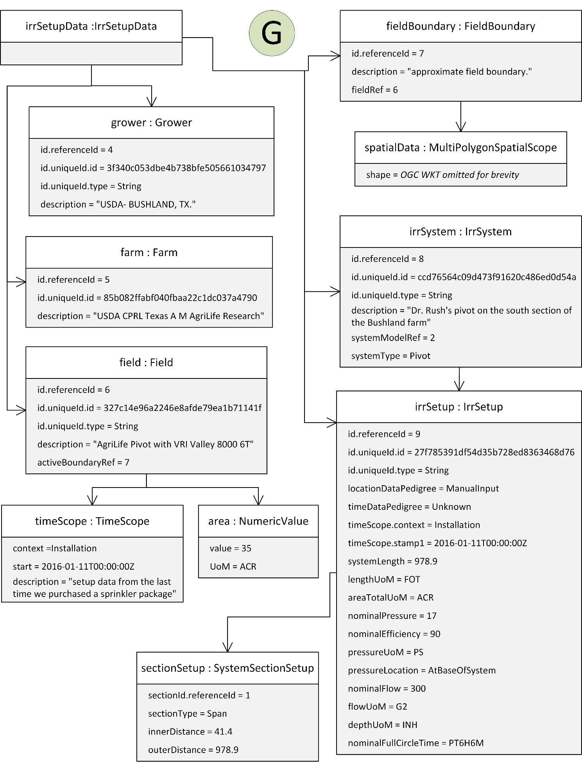

Figure 47: Example 3, setup and reference objects (part 2 of 2)

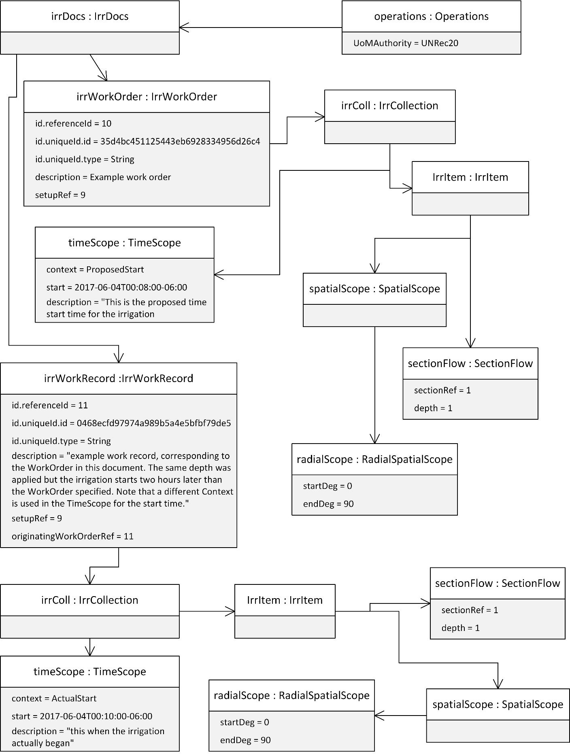

Figure 48: Example 3, work order and work record

Annex C  
(informative)  
  
XML Examples

C.1 Example 1

The following is an XML version of the same example shown in Annex A, Example 1. Readers will note that the XML file references an XML Schema but no schema is provided. Specification of serialization, which the schema would do, is deferred to a later part of the 7673 series. The XML examples are only intended as informative examples that mirror the UML examples provided in Annex A.

<?xml version="1.0" encoding="UTF-8"?>

<operations xmlns="http://aggateway.org/PAIL/0.1"

xmlns:xsi="http://www.w3.org/2001/XMLSchema-instance"

xsi:schemaLocation="http://aggateway.org/PAIL/0.1 ../PAIL%20xml/PAIL_Ops_028.xsd">

<irrRefData>

<manufacturer>

<id>

<referenceId>1</referenceId>

<uniqueId>

<idText>569d7a80e6304a50a77f936b905998c4</idText>

<idType>UUID</idType>

</uniqueId>

</id>

<description>ABC Pivot Company</description>

<contextItem>

<code>ExampleCode</code>

</contextItem>

</manufacturer>

<systemModel>

<id>

<referenceId>2</referenceId>

<uniqueId>

<idText>4e44fd99009c4849b0c62f4e77b39350</idText>

<idType>String</idType>

</uniqueId>

</id>

<manufacturerRef>1</manufacturerRef>

<description>ABC Pivot Company Model 1</description>

<sysType>Pivot</sysType>

</systemModel>

<product>

<id>

<referenceId>3</referenceId>

<uniqueId>

<idText>9b4341c0aeb04eb1812246d42db068f7</idText>

<idType>String</idType>

</uniqueId>

</id>

<description>An example fertilizer</description>

<type>CropNutrition</type>

<form>Solid</form>

<status>Active</status>

</product>

</irrRefData>

<irrSetupData>

<grower>

<id>

<referenceId>4</referenceId>

<uniqueId>

<idText>3f340c053dbe4b738bfe505661034797</idText>

<idType>String</idType>

</uniqueId>

</id>

<description>USDA- BUSHLAND, TX.</description>

</grower>

<farm>

<id>

<referenceId>5</referenceId>

<uniqueId>

<idText>85b082ffabf040fbaa22c1dc037a4790</idText>

<idType>String</idType>

</uniqueId>

</id>

<description>USDA CPRL Texas A M AgriLife Research</description>

</farm>

<field>

<id>

<referenceId>6</referenceId>

<uniqueId>

<idText>327c14e96a2246e8afde79ea1b71141f</idText>

<idType>String</idType>

</uniqueId>

</id>

<description>AgriLife Pivot with zone control VRI</description>

<timeScope>

<context>Installation</context>

<stamp1>2016-01-11T00:00:00Z</stamp1>

<description>setup data from the last time we purchased a sprinkler package</description>

</timeScope>

<area>

<value>35</value>

<unitOfMeasureCode>ACR</unitOfMeasureCode>

</area>

<activeBoundaryRef>7</activeBoundaryRef>

</field>

<fieldBoundary>

<id>

<referenceId>7</referenceId>

</id>

<description>approximate field boundary deduced from Google Earth</description>

<fieldRef>6</fieldRef>

<spatialData>

<shape>POLYGON((-102.08870686006059714 35.16221494869642328,-102.08868461962100582 35.16241503868509,-102.08870873475210317 35.16267755518924076,-102.08874050191160165 35.16292158775001297,-102.08883374447749759 35.16312778854115351,-102.08896585078649366 35.16338417523798654,-102.08907473051630177 35.16358449055753965,-102.08924571573589901 35.16383491305185061,-102.08939325798090181 35.16399757561934791,-102.08968819231920122 35.16424124002759299,-102.08994451238790191 35.16443498045150307,-102.09024718505570206 35.16459058308662833,-102.09053454093489677 35.16473378577809683,-102.09089156917059427 35.16485751729113929,-102.09124807593450157 35.16491160238491887,-102.09175173385339974 35.16496448474087089,-102.09211520286839914 35.16494244986999718,-102.09254836918209719 35.16492617737289095,-102.09288002048720045 35.16485370375159647,-102.09320307484159684 35.16473699041682721,-102.09352614554110517 35.16463300686866233,-102.09380957719480421 35.16448513202915649,-102.09406948229529632 35.16433125008199312,-102.09435121211780029 35.16412049843238918,-102.09451763034479654 35.16394877667679708,-102.09472846748249708 35.16369496633100056,-102.09492265331660121 35.16339763436147337,-102.09506248655209504 35.16309496344290153,-102.09515592829180264 35.16279318336169268,-102.09519610347270202 35.16252362881712656,-102.09519725706699944 35.16222981646617285,-102.08870686006059714 35.16221494869642328))</shape>

</spatialData>

</fieldBoundary>

<irrSystem>

<id>

<referenceId>8</referenceId>

<uniqueId>

<idText>ccd76564c09d473f91620c486ed0d54a</idText>

<idType>String</idType>

</uniqueId>

</id>

<description>half circle pivot on the south section of the Bushland farm</description>

<systemModelRef>2</systemModelRef>

<systemType>Pivot</systemType>

</irrSystem>

<irrSetup>

<id>

<referenceId>9</referenceId>

<uniqueId>

<idText>27f785391df54d35b728ed8363468d76</idText>

<idType>String</idType>

</uniqueId>

</id>

<sectionSetup>

<sectionId>

<referenceId>1</referenceId>

</sectionId>

<sectionType>Span</sectionType>

<innerDistance>41.4</innerDistance>

<outerDistance>160.0</outerDistance>

</sectionSetup>

<sectionSetup>

<sectionId>

<referenceId>2</referenceId>

</sectionId>

<sectionType>Span</sectionType>

<innerDistance>160.0</innerDistance>

<outerDistance>320.9</outerDistance>

</sectionSetup>

<sectionSetup>

<sectionId>

<referenceId>3</referenceId>

</sectionId>

<sectionType>Span</sectionType>

<innerDistance>320.9</innerDistance>

<outerDistance>480.9</outerDistance>

</sectionSetup>

<sectionSetup>

<sectionId>

<referenceId>4</referenceId>

</sectionId>

<sectionType>Span</sectionType>

<innerDistance>480.9</innerDistance>

<outerDistance>640.9</outerDistance>

</sectionSetup>

<sectionSetup>

<sectionId>

<referenceId>5</referenceId>

</sectionId>

<sectionType>Span</sectionType>

<innerDistance>640.9</innerDistance>

<outerDistance>801.0</outerDistance>

</sectionSetup>

<sectionSetup>

<sectionId>

<referenceId>6</referenceId>

</sectionId>

<sectionType>Span</sectionType>

<innerDistance>801.0</innerDistance>

<outerDistance>960.8</outerDistance>

</sectionSetup>

<sectionSetup>

<sectionId>

<referenceId>7</referenceId>

</sectionId>

<sectionType>Span</sectionType>

<innerDistance>960.8</innerDistance>

<outerDistance>978.9</outerDistance>

</sectionSetup>

<locationDataPedigree>ManualInput</locationDataPedigree>

<timeDataPedigree>Unknown</timeDataPedigree>

<timeScope>

<context>Installation</context>

<stamp1>2016-01-11T00:00:00Z</stamp1>

</timeScope>

<systemLength>978.9</systemLength>

<lengthUoM>FOT</lengthUoM>

<areaTotalUoM>ACR</areaTotalUoM>

<nominalPressure>17</nominalPressure>

<nominalEfficiency>90</nominalEfficiency>

<pressureUoM>PS</pressureUoM>

<pressureLocation>AtBaseOfSystem</pressureLocation>

<nominalFlow>300</nominalFlow>

<flowUoM>G2</flowUoM>

<depthUoM>INH</depthUoM>

<nominalFullCircleTime>PT6H6M</nominalFullCircleTime>

</irrSetup>

</irrSetupData>

<irrDocs>

<irrWorkOrder>

<id>

<referenceId>10</referenceId>

<uniqueId>

<idText>35d4bc451125443eb6928334956d26c4</idText>

<idType>String</idType>

</uniqueId>

</id>

<description>Example work order</description>

<setupRef>9</setupRef>

<irrColl>

<timeScope>

<context>ProposedStart</context>

<stamp1>2017-06-04T00:08:00-06:00</stamp1>

</timeScope>

<irrItem>

<sectionFlow>

<sectionRef>1</sectionRef>

<depth>1</depth>

</sectionFlow>

<sectionFlow>

<sectionRef>2</sectionRef>

<depth>1</depth>

</sectionFlow>

<sectionFlow>

<sectionRef>3</sectionRef>

<depth>1</depth>

</sectionFlow>

<sectionFlow>

<sectionRef>4</sectionRef>

<depth>1</depth>

</sectionFlow>

<sectionFlow>

<sectionRef>5</sectionRef>

<depth>1</depth>

</sectionFlow>

<sectionFlow>

<sectionRef>6</sectionRef>

<depth>1</depth>

</sectionFlow>

<sectionFlow>

<sectionRef>7</sectionRef>

<depth>1</depth>

</sectionFlow>

</irrItem>

</irrColl>

</irrWorkOrder>

<irrWorkRecord>

<id>

<referenceId>11</referenceId>

<uniqueId>

<idText>0468ecfd97974a989b5a4e5bfbf79de5</idText>

<idType>String</idType>

</uniqueId>

</id>

<description>example work record, corresponding to the WorkOrder in this document. The same depth was applied but the irrigation starts two hours later than the WorkOrder specified. Note that a different Context is used in the TimeScope for the start time.</description>

<setupRef>9</setupRef>

<irrColl>

<timeScope>

<context>ActualStart</context>

<stamp1>2017-06-04T00:10:00-06:00</stamp1>

</timeScope>

<irrItem>

<sectionFlow>

<sectionRef>1</sectionRef>

<depth>1</depth>

</sectionFlow>

<sectionFlow>

<sectionRef>2</sectionRef>

<depth>1</depth>

</sectionFlow>

<sectionFlow>

<sectionRef>3</sectionRef>

<depth>1</depth>

</sectionFlow>

<sectionFlow>

<sectionRef>4</sectionRef>

<depth>1</depth>

</sectionFlow>

<sectionFlow>

<sectionRef>5</sectionRef>

<depth>1</depth>

</sectionFlow>

<sectionFlow>

<sectionRef>6</sectionRef>

<depth>1</depth>

</sectionFlow>

<sectionFlow>

<sectionRef>7</sectionRef>

<depth>1</depth>

</sectionFlow>

</irrItem>

</irrColl>

<originatingWorkOrderRef>10</originatingWorkOrderRef>

</irrWorkRecord>

</irrDocs>

<unitOfMeasureAuthority>UNRec20</unitOfMeasureAuthority>

</operations>

C.2 Example 2

The following is XML version of the second example in Annex A.

<?xml version="1.0" encoding="UTF-8"?>

<operations xmlns="http://aggateway.org/PAIL/0.1" xmlns:xsi="http://www.w3.org/2001/XMLSchema-instance" xsi:schemaLocation="http://aggateway.org/PAIL/0.1 ../PAIL%20xml/PAIL_Ops_028.xsd">

<irrSetupData>

<irrSystem>

<id>

<referenceId>8</ReferenceId>

<uniqueId>

<idText>ccd76564c09d473f91620c486ed0d54a</idText>

<idType>String</idType>

</uniqueId>

</id>

<description>half circle pivot on the south section of the Bushland farm</description>

<systemModelRef>12345</systemModelRef>

<systemType>Pivot</systemType>

</irrSystem>

<IrrSetup>

<id>

<referenceId>9</referenceId>

<uniqueId>

<idText>27f785391df54d35b728ed8363468d76</idText>

<idType>String</idType>

</uniqueId>

</id>

<systemRef>8</systemRef>

<sectionSetup>

<sectionId>

<referenceId>1</referenceId>

<uniqueId>

<idText>69845dcea7e34bf194000d8c281e050a</idText>

<idType>String</idType>

</uniqueId>

</sectionId>

<sectionType>Span</sectionType>

<innerDistance>41.4</innerDistance>

<outerDistance>160.0</outerDistance>

</sectionSetup>

<sectionSetup>

<sectionId>

<referenceId>2</referenceId>

<uniqueId>

<idText>1225e20d116240f295020c9157202b5e</idText>

<idType>String</idType>

</uniqueId>

</sectionId>

<sectionType>Span</sectionType>

<innerDistance>160.0</innerDistance>

<outerDistance>320.9</outerDistance>

</sectionSetup>

<sectionSetup>

<sectionId>

<referenceId>3</referenceId>

<uniqueId>

<idText>aee3603b66d747df9454a9743b4e148c</idText>

<idType>String</idType>

</uniqueId>

</sectionId>

<sectionType>Span</sectionType>

<innerDistance>320.9</innerDistance>

<outerDistance>480.9</outerDistance>

</sectionSetup>

<sectionSetup>

<sectionId>

<referenceId>4</referenceId>

<uniqueId>

<idText>271fdd5cc5b54b1b92603dbfd67123a9</idText>

<idType>String</idType>

</uniqueId>

</sectionId>

<sectionType>Span</sectionType>

<innerDistance>480.9</innerDistance>

<outerDistance>640.9</outerDistance>

</sectionSetup>

<sectionSetup>

<sectionId>

<referenceId>5</referenceId>

<uniqueId>

<idText>e0528096245c43edb5b0491504e0a400</idText>

<idType>String</idType>

</uniqueId>

</sectionId>

<sectionType>Span</sectionType>

<innerDistance>640.9</innerDistance>

<outerDistance>801.0</outerDistance>

</sectionSetup>

<sectionSetup>

<sectionId>

<referenceId>6</referenceId>

<uniqueId>

<idText>86465b9b00774ae4ae67f0cb8261a619</idText>

<idType>String</idType>

</uniqueId>

</sectionId>

<sectionType>Span</sectionType>

<innerDistance>801.0</innerDistance>

<outerDistance>960.8</outerDistance>

</sectionSetup>

<sectionSetup>

<sectionId>

<referenceId>7</referenceId>

<uniqueId>

<idText>e952614822cc4662b67c23f02a336031</idText>

<idType>String</idType>

</uniqueId>

</sectionId>

<sectionType>Span</sectionType>

<innerDistance>960.8</innerDistance>

<outerDistance>978.9</outerDistance>

</sectionSetup>

</irrSetup>

</irrSetupData>

<irrDocs>

<irrRecommendation>

<id>

<referenceId>13</referenceId>

<uniqueId>

<idText>2c75c0976a384455937b693971def057</idText>

<idType>String</idType>

</uniqueId>

</id>

<description>This recommendation was received from a crop consultant. The IrrSetup was supplied by the grower previously. The recommendation references a IrrSetup element in this document that only contains the UniqueID for the setup (and the SectionIDs) that was supplied by the grower.</description>

<setupRef>9</setupRef>

<irrColl>

<timeScope>

<context>ProposedStart</context>

<stamp1>2017-06-04T00:08:00-06:00</stamp1>

</timeScope>

<irrItem>

<sectionFlow>

<sectionRef>1</sectionRef>

<depth>1</depth>

</sectionFlow>

<sectionFlow>

<sectionRef>2</sectionRef>

<depth>1</depth>

</sectionFlow>

<sectionFlow>

<sectionRef>3</sectionRef>

<depth>1</depth>

</sectionFlow>

<sectionFlow>

<sectionRef>4</sectionRef>

<depth>1</depth>

</sectionFlow>

<sectionFlow>

<sectionRef>5</sectionRef>

<depth>1</depth>

</sectionFlow>

<sectionFlow>

<sectionRef>6</sectionRef>

<depth>1</depth>

</sectionFlow>

<sectionFlow>

<sectionRef>7</sectionRef>

<depth>1</depth>

</sectionFlow>

</irrItem>

</irrColl>

</irrRecommendation>

<irrWorkOrder>

<id>

<referenceId>10</referenceId>

<uniqueId>

<idText>35d4bc451125443eb6928334956d26c4</idText>

<idType>String</idType>

</uniqueId>

</id>

<description>This work order was sent to the field manager. the OriginatingWorkOrderRef refers to the Recommendation element. IrrItem is a direct copy of the Recommendation indicating that the grower approved of the recommended irrigation.</description>

<setupRef>9</setupRef>

<irrColl>

<timeScope>

<context>ProposedStart</context>

<stamp1>2017-06-04T00:08:00-06:00</stamp1>

</timeScope>

<irrItem>

<sectionFlow>

<sectionRef>1</sectionRef>

<depth>1</depth>

</sectionFlow>

<sectionFlow>

<sectionRef>2</sectionRef>

<depth>1</depth>

</sectionFlow>

<sectionFlow>

<sectionRef>3</sectionRef>

<depth>1</depth>

</sectionFlow>

<sectionFlow>

<sectionRef>4</sectionRef>

<depth>1</depth>

</sectionFlow>

<sectionFlow>

<sectionRef>5</sectionRef>

<depth>1</depth>

</sectionFlow>

<sectionFlow>

<sectionRef>6</sectionRef>

<depth>1</depth>

</sectionFlow>

<sectionFlow>

<sectionRef>7</sectionRef>

<depth>1</depth>

</sectionFlow>

</irrItem>

</irrColl>

<originatingRecRef>13</originatingRecRef>

</irrWorkOrder>

<irrWorkRecord>

<id>

<referenceId>11</referenceId>

<uniqueId>

<idText>0468ecfd97974a989b5a4e5bfbf79de5</idText>

<idType>String</idType>

</uniqueId>

</id>

<description>example work record, corresponding to the WorkOrder in this document. The same depth was applied but the irrigation starts two hours later than the WorkOrder specified. Note that a different Context is used in the TimeScope for the start time.</description>

<setupRef>9</setupRef>

<irrColl>

<timeScope>

<context>ActualStart</context>

<stamp1>2017-06-04T00:10:00-06:00</stamp1>

</timeScope>

<irrItem>

<sectionFlow>

<sectionRef>1</sectionRef>

<depth>1</depth>

</sectionFlow>

<sectionFlow>

<sectionRef>2</sectionRef>

<depth>1</depth>

</sectionFlow>

<sectionFlow>

<sectionRef>3</sectionRef>

<depth>1</depth>

</sectionFlow>

<sectionFlow>

<sectionRef>4</sectionRef>

<depth>1</depth>

</sectionFlow>

<sectionFlow>

<sectionRef>5</sectionRef>

<depth>1</depth>

</sectionFlow>

<sectionFlow>

<sectionRef>6</sectionRef>

<depth>1</depth>

</sectionFlow>

<sectionFlow>

<sectionRef>7</sectionRef>

<depth>1</depth>

</sectionFlow>

</irrItem>

</irrColl>

<originatingWorkOrderRef>11</originatingWorkOrderRef>

</irrWorkRecord>

</irrDocs>

<unitOfMeasuereAuthority>UNRec20</unitOfMeasuereAuthority>

</operations>

C.3 Example 3

<?xml version="1.0" encoding="UTF-8"?>

<operations xmlns="http://aggateway.org/PAIL/0.1" xmlns:xsi="http://www.w3.org/2001/XMLSchema-instance" xsi:schemaLocation="http://aggateway.org/PAIL/0.1 ../PAIL%20xml/PAIL_Ops_028.xsd">

<irrRefData>

<manufacturer>

<id>

<referenceId>1</referenceId>

<uniqueId>

<idText>569d7a80e6304a50a77f936b905998c4</idText>

<idType>UUID</idType>

</uniqueId>

</id>

<description>ABC Pivot Company</description>

<contextItem>

<code>ExampleCode</code>

</contextItem>

</manufacturer>

<systemModel>

<id>

<referenceId>2</referenceId>

<uniqueId>

<idText>4e44fd99009c4849b0c62f4e77b39350</idText>

<idType>String</idType>

</uniqueId>

</id>

<manufacturerRef>1</manufacturerRef>

<description>ABC Pivot Company Model 1</description>

<sysType>Pivot</sysType>

</systemModel>

<product>

<id>

<referenceId>3</referenceId>

<uniqueId>

<idText>9b4341c0aeb04eb1812246d42db068f7</idText>

<idType>String</idType>

</uniqueId>

</id>

<description>An example fertilizer</description>

<type>CropNutrition</type>

<form>Solid</form>

<status>Active</status>

</product>

</irrRefData>

<irrSetupData>

<grower>

<id>

<referenceId>4</referenceId>

<uniqueId>

<idText>3f340c053dbe4b738bfe505661034797</idText>

<idType>String</idType>

</uniqueId>

</id>

<description>USDA- BUSHLAND, TX.</description>

</grower>

<farm>

<id>

<referenceId>5</referenceId>

<uniqueId>

<idText>85b082ffabf040fbaa22c1dc037a4790</idText>

<idType>String</idType>

</uniqueId>

</id>

<description>USDA CPRL and Texas A&amp;M AgriLife Research</description>

</farm>

<field>

<id>

<referenceId>6</referenceId>

<uniqueId>

<idText>327c14e96a2246e8afde79ea1b71141f</idText>

<idType>String</idType>

</uniqueId>

</id>

<description>AgriLife Pivot with zone control VRI</description>

<timeScope>

<context>Installation</context>

<dtamp1>2016-01-11T00:00:00Z</dtamp1>

<description>setup data from the last time we purchased a sprinkler package</description>

</timeScope>

<area>

<value>35</value>

<unitOfMeasure>ACR</unitOfMeasure>

</area>

<activeBoundaryRef>7</activeBoundaryRef>

</field>

<fieldBoundary>

<id>

<referenceId>7</referenceId>

</id>

<description>approximate field boundary. To reduce the overal size of the example, the field boundary is represented as a rectangle.</description>

<fieldRef>6</fieldRef>

<spatialData>

<shape>POLYGON((-102.09523157344590061 35.16497835378198289,-102.09520787541970321 35.16223662982302045,-102.08869351199899711 35.16231874215247899,-102.08870276892119477 35.16497526644141658,-102.09523157344590061 35.16497835378198289))</shape>

</spatialData>

</fieldBoundary>

<irrSystem>

<id>

<referenceId>8</referenceId>

<uniqueId>

<idText>ccd76564c09d473f91620c486ed0d54a</idText>

<idType>String</idType>

</uniqueId>

</id>

<description>Half circle pivot on the south section of the Bushland farm</description>

<systemModelRef>2</systemModelRef>

<systemType>Pivot</systemType>

</irrSystem>

<irrSetup>

<id>

<referenceId>9</referenceId>

<uniqueId>

<idText>27f785391df54d35b728ed8363468d76</idText>

<idType>String</idType>

</uniqueId>

</id>

<sectionSetup>

<sectionId>

<referenceId>1</referenceId>

</sectionId>

<sectionType>Span</sectionType>

<innerDistance>41.4</innerDistance>

<outerDistance>978.9</outerDistance>

</sectionSetup>

<locationDataPedigree>ManualInput</locationDataPedigree>

<timeDataPedigree>Unknown</timeDataPedigree>

<timeScope>

<context>Installation</context>

<stamp1>2016-01-11T00:00:00Z</stamp1>

</timeScope>

<systemLength>978.9</systemLength>

<lengthUoM>FOT</lengthUoM>

<areaTotalUoM>ACR</areaTotalUoM>

<nominalPressure>17</nominalPressure>

<nominalEfficiency>90</nominalEfficiency>

<pressureUoM>PS</pressureUoM>

<pressureLocation>AtBaseOfSystem</pressureLocation>

<nominalFlow>300</nominalFlow>

<flowUoM>G2</flowUoM>

<depthUoM>INH</depthUoM>

<nominalFullCircleTime>PT6H6M</nominalFullCircleTime>

</irrSetup>

</irrSetupData>

<irrDocs>

<irrWorkOrder>

<id>

<referenceId>10</referenceId>

<uniqueId>

<idText>35d4bc451125443eb6928334956d26c4</idText>

<idType>String</idType>

</uniqueId>

</id>

<description>Example work order</description>

<setupRef>9</setupRef>

<irrColl>

<timeScope>

<context>ProposedStart</context>

<stamp1>2017-06-04T00:08:00-06:00</stamp1>

</timeScope>

<irrItem>

<sectionFlow>

<sectionRef>1</sectionRef>

<depth>1</depth>

</sectionFlow>

</irrItem>

</irrColl>

</irrWorkOrder>

<irrWorkRecord>

<id>

<referenceId>11</referenceId>

<uniqueId>

<idText>0468ecfd97974a989b5a4e5bfbf79de5</idText>

<idType>String</idType>

</uniqueId>

</id>

<description>example work record, corresponding to the WorkOrder in this document. The fi</description>

<setupRef>9</setupRef>

<irrColl>

<timeScope>

<context>ActualStart</context>

<stamp1>2017-06-04T00:10:00-06:00</stamp1>

</timeScope>

<spatialScope>

<multiPolygonScope>

<shape>POLYGON((-102.09523157344590061 35.16497835378198289,-102.09520787541970321 35.16223662982302045,-102.08869351199899711 35.16231874215247899,-102.08870276892119477 35.16497526644141658,-102.09523157344590061 35.16497835378198289))</shape>

</multiPolygonScope>

</spatialScope>

<irrItem>

<sectionFlow>

<sectionRef>1</sectionRef>

<depth>1</depth>

</sectionFlow>

</irrItem>

</irrColl>

<originatingWorkOrderRef>11</originatingWorkOrderRef>

<note>

<noteText>Pivot got stuck about mid way through and only part of the field was irrigated. The portion that was irrigated is included in the WorkRecord as the SpatialScope element.</noteText>

</note>

</irrWorkRecord>

</irrDocs>

<unitOfMeasureAuthority>UNRec20</unitOfMeasureAuthority>

</operations>

C.4 Example 4

<?xml version="1.0" encoding="UTF-8"?>

<operations xmlns="http://aggateway.org/PAIL/0.1" xmlns:xsi="http://www.w3.org/2001/XMLSchema-instance" xsi:schemaLocation="http://aggateway.org/PAIL/0.1 ../PAIL%20xml/PAIL_Ops_028.xsd">

<irrSetupData>

<field>

<id>

<referenceId>6</referenceId>

</id>

<description>South section pivot</description>

<area>

<value>35</value>

<unitofMeasure>Acr</unitofMeasure>

</area>

</field>

<irrSystem>

<id>

<referenceId>8</referenceId>

<uniqueId>

<idText>ccd76564c09d473f91620c486ed0d54a</idText>

<idType>String</idType>

</uniqueId>

</id>

<description>Half circle pivot on the south section of the Bushland farm</description>

<systemModelRef>1234</systemModelRef>

<systemType>Pivot</systemType>

</irrSystem>

<irrSetup>

<id>

<referenceId>9</referenceId>

<uniqueId>

<idText>27f785391df54d35b728ed8363468d76</idText>

<idType>String</idType>

</uniqueId>

</id>

<fieldRef>6</fieldRef>

<sectionSetup>

<sectionId>

<referenceId>1</referenceId>

</sectionId>

<sectionType>Span</sectionType>

<innerDistance>41.4</innerDistance>

<outerDistance>978.9</outerDistance>

</sectionSetup>

<locationDataPedigree>ManualInput</locationDataPedigree>

<timeDataPedigree>Unknown</timeDataPedigree>

<timeScope>

<context>Installation</context>

<stamp1>2016-01-11T00:00:00Z</stamp1>

</timeScope>

<systemLength>978.9</systemLength>

<lengthUoM>FOT</lengthUoM>

<nominalEfficiency>90</nominalEfficiency>

<nominalFlow>300</nominalFlow>

<depthUoM>INH</depthUoM>

<nominalFullCircleTime>PT6H6M</nominalFullCircleTime>

</irrSetup>

</irrSetupData>

<irrDocs>

<irrWorkRecord>

<id>

<referenceId>11</referenceId>

</id>

<description>There is no WorkOrder associated with this WorkRecord</description>

<setupRef>9</setupRef>

<irrColl>

<timeScope>

<context>Actual</context>

<stamp1>2017-06-04T00:08:00-06:00</stamp1>

<stamp2>2017-06-04T00:20:00-06:00</stamp2>

</timeScope>

<irrItem>

<spatialScope>

<radialScope>

<startDeg>270</startDeg>

<endDeg>90</endDeg>

</radialScope>

</spatialScope>

<sectionFlow>

<sectionRef>1</sectionRef>

<depth>1</depth>

</sectionFlow>

</irrItem>

</irrColl>

</irrWorkRecord>

</irrDocs>

<unitOfMeasureAuthority>UNRec20</unitOfMeasureAuthority>

</operations>

# Bibliography

[1] ISO/IEC Directives, Part 2, *Rules for the structure and drafting of International Standards*, 2001

[2] ISO/IEC TR 10000‑1, *Information technology — Framework and taxonomy of International Standardized Profiles — Part 1: General principles and documentation framework*

[3] ISO 10241, *International terminology standards — Preparation and layout*

[4] ISO 128-30, *Technical drawings — General principles of presentation — Part 30: Basic conventions for views*

[5] ISO 128-34, *Technical drawings — General principles of presentation — Part 34: Views on mechanical engineering drawings*

[6] ISO 128-40, *Technical drawings — General principles of presentation — Part 40: Basic conventions for cuts and sections*

[7] ISO 128-44, *Technical drawings — General principles of presentation — Part 44: Sections on mechanical engineering drawings*

[8] ISO 31 (all parts), *Quantities and units*

[9] IEC 60027 (all parts), *Letter symbols to be used in electrical technology*

[10] ISO 1000, *SI units and recommendations for the use of their multiples and of certain other units*

[11] ISO 690, *Documentation — Bibliographic references — Content, form and structure*

[12] ISO 690‑2, *Information and documentation — Bibliographic references — Part 2: Electronic documents or parts thereof*

[13]ISO 15081:2011(en) Agricultural equipment — Graphical symbols for pressurized irrigation systems